**CRUD**: Create Read Update Delete

V8 engine is used in Google Chrome and Nodejs. Actually, V8 engine is coded from C++. But V8 engine helps to run javascript on our machine.

npm: Node Package Manager

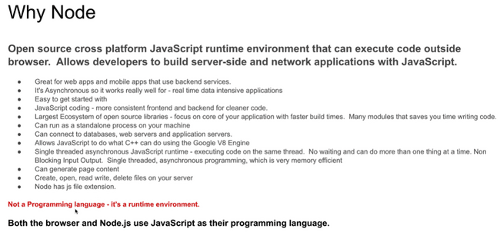

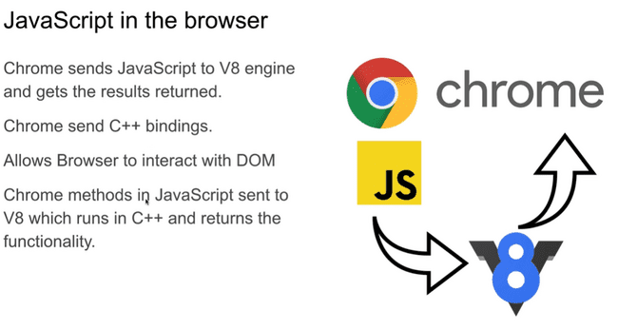

The working of browser and nodejs is same, as can be seen, both send their js codes to the browser and as V8 works on C++ so, get their outputs returned from V8 and hence, work on it.

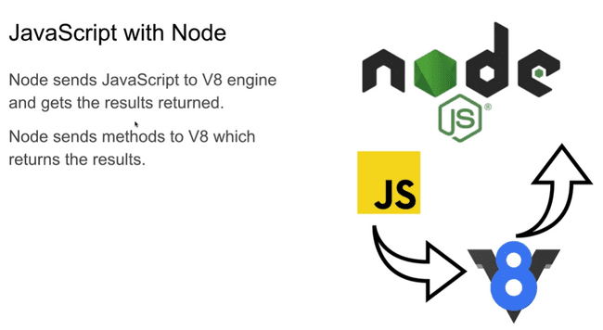

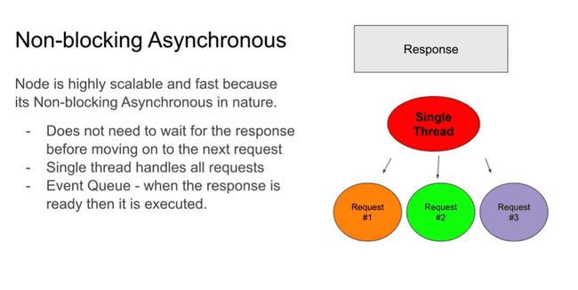

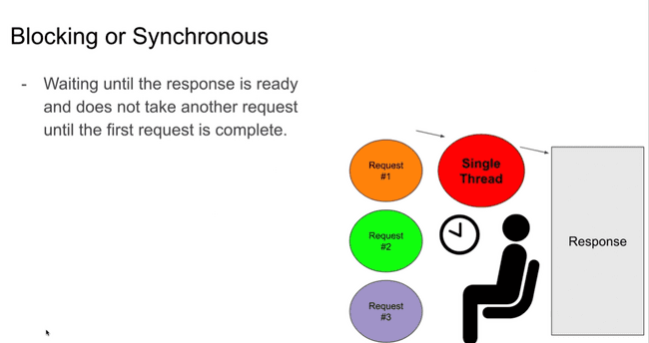

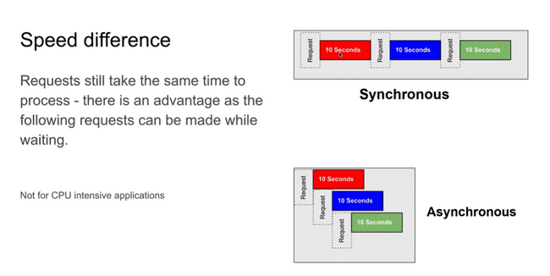

**Ctrl+C** : to break a loop which was executing in the console.

‘**Break**’ keyword and **process.exit()** are used to end a loop at specific condition. Note that process which we have used above is in-built object of nodejs.

**REPL:** Read Evaluate Print Loop

Type ‘**clear**’ in the terminal to clear the output screen.

To enter REPL mode, type ‘node’ in the terminal. And then one can write ‘.help’ to get all commands which will work in the REPL.

Syntax for loading file in repl mode: **.load (filename)**

Type ‘console.’ In REPL mode and then clcking on ‘Tab’ button gives all pre-defined functions related to console. Same works for other objects as well.

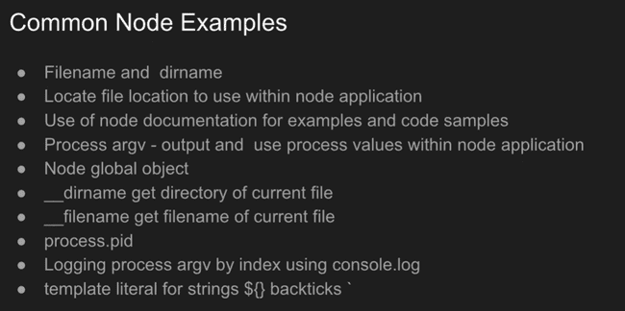

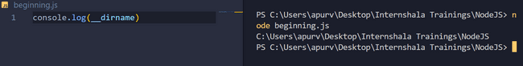

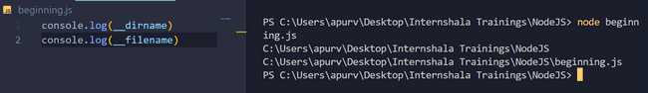

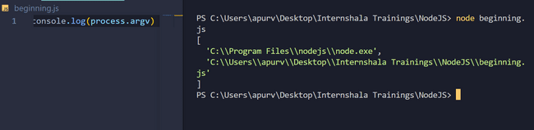

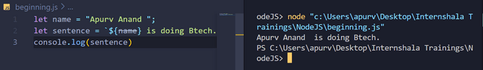

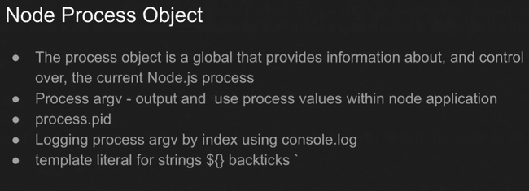

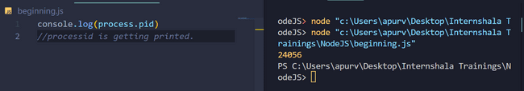

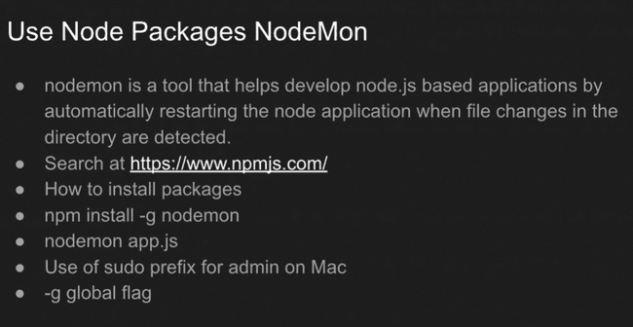

**Nodemon** will automatically restart the terminal to give a new output wheneven we will make any changes in the file relating to code etc.

**ALWAYS RUN PROGRAMS IN COMMAND PROMPT TERMINAL for ‘Nodemon’.**

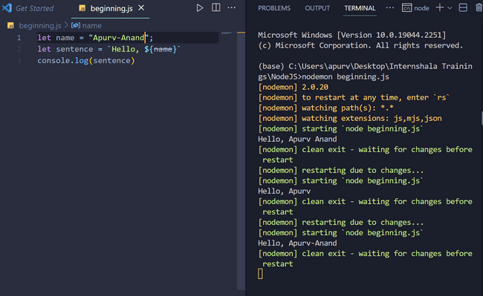

**NOTE: terminal above is selected to be ‘command prompt’ and not ‘powershell’ which is set by default.**

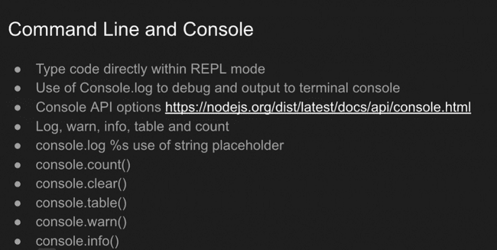

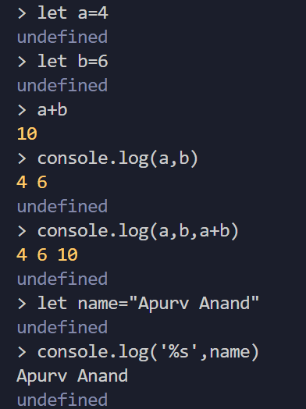

**Syntax is similar to C++.**

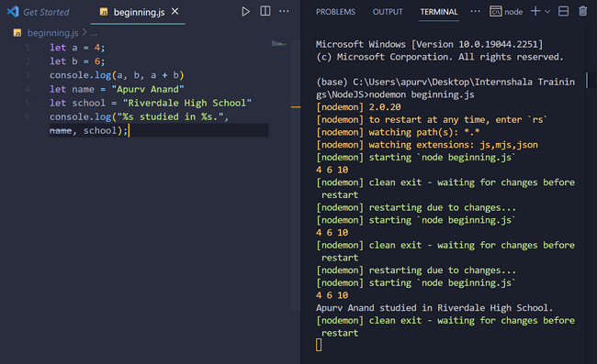

**Console.count(/name of string/)** : counts how many times a string has been used in the console.

Like in example below, when we had counted ‘name’ using console.count() for the first time , it gave output as 1 but when we write console.count(name) again and again as the string is used repeatedly in the console ,so, its count is getting increased as can be seen from output of console.count() function as it counts how many times a string has been used in the console.

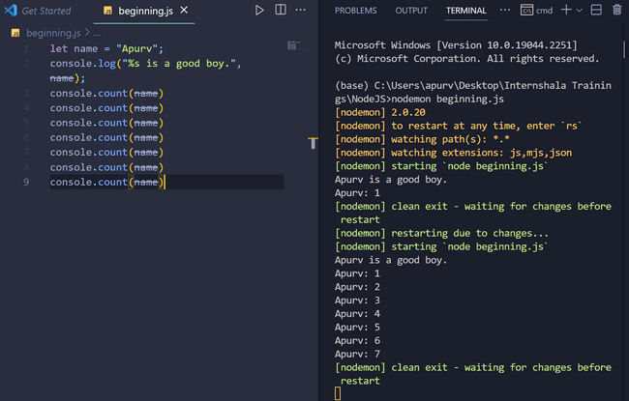

**Console.clear()** : clears everything written before that line on the console.

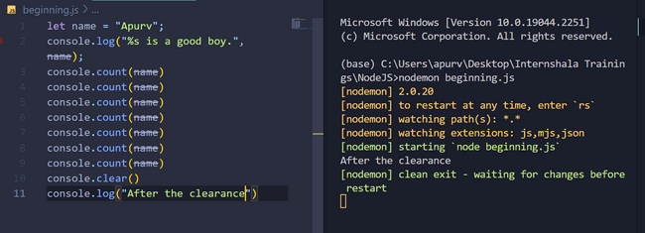

**Console.log() , console.warn(), console.info()** : are all synonymous as they all print the things written within the parenthesis on console.

**Console.table()** is used to output in form of a table. It consists of key:value pairs as can be seen in input.

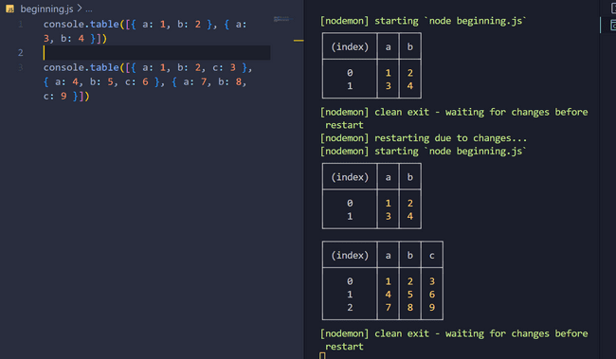

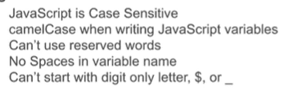

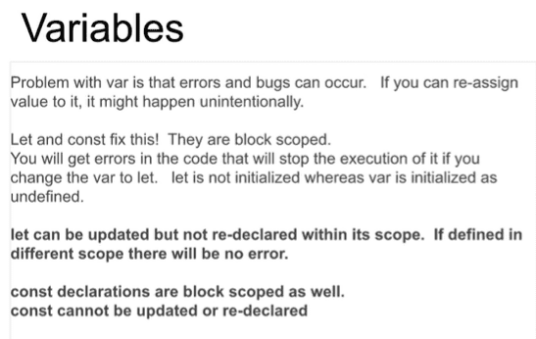

**Var can be redeclared and reassigned.**

**Let can be reassigned. Const has none.**

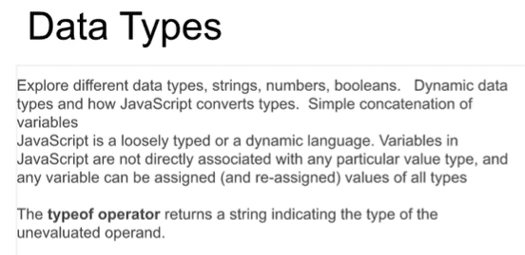

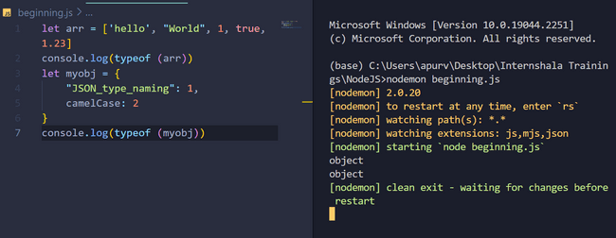

Arrays have square bracket and objects have curly bracket. Objects have key:value pairs within them and we can denote keys in double quotes like in JSON format or in form of camelCase as done in normal javascript objects.

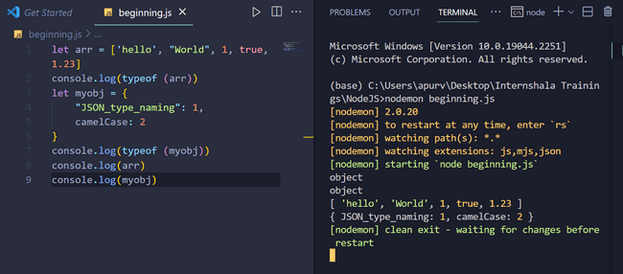

Functions in JS:

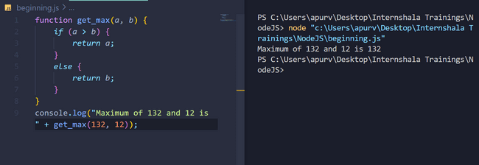

**Function declarations** are uploaded before any code is executed in javascript, so, if a function is declared even at end of the program it will not throw any error as all other codes will be executed only after all function declarations have been loaded.

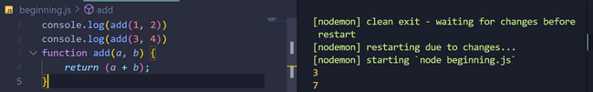

**Function expression**: Function expression is formed from function declaration where function name is declared with a ‘const’ or any other keyword on other side of equal to . Function expressions have to be declared before their use i.e unlike function declarations , function expressions have to be declared before their use.

Before:



After:

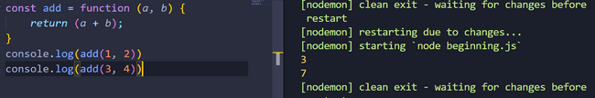

Arrow function form:

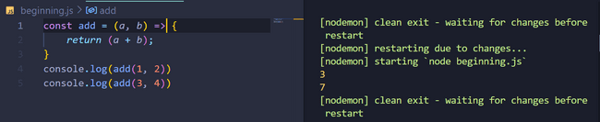

And if function expressions are declared after than their calls:

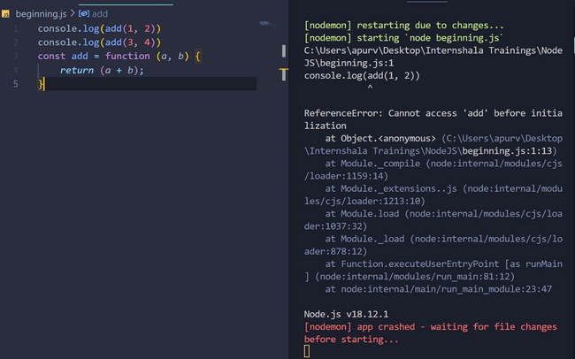

Immediately Invoked Function Expression:

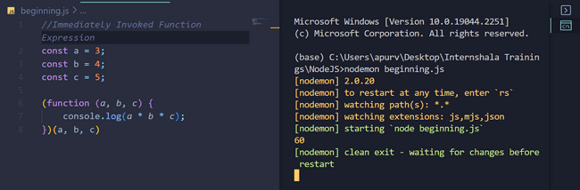

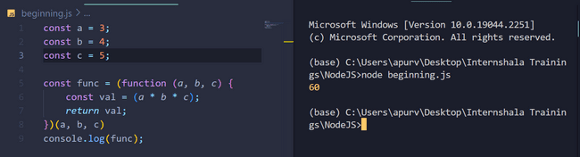

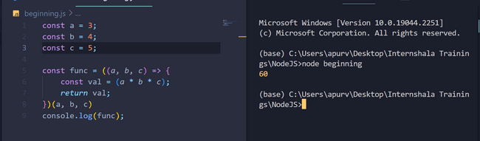

Recursion:

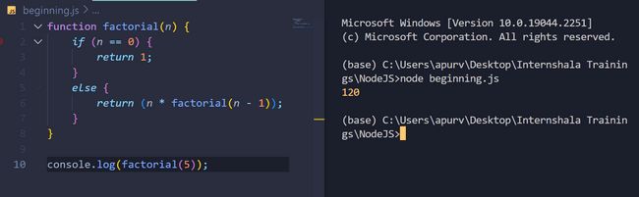

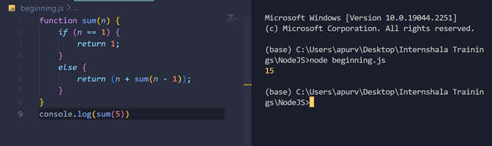

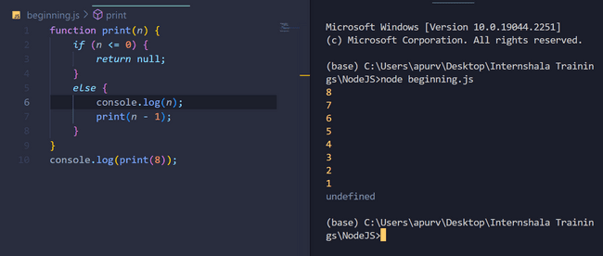

**JavaScript function closure: A function returns another function that may or may not return another function, but process of returning functions can continue many-a-times.**

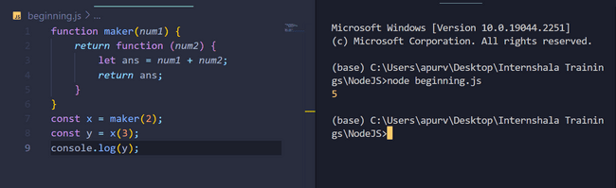

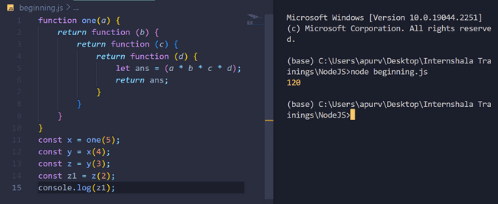



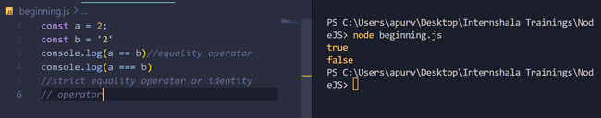

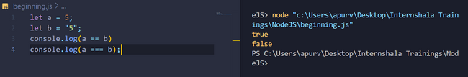

**& and | are bitwise ‘and’ and ‘or’ operations but && and || are logical ‘and’ and ‘or’ operations.**

**‘0’ i.e numerical zero is ‘false’ and anything except ‘0’ is ‘true’.**

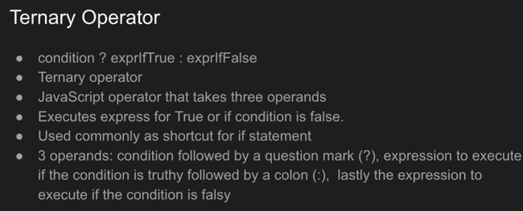

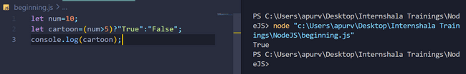

**Javascripts Objects:**

**Js file:**

const myobj={

    f_name:"Apurv",

    l_name:"Anand",

    scholar_id:2112052,

    branch:"CSE"

};

console.log(myobj);

*//Dot notation*

console.log(myobj.f_name+" "+myobj.l_name+" "+myobj.scholar_id+" "+myobj.branch);

console.log("---------------------------");

*//Bracket notation:*

console.log(myobj['f_name']+' '+myobj['l_name']+" "+myobj['scholar_id']+" "+myobj['branch']);

console.log("---------------------------");

*//using 'for' loop:*

*for*(let ele in myobj){

    console.log(ele+">>"+myobj[ele]);

}

console.log("---------------------------");

**Output:**

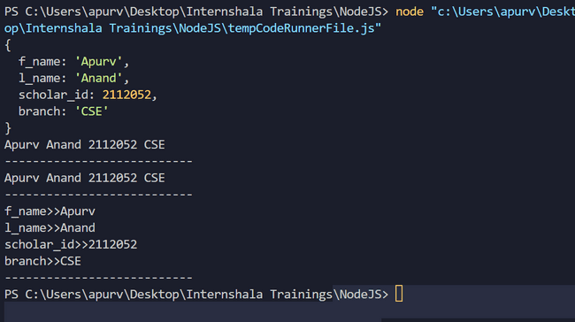

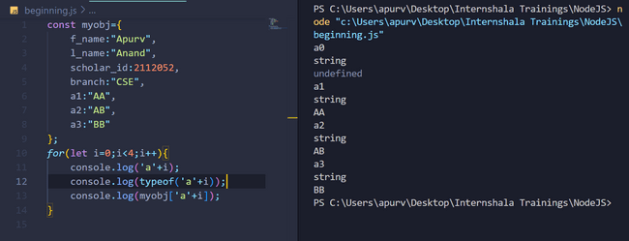

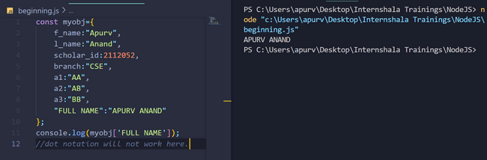

**Dot notation will not work if key is already defined in terms of string inside double quotes ,infact, if we will try to write it using dot , VS code will automatically convert it to bracket notation.**

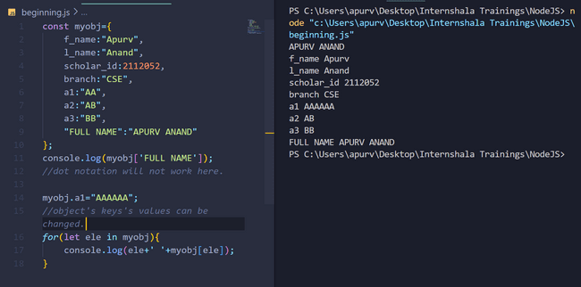

**Why are we able to add /delete/ change values even though we have defined const with the object?  
Because ‘const’ refers to ‘constant memory locations’ taken by the object and not constant key and value pairs.**

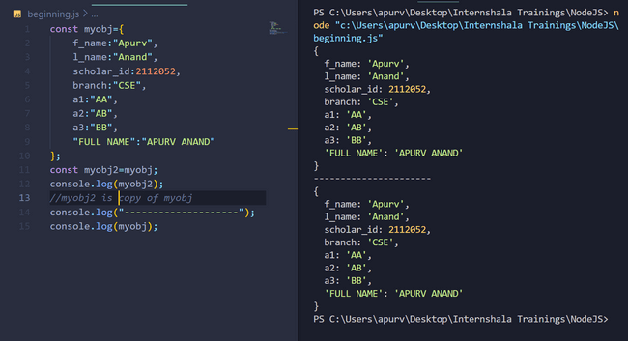

**NOTE: ‘myobj2’ is copy of ‘myobj’ but ‘const’ in ‘myobj’ refers to constant memory locations of myobj as we are copying myobj2 so, my obj2 will also get same memory locations same as that of myobj.**

**So if we change any thing/property/value in myobj, we will also see same change in myobj2 and if myobj2 changes, same changes will be seen if myobj.**

**myobj changed:**

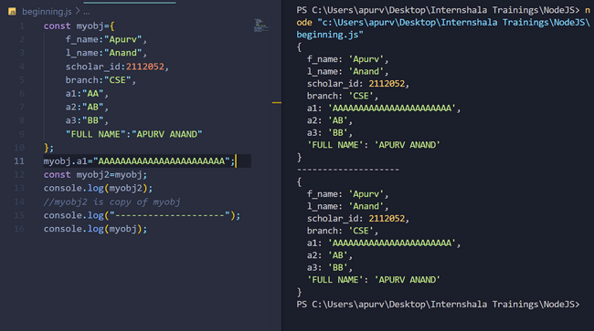

**myobj2 changed:**

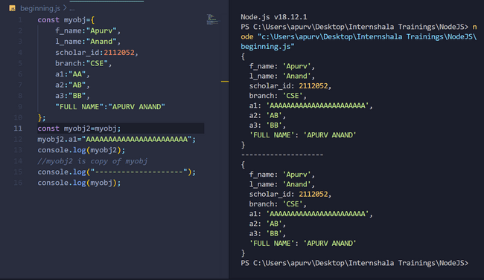

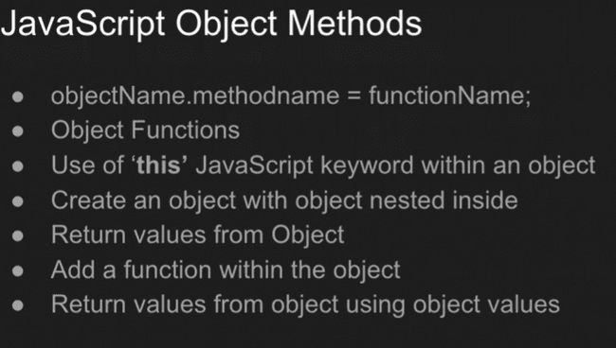

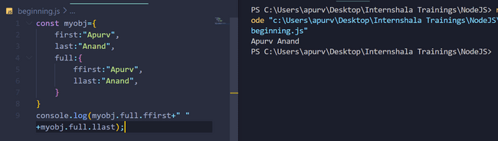

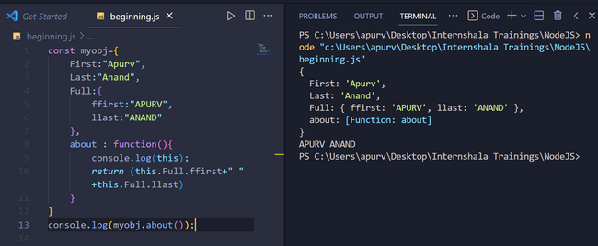

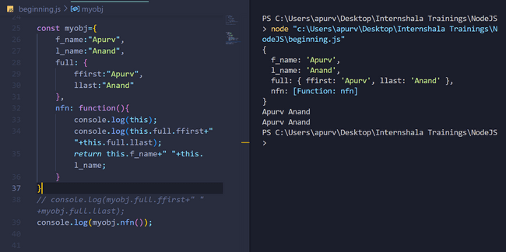

**From Above example we can see that an object can contain another object within it and also functions within it.**

**‘this’ keyword refers to the object in which it is present. ‘this’ keyword is useful only inside the object.**

**Nfn in above example is a function and outside the object it must be represented with parenthesis.**

**ARRAYS:**

**Storing and printing different data types in array:**

const myarr=['apurv',1,2112052,true,1.0,{ roll:2112052,fname:"Apurv Anand"}];

console.log(myarr);

*for*(let ele in myarr){

*if*(typeof(myarr[ele])=="object"){

*for*(let element in myarr[ele]){

            console.log(element+" "+myarr[ele][element]);

        }

    }

*else*{

        console.log(myarr[ele]);

    }

}

**OUTPUT:**

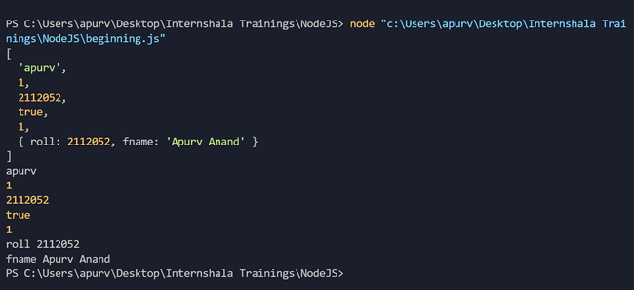

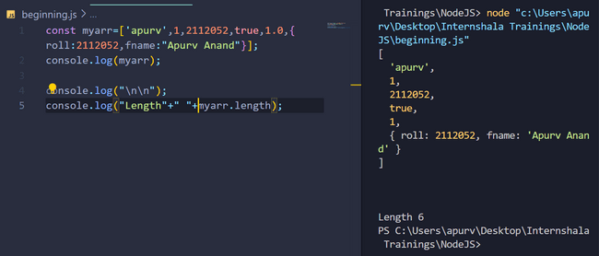

**Updating an array:**

**Appending at the end:**

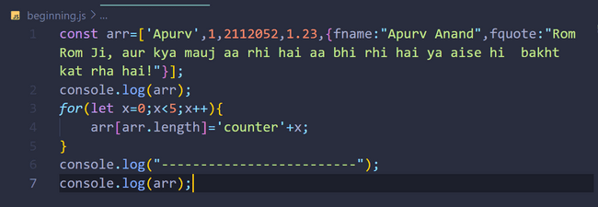

**Output:**

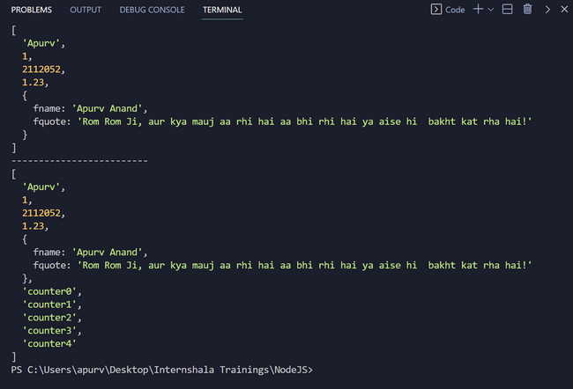

**Using push :**

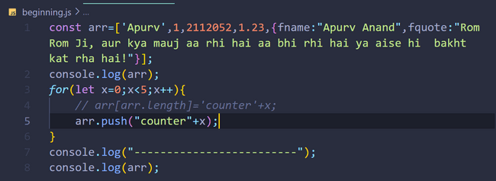

**Output:**

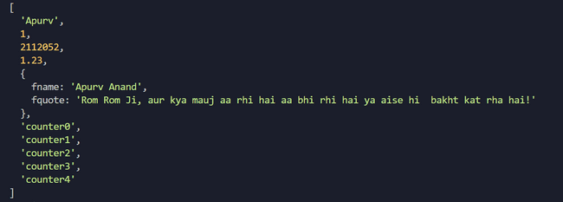

**Pop:**

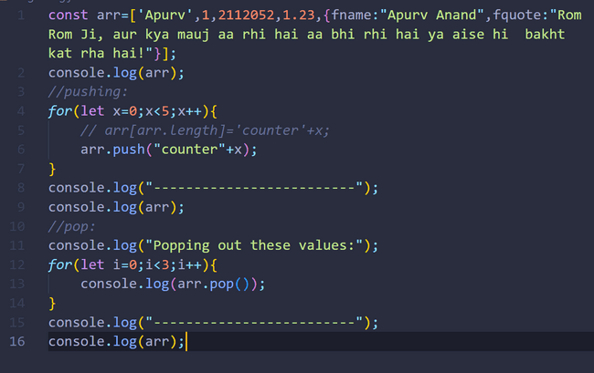

**Output:**

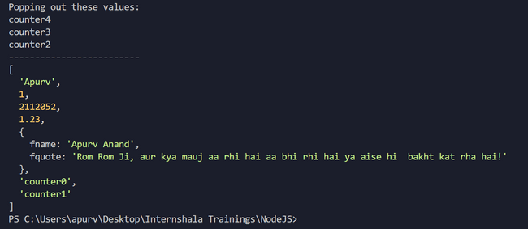

**Arr.pop() will remove the elements from the beginning and for removing elements from the start , we will use shift() function.**

**Shift function to remove elements from the front:**

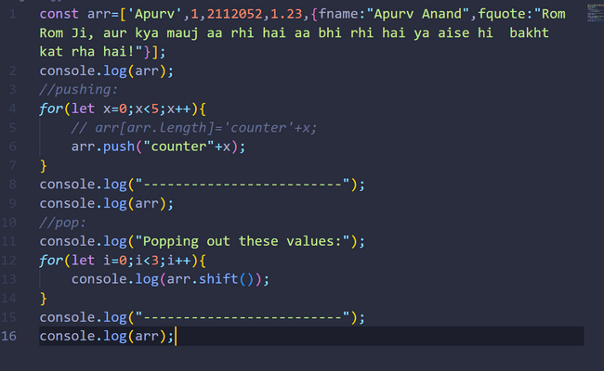

**Output:**

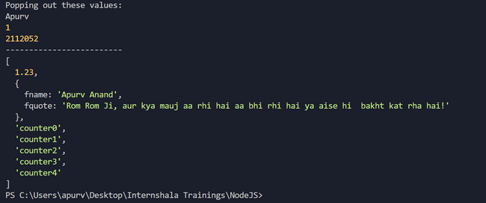

**Unshift function is used to add elements to the front:**

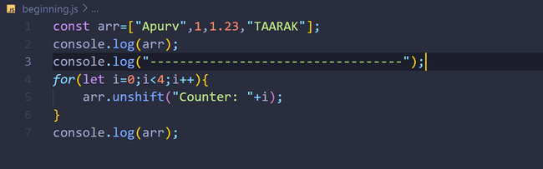

**Output:**

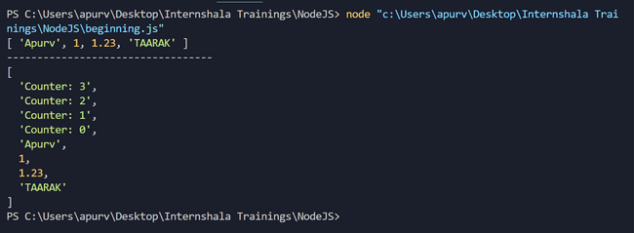

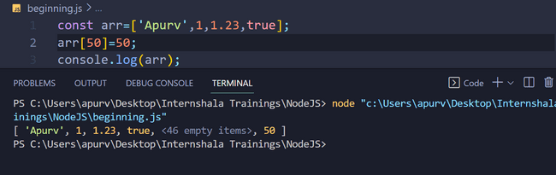

If we add an element having a very larger index than that of the last element then in between empty elements will be added as seen above.

**Splice function: It is a function of array in which we can add and remove elements directly.**

**SYNTAX: arr.splice(num1,num2,value)**

**num1: index at which value is to be inserted**

**num2: number of elements to be removed from the back at each insertion. Removed elements can also be accessed.**

**value: Value to be inserted.**

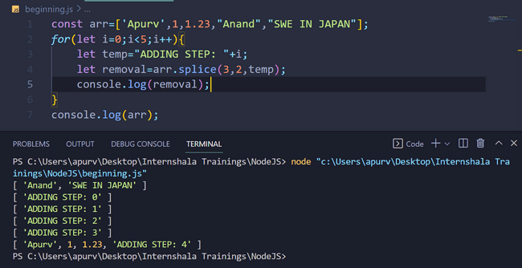

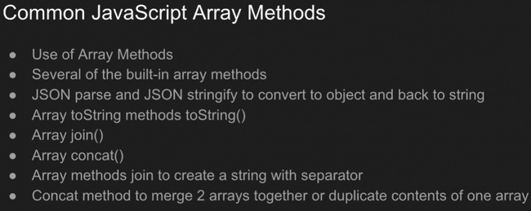

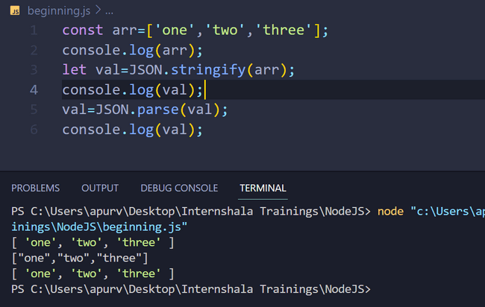

**JSON.stringify(<array name>): to convert array to string**

**JSON.parse(<array name>): to convert string to array.**

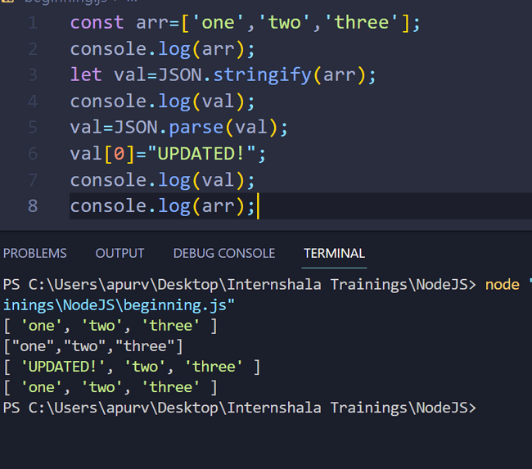

**Now, val and arr in above example are 2 different arrays.**

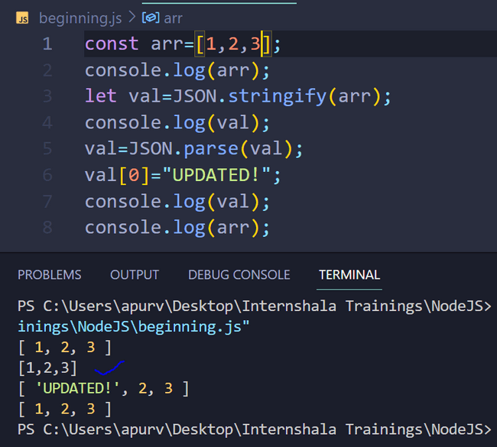

**See blue tick at [1,2,3] ,it is string form of above integer string also, represented by change of colour.**

**Join (<separator>): is also used to stringify i.e. to convert array to string.**

**Advantage of using join is we can seperators of our choice.**

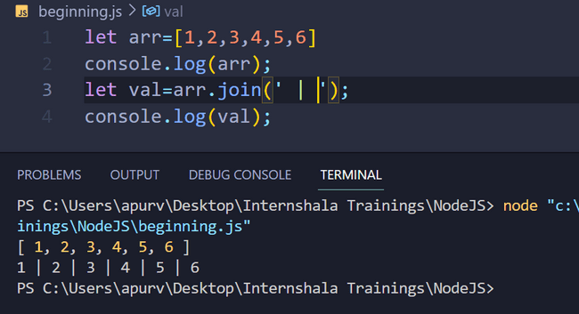

**String concatenation:**

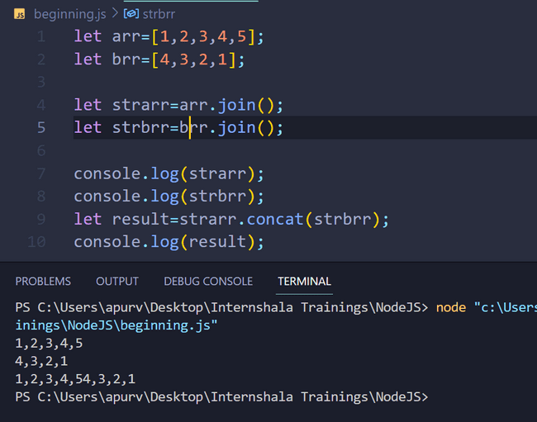

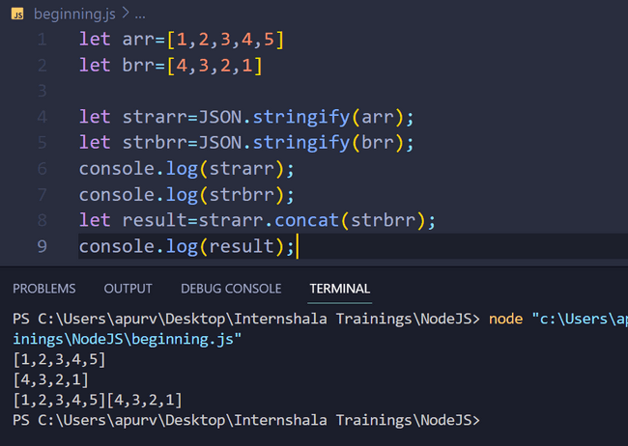



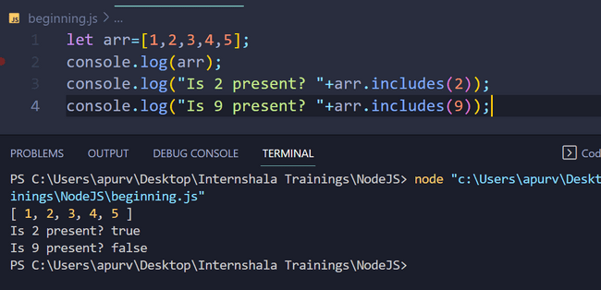

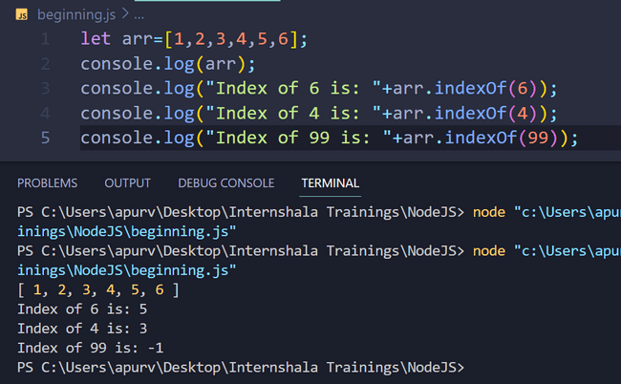

**-1 index implies that element is not present in the array.**

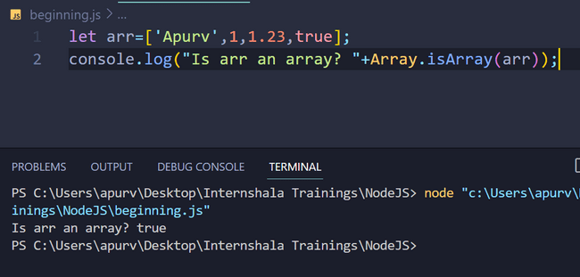

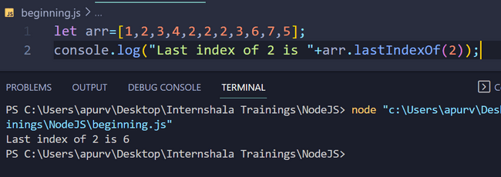

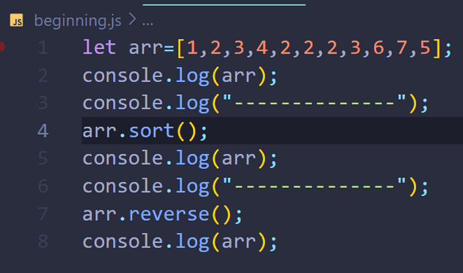

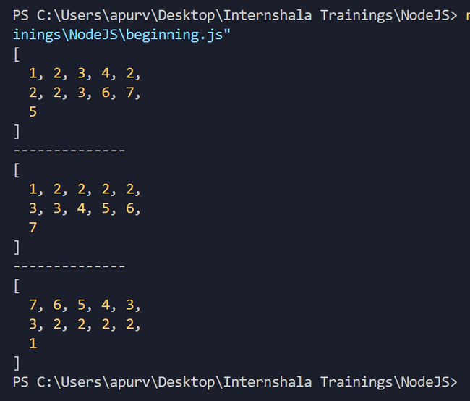

**Clearing the array i.e. making array empty:**

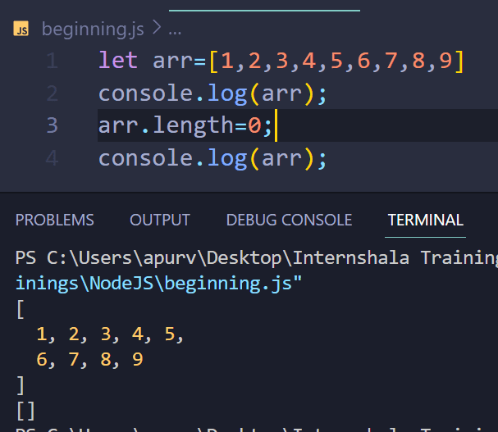

**Duplicating an array:**

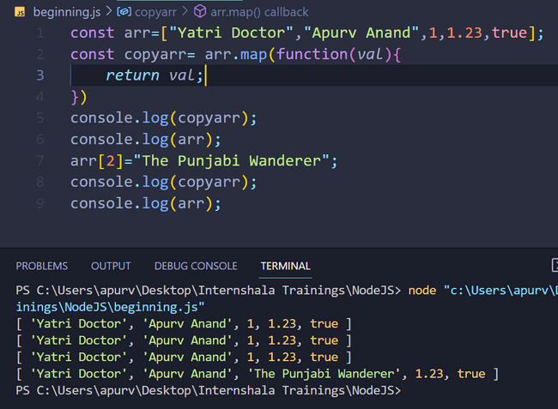

**Note: At last we tried to change value inside ‘arr’ but no change was visible in ‘copyarr’ as seen in example above. It means that though they are copy of each other but they have different memory locations assigned to them.**

**forEach function:**

**use forEach loop for arrays only.**

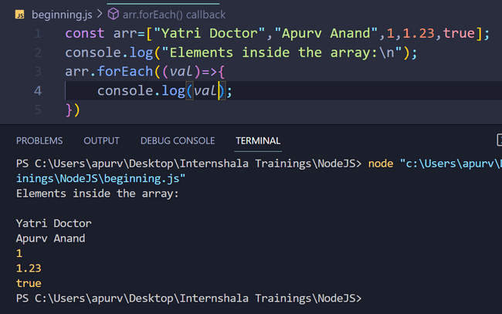

**For-in loop:**

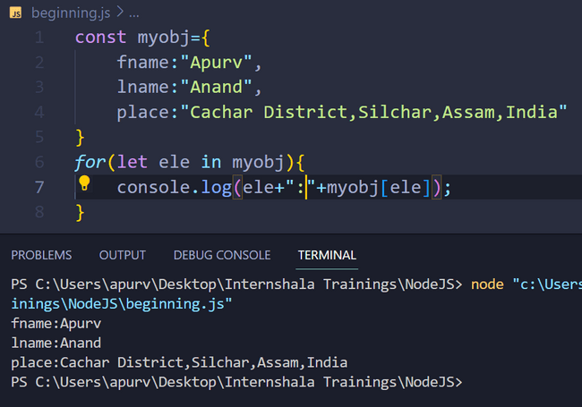

**For in loop is used for objects only.**

**Object.entries(<object name>): converts object to array.**

const myobj={

    fname:"Apurv",

    lname:"Anand",

    place:"Cachar District,Silchar,Assam,India"

}

console.log(myobj);

console.log("--------------");

console.log(Object.entries(myobj));

*//Note that Object.entries(myobj) returns arrays.So,one can use*

*// forEach for iteration.*

console.log("--------------");

Object.entries(myobj).forEach((*val*)=>{

    console.log(*val*[0] +" : "+ *val*[1]);

})

console.log("--------------");

Object.entries(myobj).forEach(([*key*,*value*])=>{

    console.log(*key*+" : "+*value*);

})

**Output:**

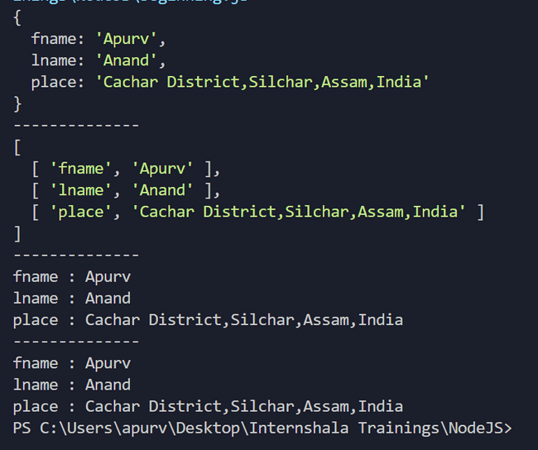

**Object.keys(<object name>): for getting keys**

**Object.values(<object name>): for getting values**

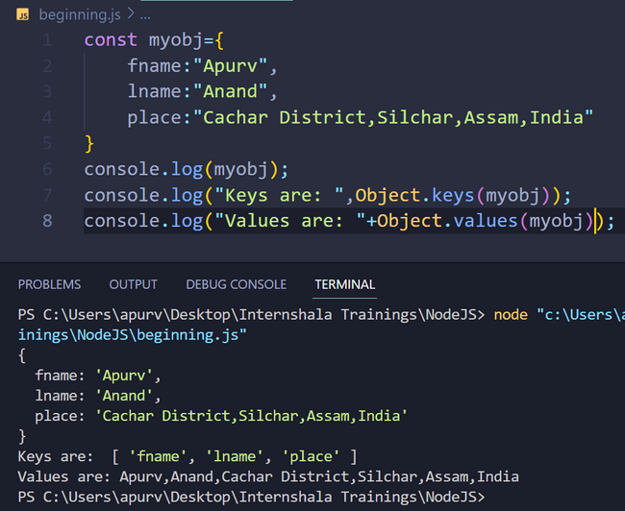

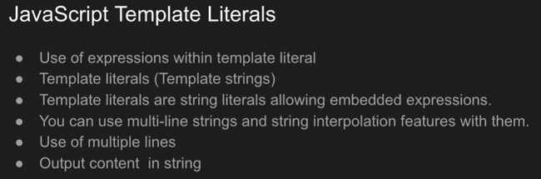

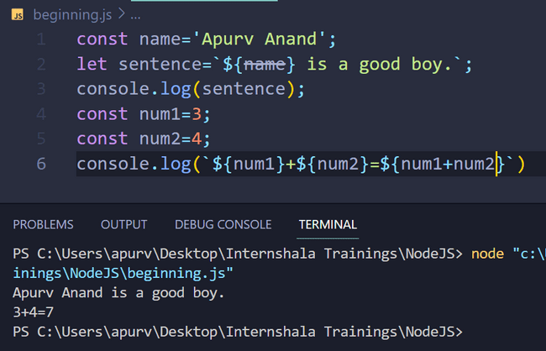

**Using backticks(`) gives us flexibility in writing strings as in single and double quotes whitespaces were neglected at various places by the compiler but here backticks are used as the way we use the space in writing our programs , the same way the output is shown. So, every space within the backticks is counted and in same-to-same way represented in the output.**

**Random Number in a given range generator:**

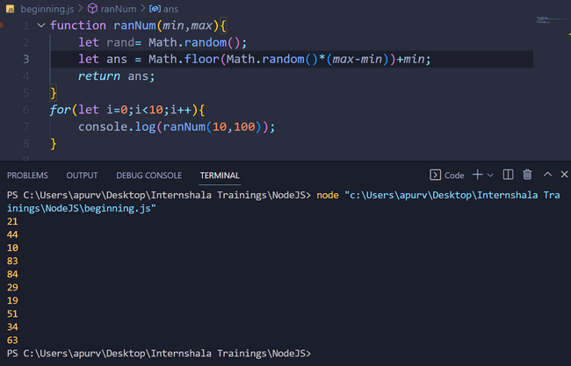

**Date Objects:**



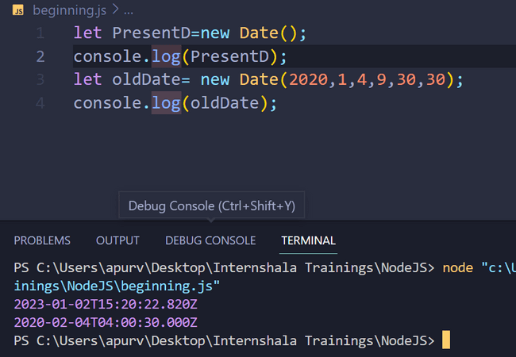

**Above picture show how to take present date as input and how to get old date in UTC form.**

**NOTE: zero(0) in months part represents January so, December is 11 in the series.**

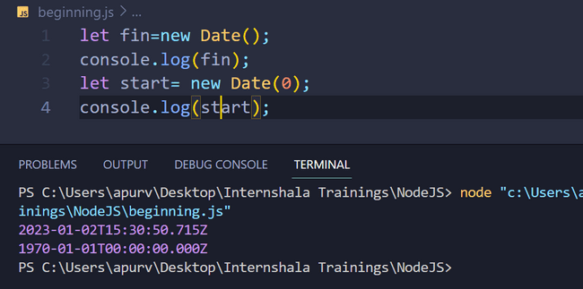

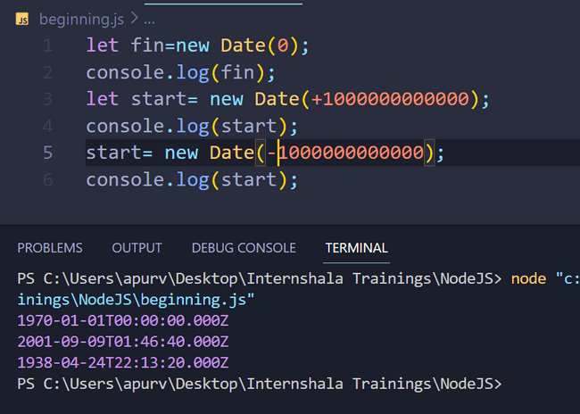

**NOTE:**

**-10000000000 and +100000000 in above picture represent number of milliseconds , these are added to and subtracted from start date and time of this clock i.e. 1-1-1970 00:00:000.**

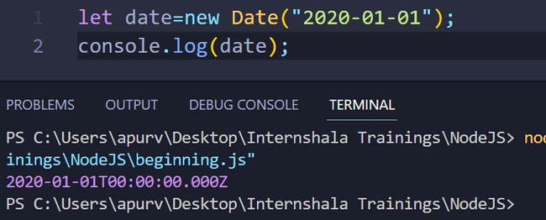

**Whenever we enter any date , we get the corresponding UTC date and time as output but it is necessary many-a-times to get our entered date as output, so, we use the above method.**

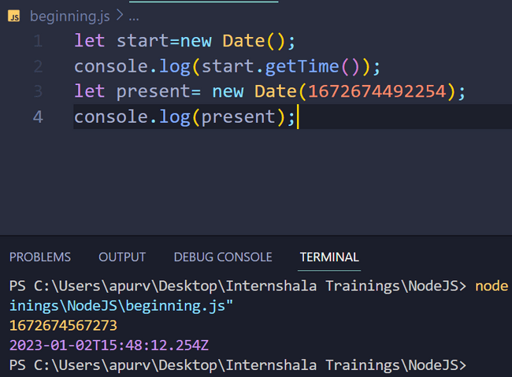

**Set a start time and get mill-seconds from that start using getTime().**

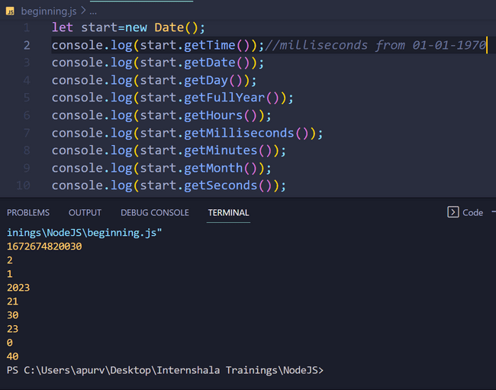

**Note: Did this on 2 January 2023 at 21:23 approx.**

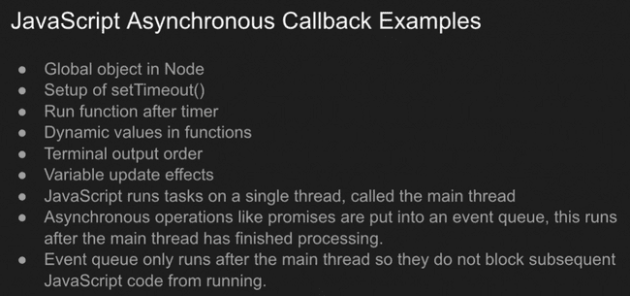

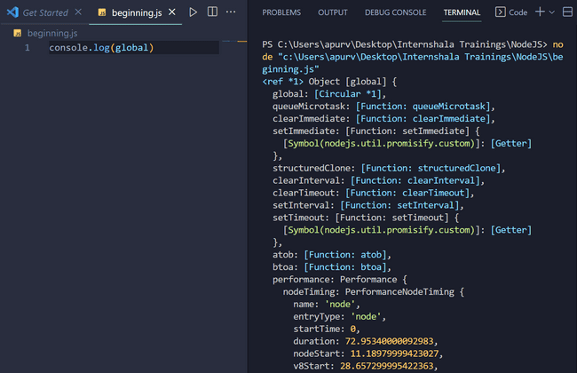

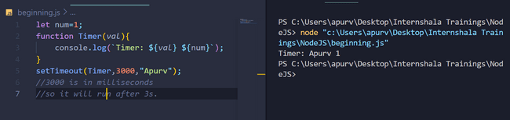

**3000 is in milliseconds so, it will be run after 3s , and “Apurv” in setTimeout() is argument of the function.**

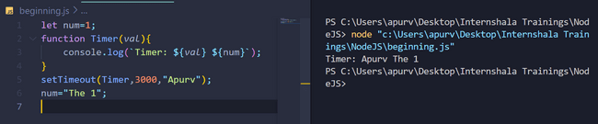

**We see that in place of num above, we get ‘The 1’ printed ,it is because setTimeout had set that Timer function would run after 3000 milliseconds or 3 seconds but code continued to execute and hence, value of num changed during the execution within 3s timespan. It is because JavaScript works ‘asynchronously’ i.e. gives request and doesn’t wait for the response and continues execution of further instruction and when the response comes ,it gives it as output.**

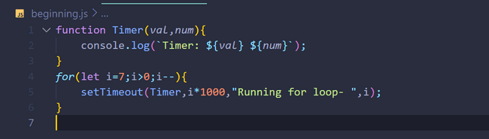

Output:

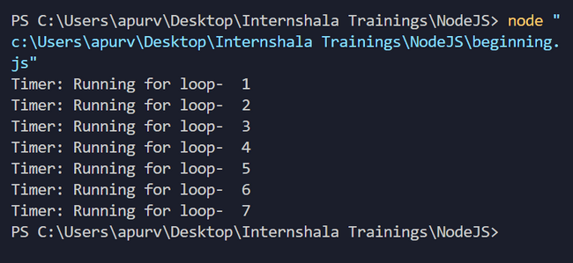

Now, using arrow function:

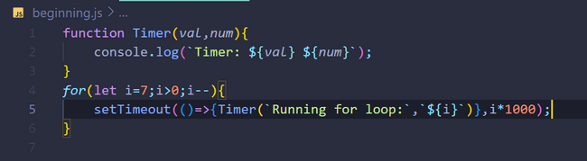

Output:

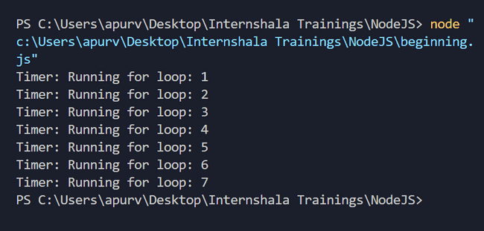

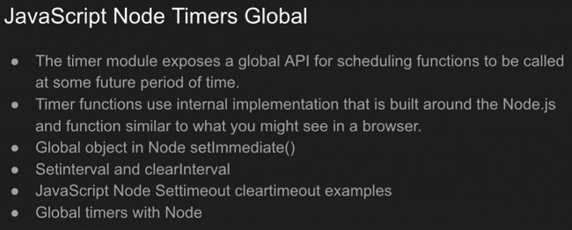

setTimeout() will execute after a specified time whether further code is completed or not.

But setImmediate() will work only if all further code is completely executed, it has no relation w.r.t. time.

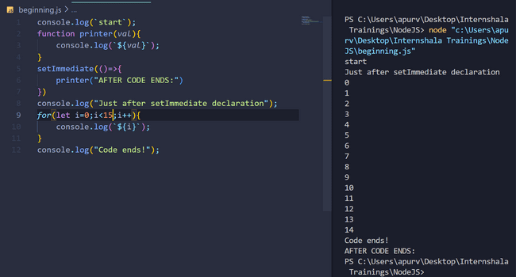

Use of setImmediate() is shown above.

setInterval() usage:

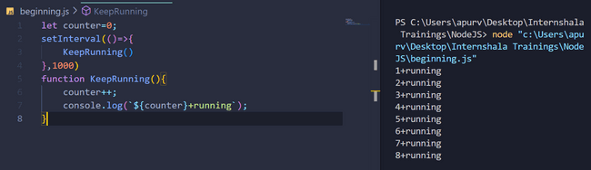

It will continue indefinitely unless we break the loop using **Ctrl+C**.

If we don’t want to break it ourselves, we will use clearInterval() function.

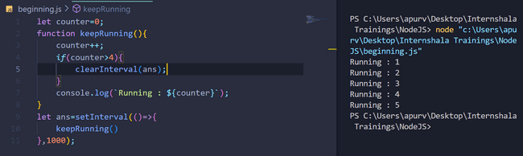

IMPORTANT:  
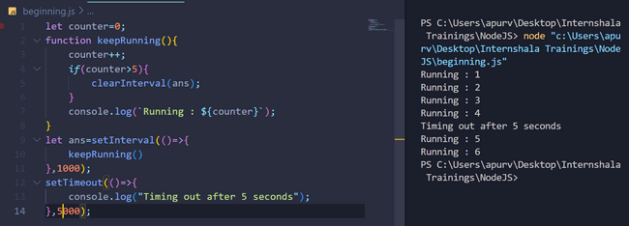

As JS works asynchronously ,so both stTimeout and setInterval start and are executed simultaneously ,hence, after 5 seconds , boith print simultaneously as can be seen above.

JavaScript Promises:

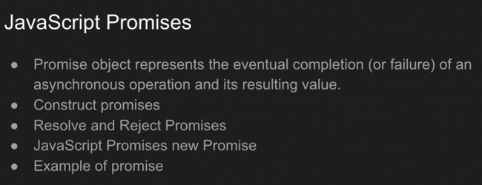

Basic JS promise syntax:

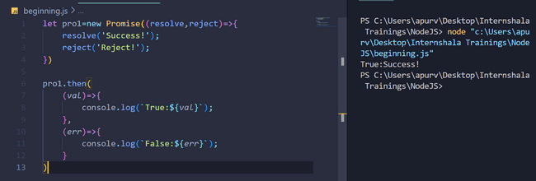

Using some conditional statements in example below:

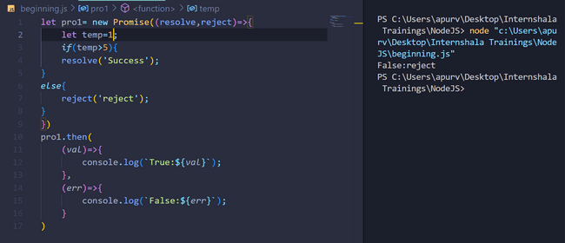

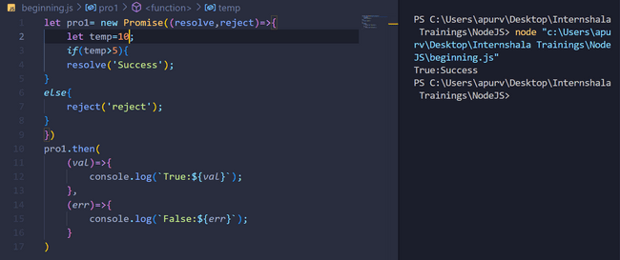

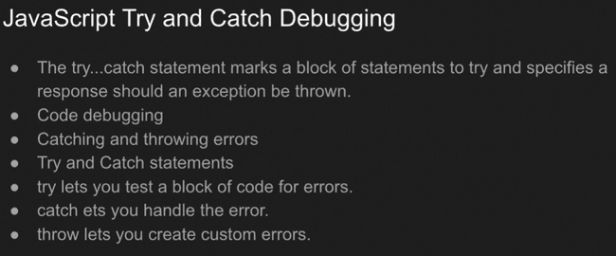

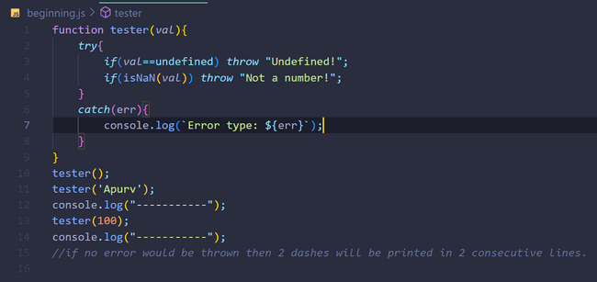

OUTPUT:

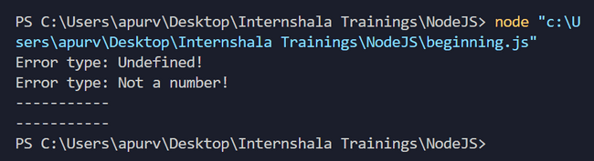

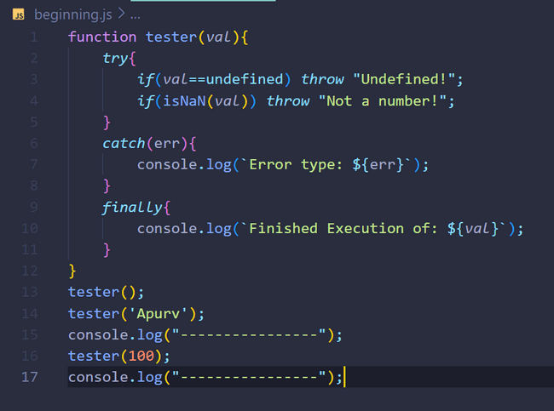

OUTPUT:

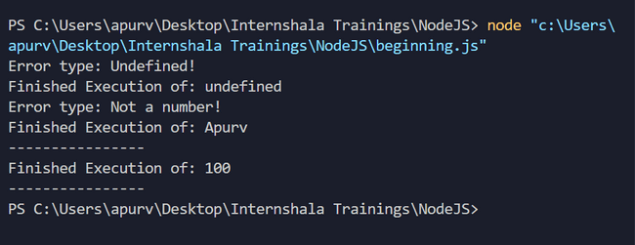

**‘Finally’** part in the code above will be executed irrespective of the argument passed ,i.e. whether the argument throws error or not.

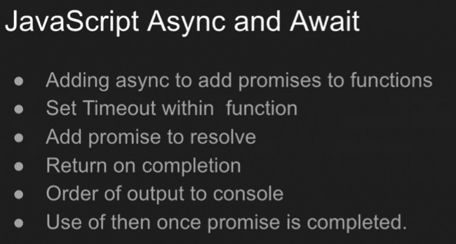

**‘Async’ converts a function into a promise.**

Adding async to a function incorporated 2 changes, one, as it now a ‘promise’ so, it will always have to return an output. So, we will have to necessarily include a return condition. Second, we can ‘then()’ method as we saw in Promise section.

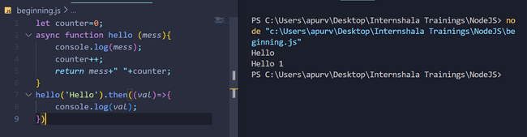

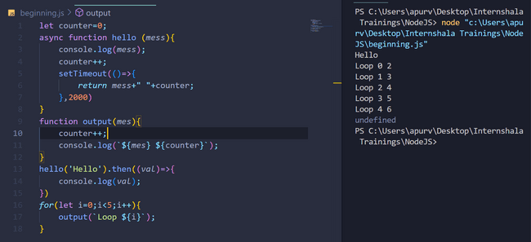

‘async’ is converting it to a ‘promise’. ‘await’ converts anything to a ‘promise’ value i.e. it will either be a ‘resolve’ or ‘reject’.

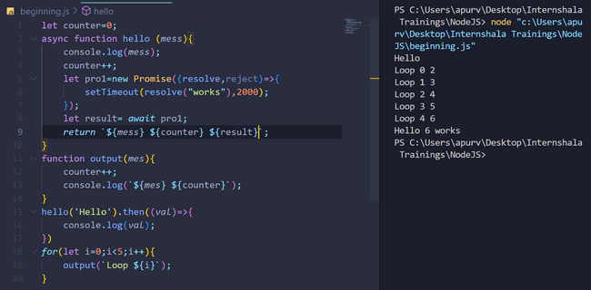

‘async’ added to a function converts it a promise ,so, as seen above ‘await’ converts anything to a promise but **the reality is ‘await’ helps to stop the program or make the program wait as due to faster computation js(javascript) may check on a different thread other than that of actual thread.**

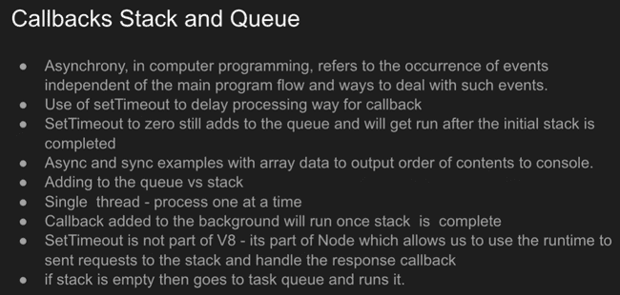

**Once we write a code and it starts executing , the program knows which steps will be executed after which steps as we have already defined them sequentially in our code. But compiler in Javascript has a ‘stack’ which stores which process will be executed after which. But operations/ functions like setTimeout() take a process out of stack and put it in another queue, once all processes of stack is done, then it starts executing the ‘queue’. As queue processes are stored from stack ,so, it may be a process that may have been declared in distant past in stack , hence, for accessing it , from queue ,we do ‘callback’.**

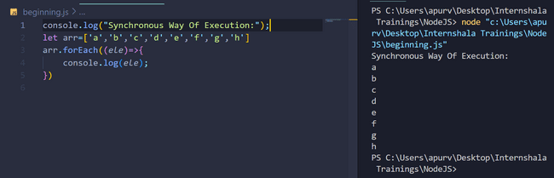

**Synchronous way of Execution is shown above.**

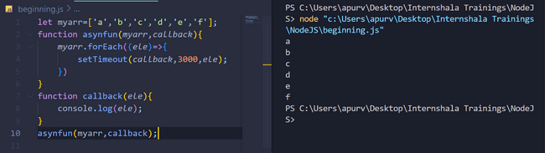

**The above photo shows asynchronous/non-blocking way of execution.setTimeout() is used to push an element into the queue so, that it is implemented after stack is empty.**

**#Very Very Important:**

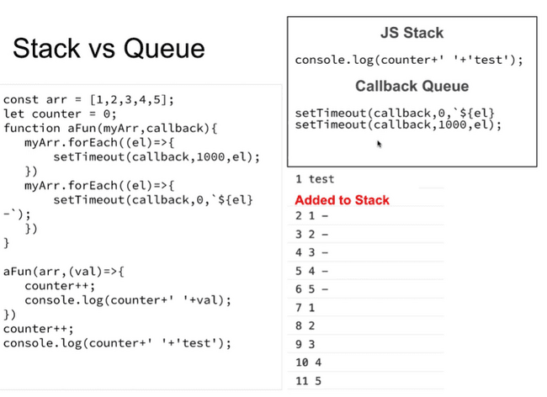

As soon as setTimeout() is encountered, the stack elements are pushed into queue . But here we see that second setTimeout() has time delay as 0 milliseconds ,hence, one must know that as soon as setTimeout() is encountered although it has a delay of 0 ms but it will definitely be thrown in the queue from the stack ,so, it means as stated previously it will be executed later on and first remaining code which is present inside the stack will be executed. Inside queue as one has delay of 0ms and other has 1000ms so, the one with 0ms will be executed first and then 1000ms delayed callback and same order will be followed if other callback instructions were also present in the queue.



  
As javascript is single threaded so, it can perform only one operation at a time and it does not have additional thread to store anything for future execution. But we see javascript as ‘asynchronous’ or ‘non-blocking’ and it can peform some operations like setTimeout() which perform execution in future though there is nothing to store in memory so, all this possible due to queue presence along with stack.

**If in the queue there is a clash of ‘time of delay’ means , like in a queue an instruction was already present and later on we have added another callback having same delay as that of any previous callback, so, the later one i.e. later callback will be executed later but before than any previous callback that has more time delay than this.**

**Remember: Always first stack will be made empty, then the queue will start executing.**

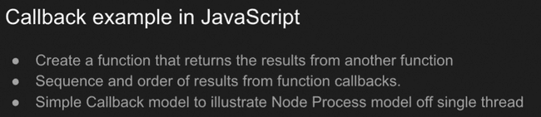

**The ‘event’ loop always gives priority to the call of ‘Stacks’, once the stack becomes empty then only it jumps for the execution of the queue.**

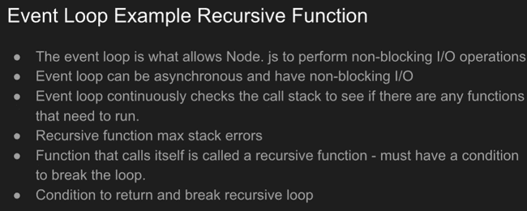

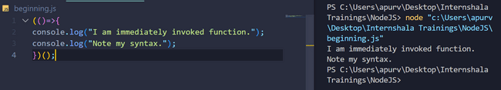

This is an **immediately invoked function.**

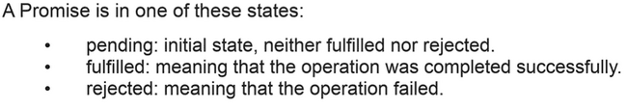

In one of these state implies different states of event loop.

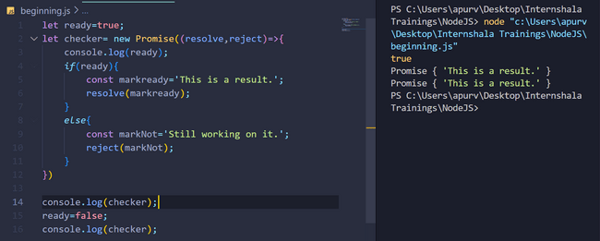

Once a promise is set , it can not be reset.

let ready=true;

let checker= new Promise((resolve,reject)=>{

    console.log(ready);

*if*(ready){

        const markready='This is a result.';

        resolve(markready);

    }

*else*{

        const markNot='Still working on it.';

        reject(markNot);

    }

})

console.log(checker);

ready=false;

console.log(checker);*// once a promise is set it can not be reset.*

const check1=()=>{

    checker.then((*val*)=>{

        console.log(*val*);

    })

    .catch(*err*=>{

        console.log(*err*);

    })

}

check1();

Another way of using val and err is shown above, here, we have used catch to catch the error.

OUTPUT:

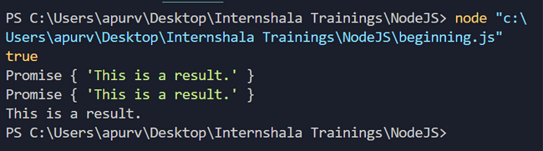

Above same example for false condition:

let ready=false;

let checker= new Promise((resolve,reject)=>{

    console.log(ready);

*if*(ready){

        const markready='This is a result.';

        resolve(markready);

    }

*else*{

        const markNot='Still working on it.';

        reject(markNot);

    }

})

console.log(checker);

ready=true;

console.log(checker);*// once a promise is set it can not be reset.*

const check1=()=>{

    checker.then((*val*)=>{

        console.log(*val*);

    })

    .catch(*err*=>{

        console.log(*err*);

    })

}

check1();

Note that even though in both cases above we have tried to change the value of ‘ready’ but one must remember that **ones a promise is set it can not be changed.**

**OUTPUT:**

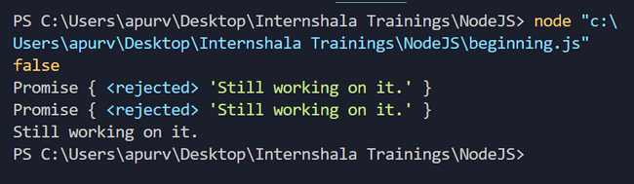

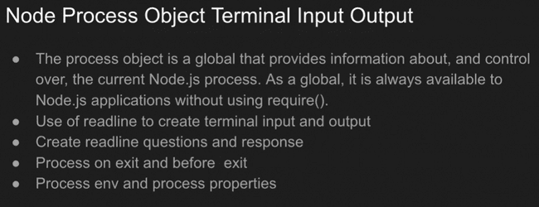

**HOW TO TAKE INPUT IN OUR NODEJS APPLICATION?**

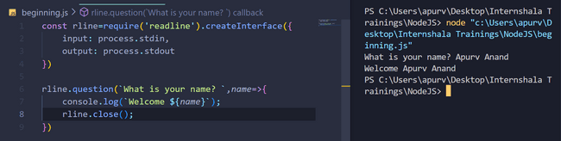

We take input and output using ‘process’ object ,it is global object ,so, we do not need to use function require() for it.

**rline.close()** is necessary to add so, that we can stop taking the input.

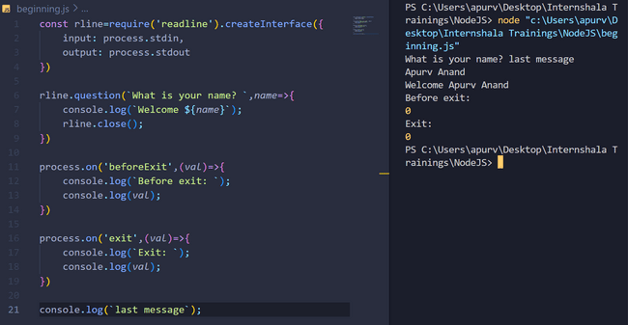

‘beforeExit’ is executed just before the exit. ‘exit’ part is executed at the exit.

We here need to note that ‘.on’ is used in many places whenever a particular condition is encountered ,hence, a particular code is run.

**But ‘last message’ is executed at the first because the program doesn’t wait for the user input and continues the further execution.**

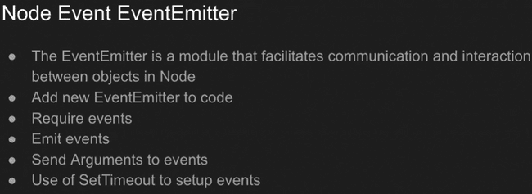

**Every option on the computer is an event. ‘event’ is not global object / module, we first need to import it. Then we need to make an event emitter and hence, we need to make it emit in different conditions using ‘.on’.**

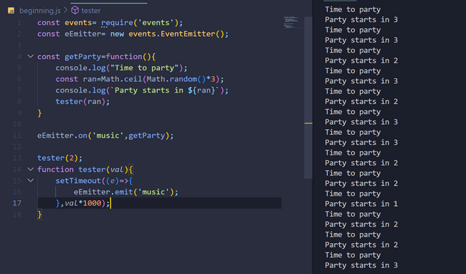

It is an infinite loop in above example as we have declared no stopping condition, but we can declare stopping condition using a new variable creation and then using if condition to stop when it overcomes a condition.

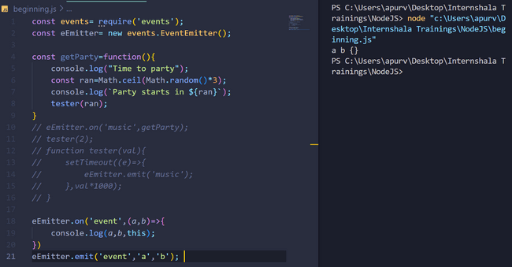

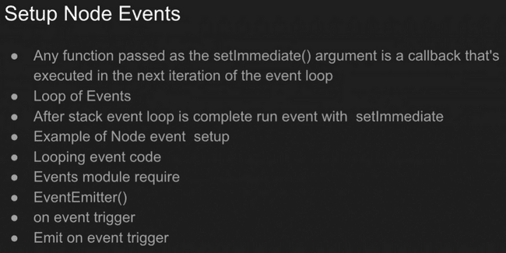

const events= require('events');

const eEmitter= new events.EventEmitter();

const getParty=function(){

    console.log("Time to party");

    const ran=Math.ceil(Math.random()*3);

    console.log(`Party starts in ${ran}`);

*// tester(ran);*

}

eEmitter.on('music',getParty);

tester(2);

function tester(*val*){

    setTimeout((*e*)=>{

        eEmitter.emit('music');

    },*val*\*1000);

}

eEmitter.on('event',(*a*,*b*)=>{

    console.log(*a*,*b*,this);

})

eEmitter.emit('event','a','b');

*////////////////////////////////////////////////*

let m=0;

eEmitter.on('event4',()=>{

    console.log(++m);

})

eEmitter.emit('event4');

eEmitter.emit('event4');

eEmitter.emit('event4');

eEmitter.emit('event4');

eEmitter.emit('event4');

*///////////////////////////////////////////////*

eEmitter.on('event1',(*a*,*b*)=>{

    setImmediate(()=>{

    console.log(`Asynchronous ${*a*} ${*b*}`);

})

})

eEmitter.on('event2',(*a*,*b*)=>{

    console.log(`Synchronous ${*a*} ${*b*}`);

})

eEmitter.emit('event1','A','P');

eEmitter.emit('event1','U','R');

eEmitter.emit('event2','A','P');

eEmitter.emit('event2','U','R');

console.log("Final line of CODE");

*///////////////////////////////////////////////*

eEmitter.once('event3',()=>{

    console.log(`One time run!`);

})

eEmitter.emit('event3');

eEmitter.emit('event3');

eEmitter.emit('event3');

eEmitter.emit('event3');

**Output:**

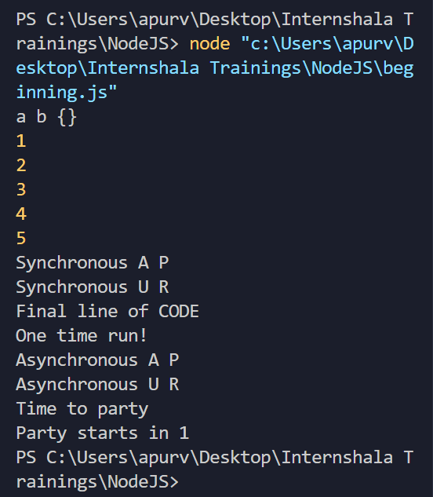

The above code will be very useful in creating event object,its emitter , assigning it on various different conditions to different functions.

**setTimeout() vs setImmediate() vs process.nextTick() :**

**setTimeout()** : starts after a given interval after all things of the stack have been complted.

**setImmediate() vs process.nextTick():**

setImmediate(): will start immediately after all things of stack has been completed and all events have completed all steps.

Process.nextTick(): will start irrespective of whether stack has been emptied or not or irrespective of whether all events have completed all their steps. It will execute at the end of one event steps. WKT, one event also consists of many steps , process.nextTick() is executed at the end of one step on an event.

So, seeing these trends general order of setTimeout(), setImmediate() and process.nextTick() is: Process.nextTick() then setImmediate() then setTimeout()

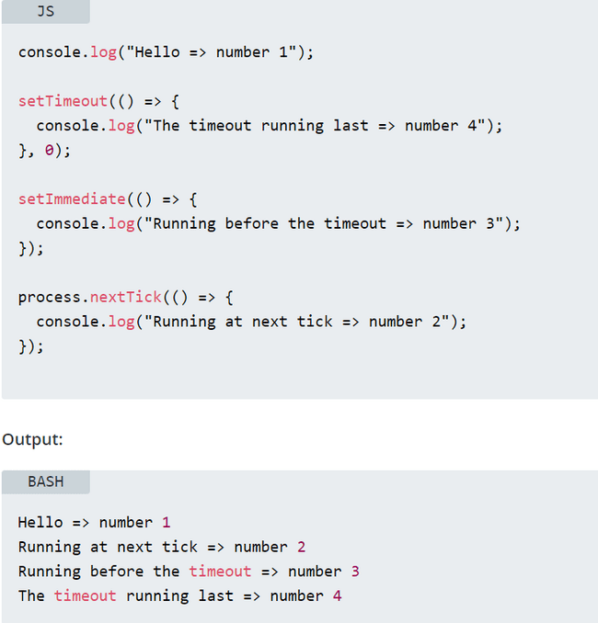

**Exceptions:**  
In some versions of compilers when setTimeout() is set to 0 ms and it also has setImmediate(), then in some compilers setImmediate () is processed first but in others setTimeout() is processed first.

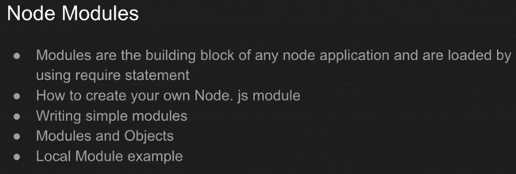

‘Modules’ refers to functions but all modules of a file are linked to a main modules which links it to other modules ,this main module is nothing but that file only as only that file can help us to communicate with other outer files i.e. outer modules.

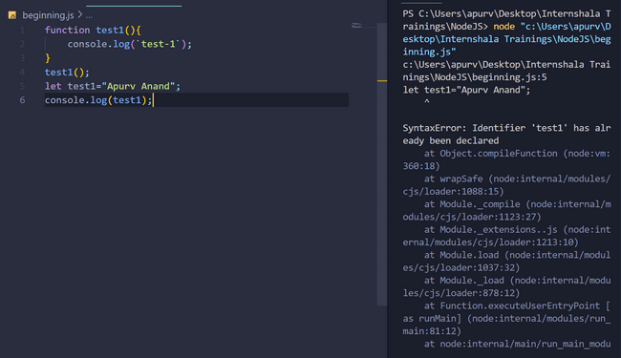

As all modules of a file are stored ina common main module called file module, so, no two functions/modules or a module or text can have same name.

In the picture below, we are trying to print module, it seems that it is a ‘global’ object like ‘process’ etc but actually it is not , but it is working here as its scope is that file in which it is declared.

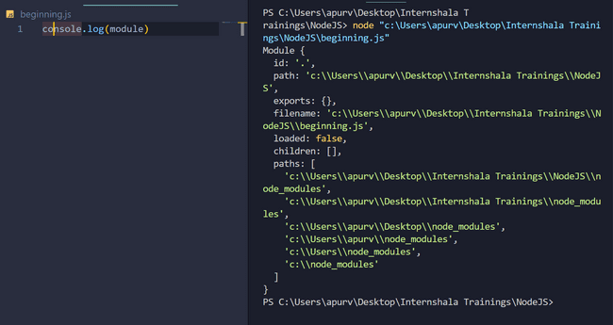

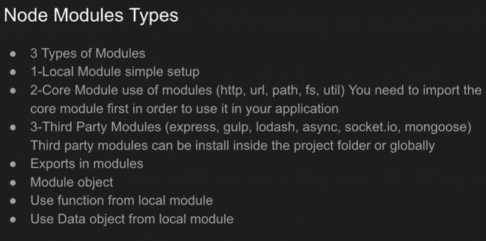

ALL FURTHER ARE EXAMPLES OF local modules.

Exporting test1() function from beginning.js to coremodule.js:

Using **‘require()’** we only import functions and objects of other file in our present working file.

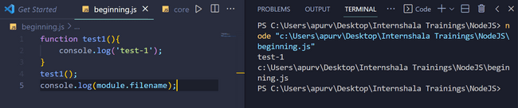

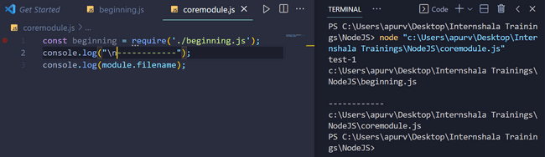

We have used require() above.

Using **‘require()’** we only import functions and objects of other file in our present working file.

As we have used require() in the first line, whenever it is called , the file which we have declared inside require() is called out first. And so, first that file is printed on the screen.

Using **‘require()’** we only import functions or objects of other file in our present working file.

That’s why in the example below though we have not called ‘testis()’ function in coremodule.js but printed many times as it was printed many times in beginning.js.

**The name we declare along with exports in carried onto the file in which copy is needed.**

**NOTE: We are copying beginning.js in coremodule.js**

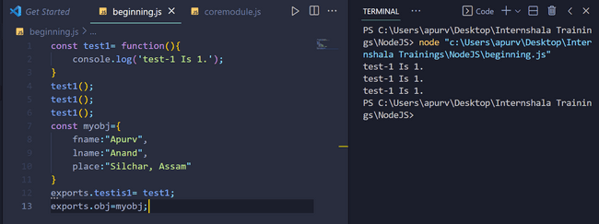

**The main file from which exporting is to be done is shown above.**

**Note ‘test1’ is denoting a function and ‘testis1’ is also a function. Note its syntax as putting parenthesis at one or both side of equality will give incorrect answer.**

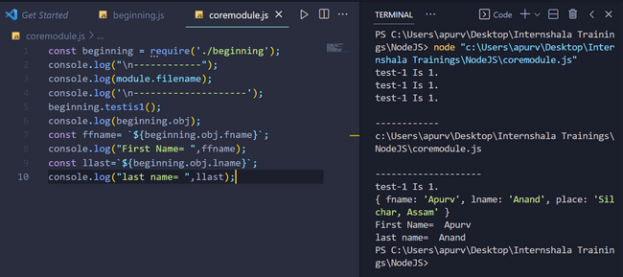

‘beginning’ is the function from which we get all exports from beginning.js into coremodule.js .

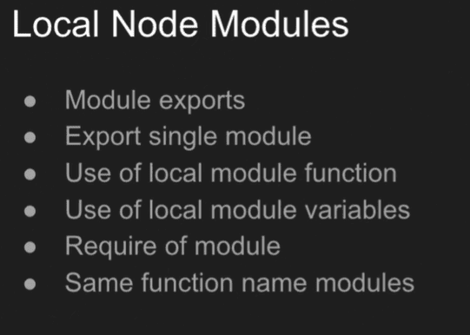

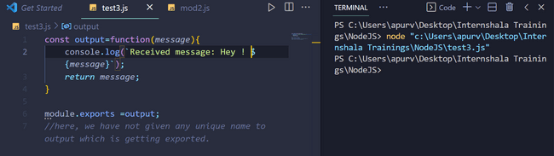

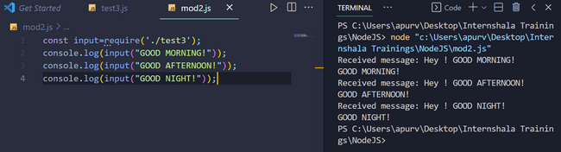

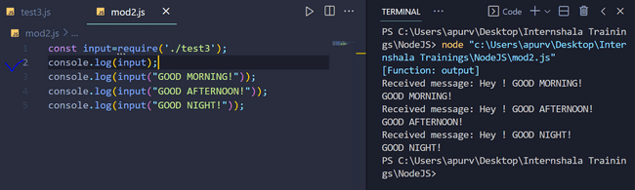

Using **‘require()’** we only import functions and objects of other file in our present working file. We can check the type of things created after using ‘require’ ,it will be always of **function type or ‘object type.**

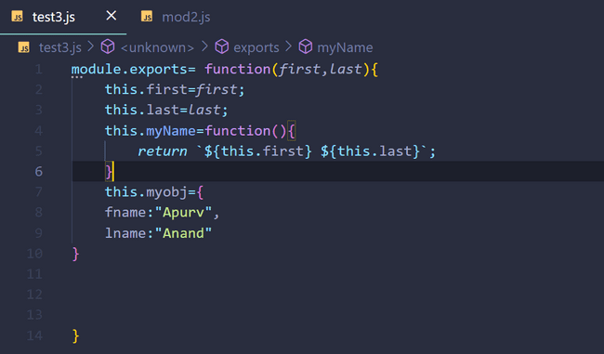

Source file above:

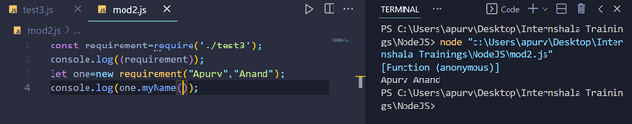

File in which we have imported is shown in above picture:

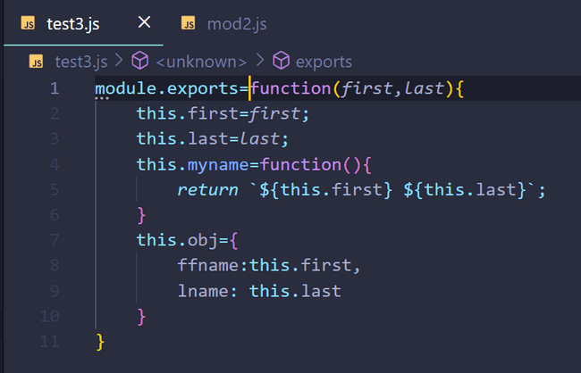

Above is source file from which we will export our function.

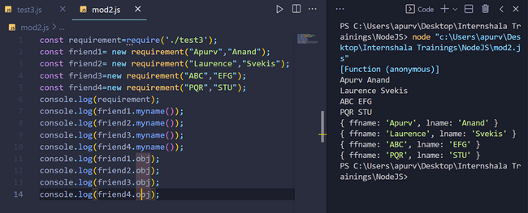

The above is of file in which function is imported.

**NOTE: functions and objects are exported using ‘require()’ .**

**Till now we were only talking about ‘LOCAL MODULES’.**

**CORE MODULES:**

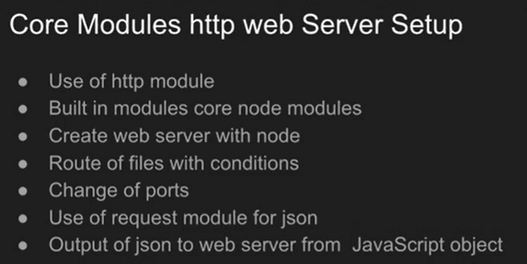

Nodejs comes with a lot of inbuilt core modules. So, we only need to include them in our files using **require()** and then use their inbuilt functions.

**http module:**

the ‘http’ module helps us to start hosting our html page locally on our device but first we need to import ‘http’ module using ‘require()’ and then we can other inbuilt functions as shown below. Note that local hosting will start only when the code with ‘http’ module is executing and so as to continue hosting, it will run indefinitely but hosting can be stopped by us manually using ‘Ctrl+C’ in terminal.

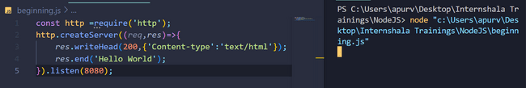

**200** in ‘writeHead()’ denotes **‘a successful connection’ and it is important to note that we are using only head part here as it will decide our content type like “Content-type’:’text/html’ “ in our above example. If res.write() (shown below) or res.end() is not used then localhost8080 will show timeout error.**

**To start localhost , type on web browser localhost:8080 after executing the http module containing code.**

**OUTPUT:**

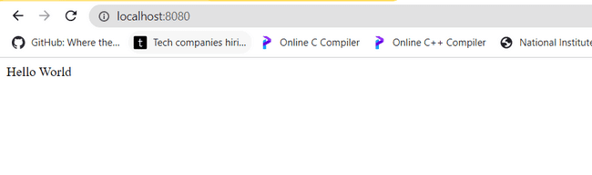

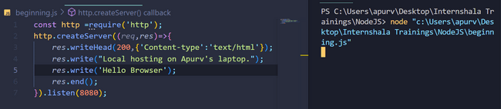

**OUTPUT:**

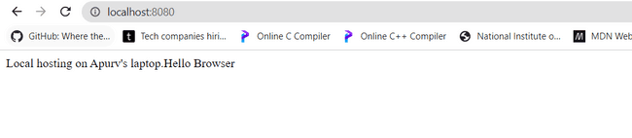

**We can change local hosting port address by changing number inside .listen() function . To break line use <br> tag.**

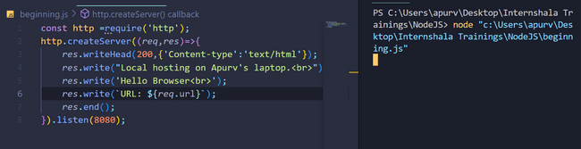

**Output:**

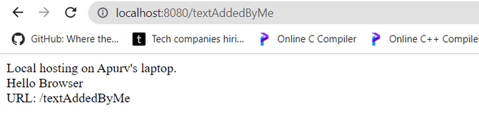

**Whatever you write after / on default i.e. (see below)**

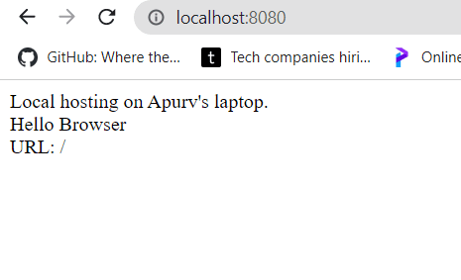

**Will be shown in URL: part as was shown in output picture above.**

**Using some conditional statements:**

**CODE:**

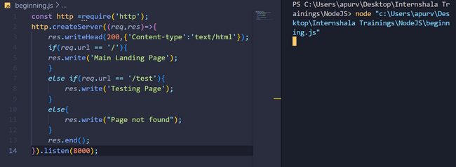

**OUTPUT:**

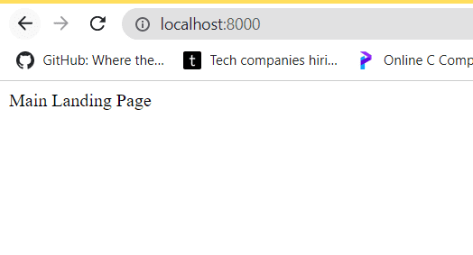

**On changing localhost:8000 to ‘localhost:8000/test’**

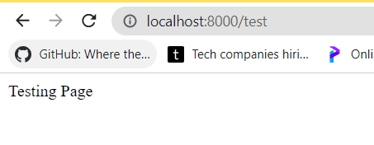

**On changing ‘localhost:8000’ to ‘localhost:8000/arbitrary’ or anyother name of your choice:**

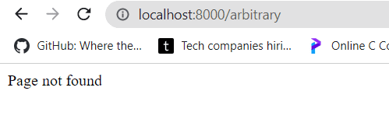

**Performing the above steps with JSON files:**

JSON is Java Script Object Notation is a file containing java script objects i.e. key value pairs connected by colon and separated by commas, so, it is nothing new but a file containing objects.

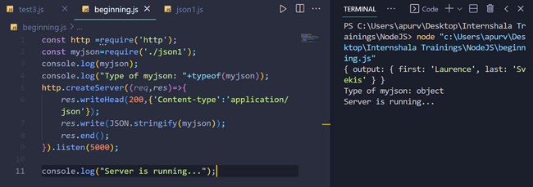

json1.js file:

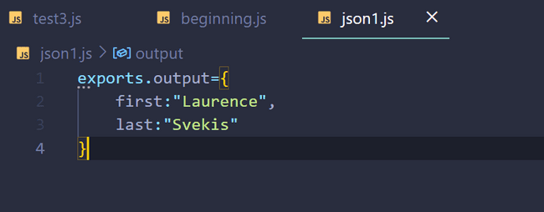

OUTPUT:

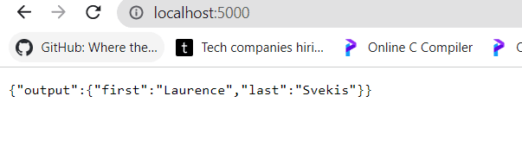

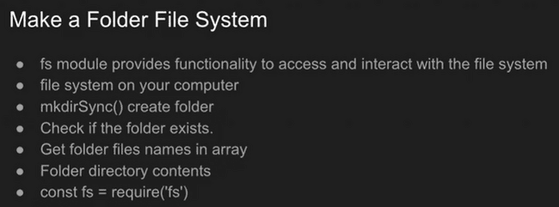

Note: fs means ‘file system’.

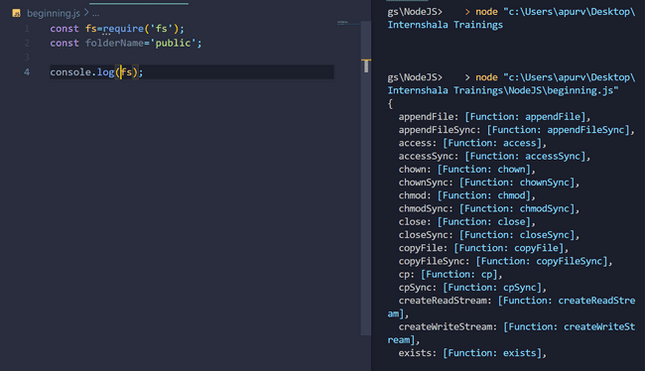

To get all information of **file system(fs)** module use above code.

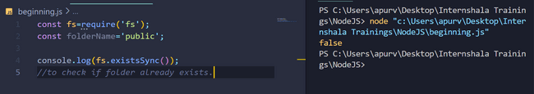

Wherever you see empty parenthesis please write ‘folderName’ there in above picture. Here it was giving false because of empty parenthesis.

CORRECTED:-

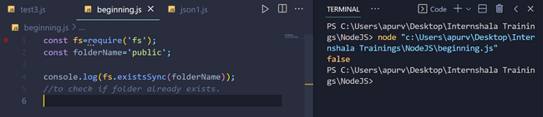

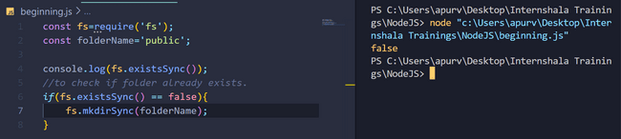

mkdirSync(<folder name>): make directory sync function to make directory.

Wherever you see empty parenthesis please write ‘folderName’ there in above pictures. Here it was giving false because of empty parenthesis.

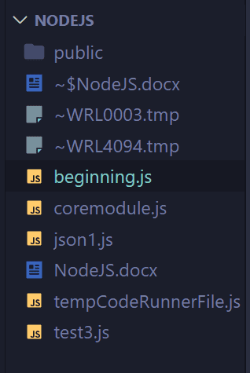 so, a new folder named ‘public’ is added.

**After making the folder named ‘public’ , tried to check what type of error is thrown if the file already exists. But we must include try and catch conditions in these areas even if we are making a new file as a precaution.**

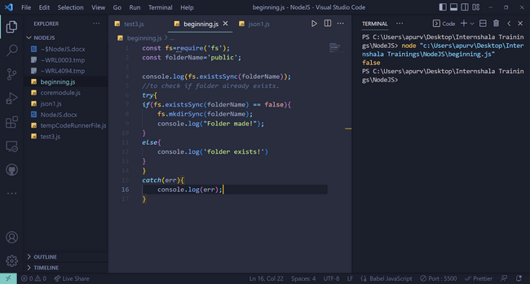No folder named ‘public’ existed before executing this code.

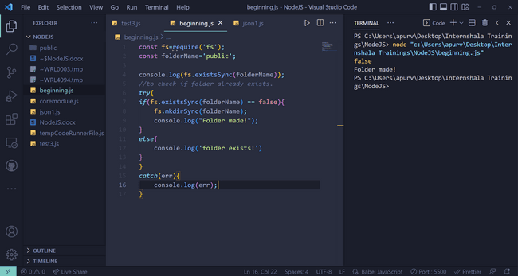

After the execution see the output and ‘public’ folder in left folders panel.

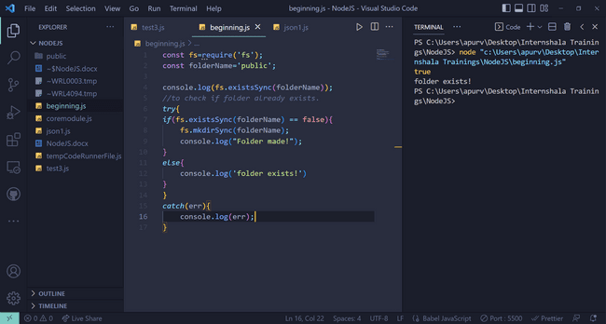

On again executing the previous code.

To add a new file in newly created folder:

const fs=require('fs');

const folderName='public';

console.log(fs.existsSync(folderName));

*//to check if folder already exists.*

*try*{

*if*(fs.existsSync(folderName) == false){

    fs.mkdirSync(folderName);

    console.log("Folder made!");

}

*else*{

    console.log('folder exists!')

}

}

*catch*(err){

    console.log(err);

}

const folderPath=`./${folderName}`;

*//because we saw in exporting part that every .js file location is represented by a dot*

*// folowed by that filename.*

console.log(folderPath);

console.log(folderPath+"./index.html");

fs.writeFile(folderPath+ '/index.html', "<h1>Hello World</h1>",(*err*)=>{

*if*(*err*) {*throw* *err*};

    console.log('File Created!');

})

fs.writeFile(folderPath+ '/appy.css',

"*{box-sizing:border-box}",(*err*)=>{

*if*(*err*) {*throw* *err*};

    console.log('File Created!');

})

let value=fs.readdirSync(folderPath);

console.log(value);

Output:

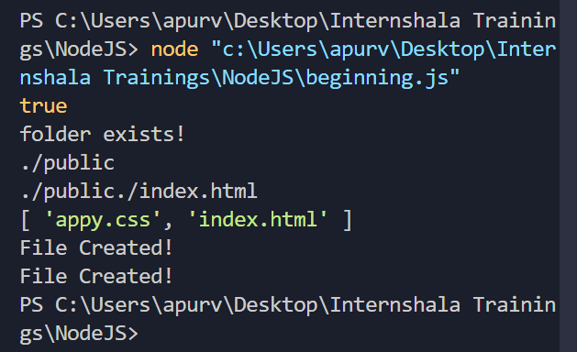

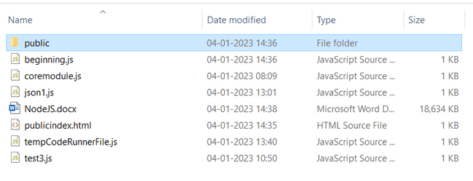

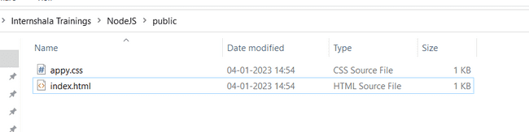

So, files are added inside the newly created folder.

Index.html (newly created file) :

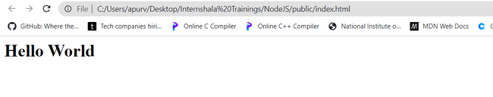

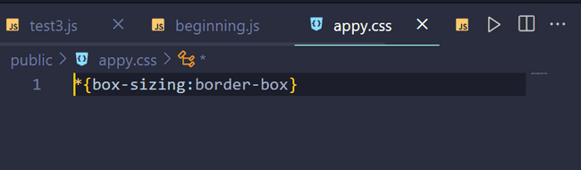

let value=fs.readdirSync(folderPath);

console.log(value);

in some last lines of above code, we have used it, it returns names of all files in the folder.

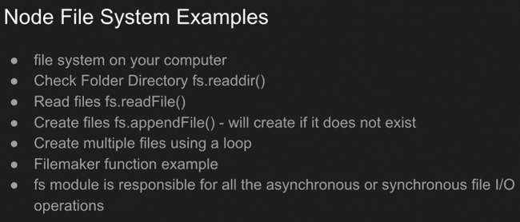

Reading a folder to get its file name:

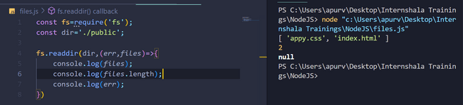

Adding new files by creating a function:

In files.js file:

const fs=require('fs');

const dir='./public';

let tempCounter=1;

let newFileName= `new${tempCounter}.html`;

fs.readdir(dir,(*err*,*files*)=>{

    console.log(*files*);

    console.log(*files*.length);

    console.log(*err*);

    tempCounter= *files*.length +1;

    newFileName=`new${tempCounter}.html`;

    createNewFile(newFileName);

})

function createNewFile(*fileName*){

    const html=`<h1>Hello ${tempCounter}</h1>`;

    fs.appendFile(dir+"/"+*fileName*,html,(*err*)=>{

*if*(*err*) *throw* *err*;

        console.log(`Saved File: ${*fileName*}`);

    })

}

Output:

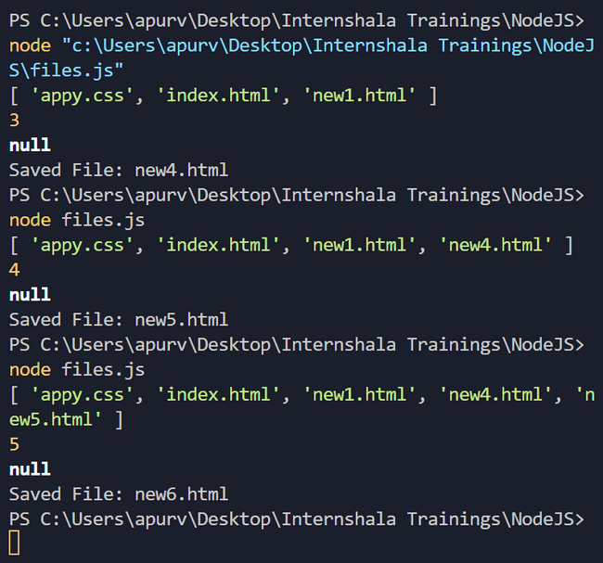

So, as is visible from output , if we go on writing ‘node files.js’ , the number of files keep on increasing inside the folder. Note files.js is name of javascript file.

**It can also be kept inside a loop or a function for automation.**

Shown in code on next page:

const fs=require('fs');

const dir='./public';

let tempCounter=1;

let newFileName= `new${tempCounter}.html`;

*for*(let i=0;i<10;i++){

fs.readdir(dir,(*err*,*files*)=>{

    console.log(*files*);

    console.log(*files*.length);

    console.log(*err*);

    tempCounter= *files*.length +i;

    newFileName=`new${tempCounter}.html`;

    createNewFile(newFileName);

})

}

function createNewFile(*fileName*){

    const html=`<h1>Hello ${tempCounter}</h1>`;

    fs.appendFile(dir+"/"+*fileName*,html,(*err*)=>{

*if*(*err*) *throw* *err*;

        console.log(`Saved File: ${*fileName*}`);

    })

}

OUTPUT:

We notice from pictures below, that file saving occurs later. As saving part is executed later.

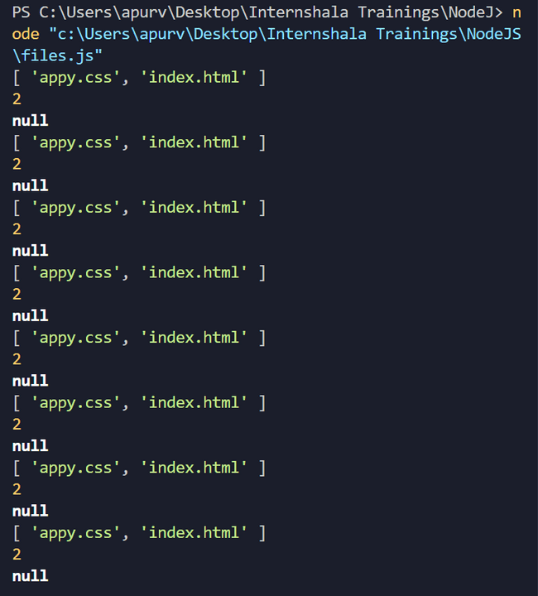

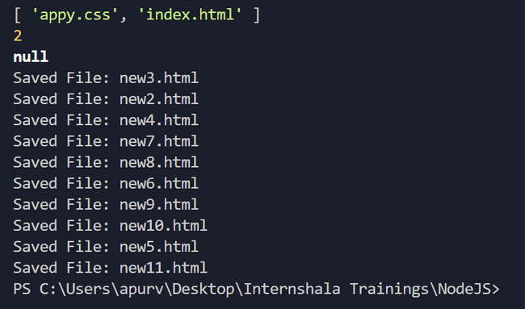

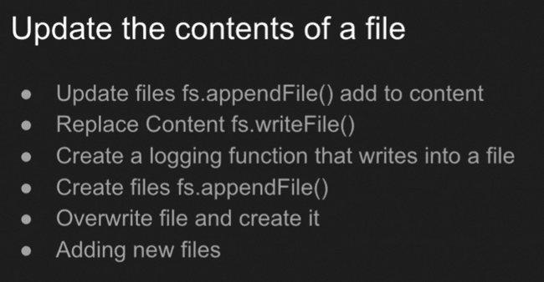

**Earlier, we have made new file inside a folder using ‘appendFile()’ but we can use ‘writeFile()’ also. But the problem with ‘writeFile()’ is whenever we repeat the occurences of the same function, we do not get multiple occurences but actually the file resets i.e. erases everything that it had in the past and writes completely newer things from the beginning. So, to add newer things in the file along with previous texts ,we need to append (not write) in the file.**

**CODE:**

const fs=require('fs');

const dir='./public';

let tempCounter=1;

let newFileName= `new${tempCounter}.html`;

function maker(){

*for*(let i=0;i<10;i++){

fs.readdir(dir,(*err*,*files*)=>{

    console.log(*files*);

    console.log(*files*.length);

    console.log(*err*);

    tempCounter= *files*.length +i;

    newFileName=`new${tempCounter}.html`;

    createNewFile(newFileName);

})

}

}

function createNewFile(*fileName*){

    const html=`<h1>Hello ${tempCounter}</h1>`;

    fs.appendFile(dir+"/"+*fileName*,html,(*err*)=>{

*if*(*err*) *throw* *err*;

        console.log(`Saved File: ${*fileName*}`);

    })

}

maker();

*// Till now, we have made new files using 'appendFile()' function only*

*//Now, we will use write'File()' function.*

function overmylog(*val*){

    const html=`-${*val*}`;

    fs.writeFile(dir+"/log.html",html,(*err*)=>{

*if*(*err*) *throw* *err*;

        console.log(`Created new file using writeFile()`);

    })

}

overmylog('test');

*// We append in the file ,so, that it contains past texts as well as new texts.*

function mylog(*val*){

    const html=`<br>*${*val*}`;

    fs.appendFile(dir+"/log.html",html,(*err*)=>{

*if*(*err*) *throw* *err*;

        console.log(`<br>Appending a previously written file`);

    })

}

mylog("appended1");

mylog("appended2");

mylog("appended3");

mylog("appended4");

**OUTPUT:**

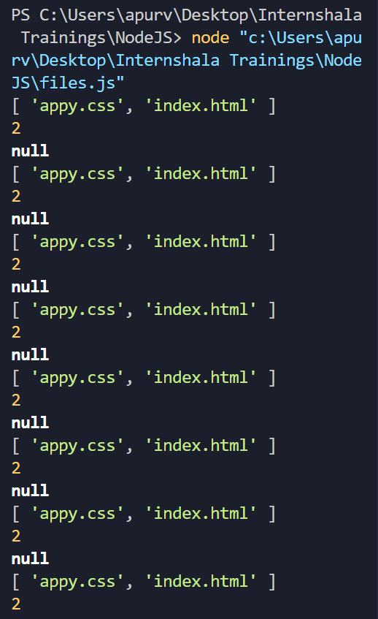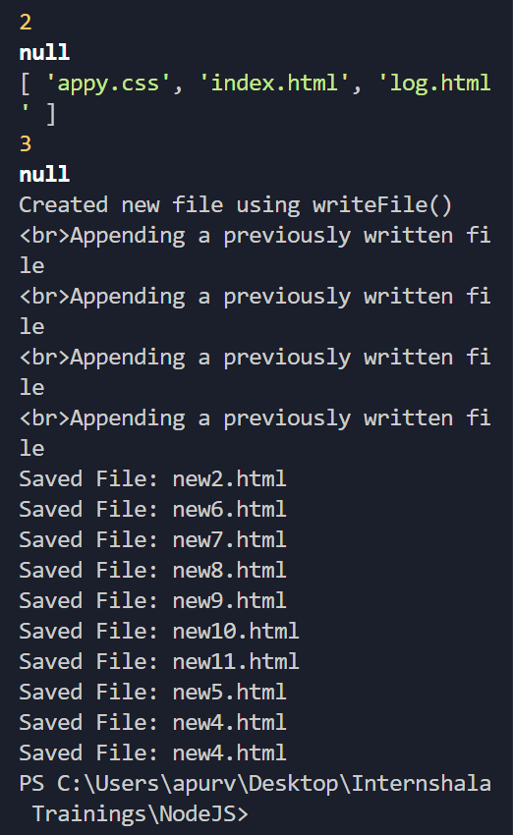

**See the images from left to right i.e. first left then right.**

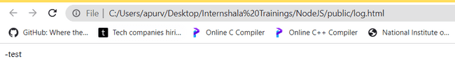

**When only writeFile() was used, it was not getting appended. Everytime, all past texts were erased and a file was written.**

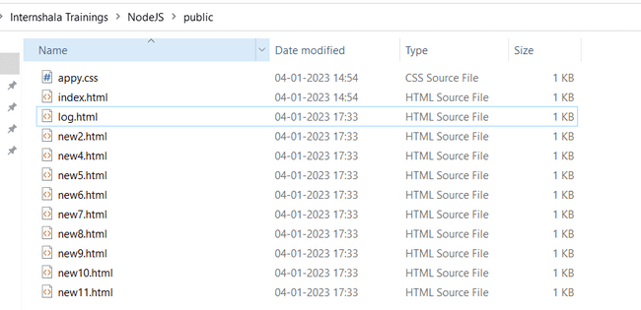

**On using appendFile(), output of log.html**

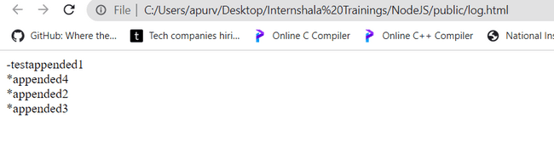

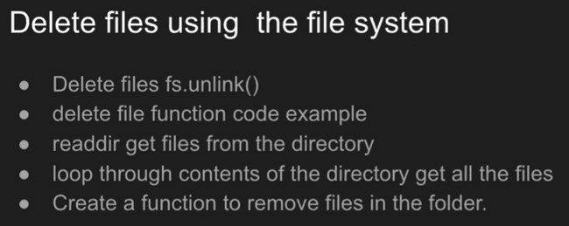

**CODE: delFile() code added at the end:**

const fs=require('fs');

const dir='./public';

let tempCounter=1;

let newFileName= `new${tempCounter}.html`;

function maker(){

*for*(let i=0;i<10;i++){

fs.readdir(dir,(*err*,*files*)=>{

    console.log(*files*);

    console.log(*files*.length);

    console.log(*err*);

    tempCounter= *files*.length +i;

    newFileName=`new${tempCounter}.html`;

    createNewFile(newFileName);

})

}

}

function createNewFile(*fileName*){

    const html=`<h1>Hello ${tempCounter}</h1>`;

    fs.appendFile(dir+"/"+*fileName*,html,(*err*)=>{

*if*(*err*) *throw* *err*;

        console.log(`Saved File: ${*fileName*}`);

    })

}

maker();

*// Till now, we have made new files using 'appendFile()' function only*

*//Now, we will use write'File()' function.*

function overmylog(*val*){

    const html=`-${*val*}`;

    fs.writeFile(dir+"/log.html",html,(*err*)=>{

*if*(*err*) *throw* *err*;

        console.log(`Created new file using writeFile()`);

    })

}

overmylog('test');

*// We append in the file ,so, that it contains past texts as well as new texts.*

function mylog(*val*){

    const html=`<br>*${*val*}`;

    fs.appendFile(dir+"/log.html",html,(*err*)=>{

*if*(*err*) *throw* *err*;

        console.log(`<br>Appending a previously written file`);

    })

}

mylog("appended1");

mylog("appended2");

mylog("appended3");

mylog("appended4");

*//function for deleting the file*

function delFile(*val*){

    fs.unlink(*val*,(*err*)=>{

*if*(*err*) {*throw*(*err*);}

*else*{

        console.log(`${*val*} is deleted`);}

    })

}

delFile(dir+'/log.html');

**output:**

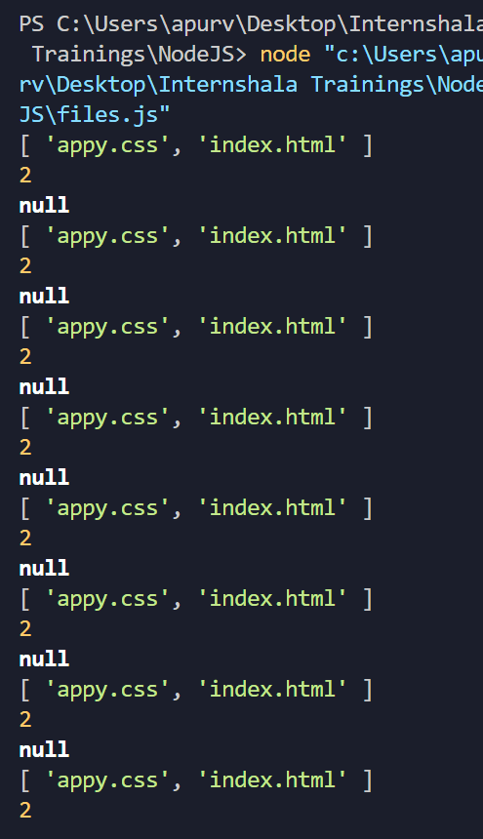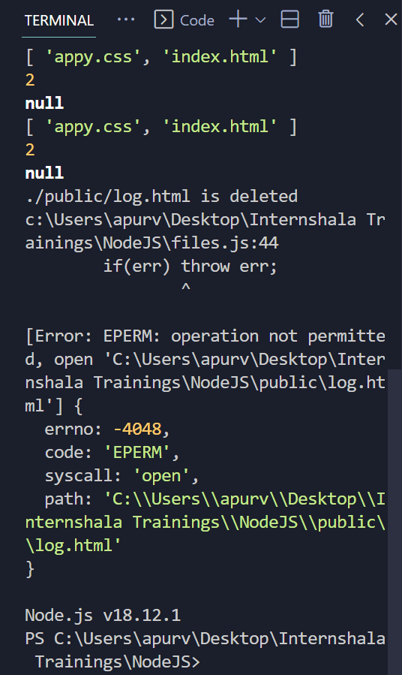

Error message in last lines is not of delete function but it is due to user permissions regarding the file deletion. We can see that ‘./public/log.html is deleted ‘ is clearly visible before the error. And also in folder as shown below:

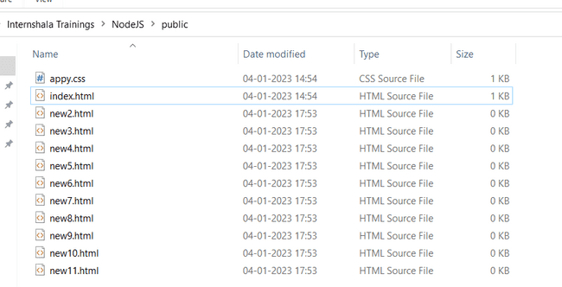

Making a function named ‘removeAll()’ to remove all files:

CODE:

const fs=require('fs');

const dir='./public';

*// let tempCounter=1;*

*// let newFileName= `new${tempCounter}.html`;*

*// function maker(){*

*// for(let i=0;i<10;i++){*

*// fs.readdir(dir,(err,files)=>{*

*//     console.log(files);*

*//     console.log(files.length);*

*//     console.log(err);*

*//     tempCounter= files.length +i;*

*//     newFileName=`new${tempCounter}.html`;*

*//     createNewFile(newFileName);*

*// })*

*// }*

*// }*

*// function createNewFile(fileName){*

*//     const html=`<h1>Hello ${tempCounter}</h1>`;*

*//     fs.appendFile(dir+"/"+fileName,html,(err)=>{*

*//         if(err) throw err;*

*//         console.log(`Saved File: ${fileName}`);*

*//     })*

*// }*

*// maker();*

*// // Till now, we have made new files using 'appendFile()' function only*

*// //Now, we will use write'File()' function.*

*// function overmylog(val){*

*//     const html=`-${val}`;*

*//     fs.writeFile(dir+"/log.html",html,(err)=>{*

*//         if(err) throw err;*

*//         console.log(`Created new file using writeFile()`);*

*//     })*

*// }*

*// overmylog('test');*

*// // We append in the file ,so, that it contains past texts as well as new texts.*

*// function mylog(val){*

*//     const html=`<br>*${val}`;*

*//     fs.appendFile(dir+"/log.html",html,(err)=>{*

*//         if(err) throw err;*

*//         console.log(`<br>Appending a previously written file`);*

*//     })*

*// }*

*// mylog("appended1");*

*// mylog("appended2");*

*// mylog("appended3");*

*// mylog("appended4");*

*// //function for deleting the file*

function delFile(*val*){

    fs.unlink(*val*,(*err*)=>{

*// if(err) {throw(err);}*

*// else{*

        console.log(`${*val*} is deleted`);

*// }*

    })

}

delFile(dir+'/log.html');

*//function to delete all files*

function removeAll(){

    fs.readdir(dir,(*err*,*files*)=>{

*files*.forEach((*myfile*)=>{

            delFile(dir+'/'+*myfile*);

        })

    })

}

removeAll();

Output:

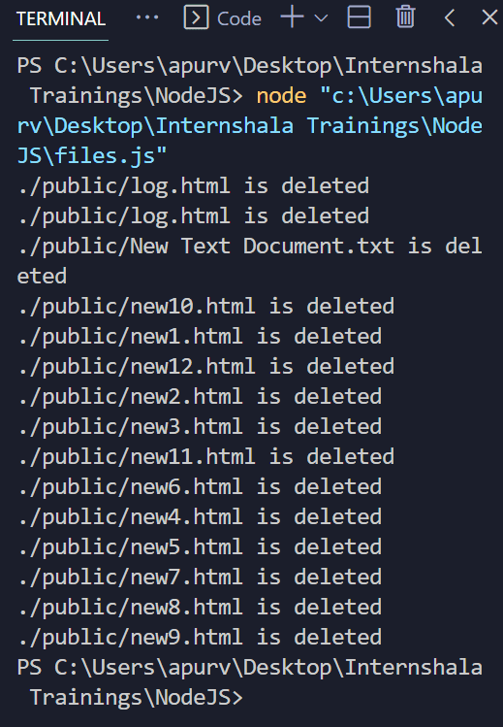

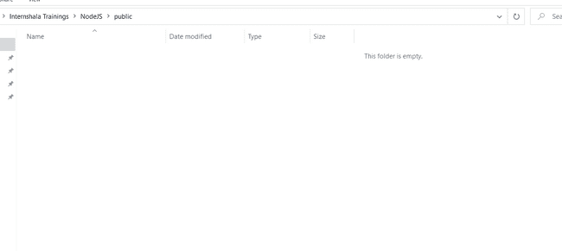

One must note here that in the code above we have commented a lot of code part as the code was both saving and deleting the files ,so, during execution as js is single threaded and non-blocking i.e. asynchronous ,so, it continues execution for next instruction ,so, when we executed it ,it doesn’t delete all files but only those file which were saved before deletion started so, if we execute without appending ,we will always find that all files have not deleted.

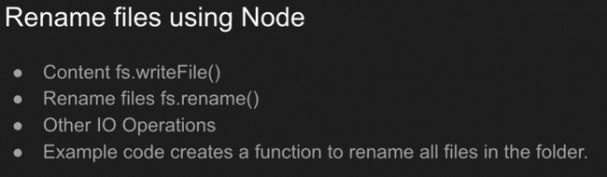

CODE:

const fs=require('fs');

const dir='./public';

*// let tempCounter=1;*

*// let newFileName= `new${tempCounter}.html`;*

*// function maker(){*

*// for(let i=0;i<10;i++){*

*// fs.readdir(dir,(err,files)=>{*

*//     console.log(files);*

*//     console.log(files.length);*

*//     console.log(err);*

*//     tempCounter= files.length +i;*

*//     newFileName=`new${tempCounter}.html`;*

*//     createNewFile(newFileName);*

*// })*

*// }*

*// }*

*// function createNewFile(fileName){*

*//     const html=`<h1>Hello ${tempCounter}</h1>`;*

*//     fs.appendFile(dir+"/"+fileName,html,(err)=>{*

*//         if(err) throw err;*

*//         console.log(`Saved File: ${fileName}`);*

*//     })*

*// }*

*// maker();*

*// // Till now, we have made new files using 'appendFile()' function only*

*// //Now, we will use write'File()' function.*

*// function overmylog(val){*

*//     const html=`-${val}`;*

*//     fs.writeFile(dir+"/log.html",html,(err)=>{*

*//         if(err) throw err;*

*//         console.log(`Created new file using writeFile()`);*

*//     })*

*// }*

*// overmylog('test');*

*// // We append in the file ,so, that it contains past texts as well as new texts.*

*// function mylog(val){*

*//     const html=`<br>*${val}`;*

*//     fs.appendFile(dir+"/log.html",html,(err)=>{*

*//         //if(err) throw err;*

*//         console.log(`<br>Appending a previously written file`);*

*//     })*

*// }*

*// mylog("appended1");*

*// mylog("appended2");*

*// mylog("appended3");*

*// mylog("appended4");*

*// //function for deleting the file*

*// function delFile(val){*

*//     fs.unlink(val,(err)=>{*

*//         // if(err) {throw(err);}*

*//         // else{*

*//         console.log(`${val} is deleted`);*

*//     // }*

*//     })*

*// }*

*// // delFile(dir+'/log.html');*

*// //function to delete all files*

*// function removeAll(){*

*//     fs.readdir(dir,(err,files)=>{*

*//         files.forEach((myfile)=>{*

*//             delFile(dir+'/'+myfile);*

*//         })*

*//     })*

*// }*

*// removeAll();*

*//function to rename 1 file*

function renameFile(*fileName*,*newName*){

    fs.rename(*newName*,*fileName*,(*err*)=>{

*//if(err) throw err;*

        console.log(`File ${*fileName*} renamed to ${*newName*}`);

    })

}

*//function to rename All files*

function renameAll(){

    fs.readdir(dir,(*err*,*files*)=>{

*files*.forEach((*myfile*,*ind*)=>{

            renameFile(dir+'/'+*myfile*,`${dir}/new${*ind*}.html`);

        })

    })

}

renameAll()

OUTPUT:

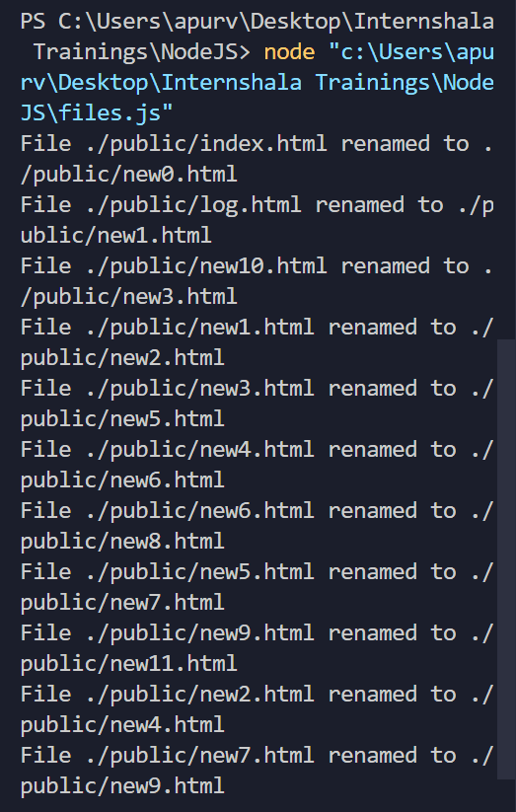 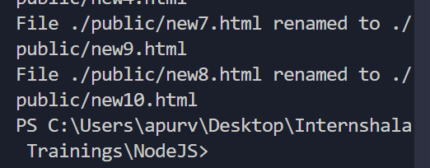

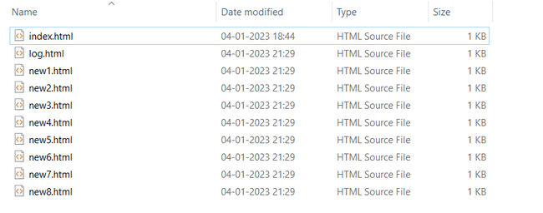

NOTE: For executing above code, remove comments from commented part and comment the remaining part as that part is responsible for creation of files and further return to this state as uncommented part is responsible for renaming here as can be seen from reading code.

This feature was not working on my laptop even though console says it has renamed but no renaming occurred in reality. It is visible from files photo on top of this page.

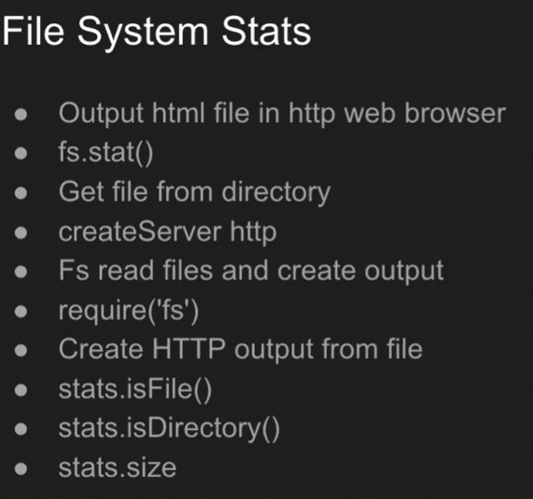

**OUTPUT HTML FILE IN WEB BROWSER:**

**Files.js :**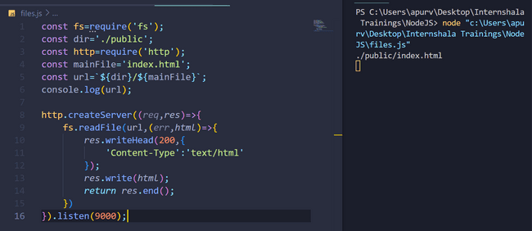

**Index.html :**

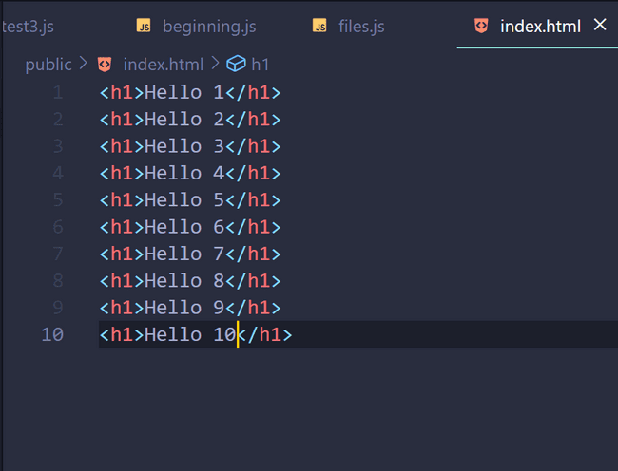

**Output:**

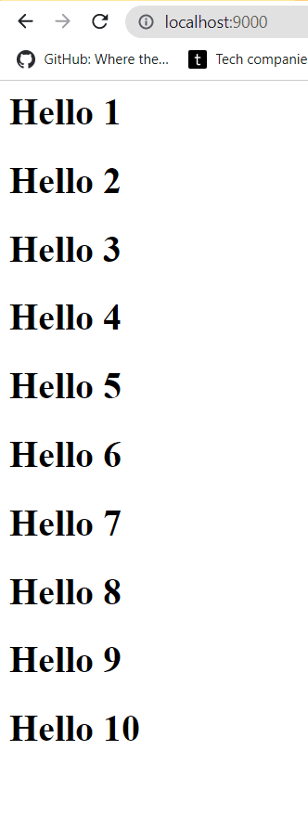

**To check if a file is opened and update the file whenever it is opened.**

**CODE:**

const fs=require('fs');

const dir='./public';

const http=require('http');

const mainFile='index.html';

const url=`${dir}/${mainFile}`;

console.log(url);

http.createServer((*req*,*res*)=>{

    fs.readFile(url,(*err*,*html*)=>{

*res*.writeHead(200,{

            'Content-Type':'text/html'

        });

*res*.write(*html*);

*return* *res*.end();

    })

}).listen(9000);

*//To check if file is open or not now.*

const rs=fs.createReadStream(url);

rs.on('open',(*e*)=>{

    console.log('File is open.');

    let val='<br>Opened';

    updateFile(val);

})

function updateFile(*val*){

    fs.appendFile(url,*val*,(*err*)=>{

*if*(*err*) *throw* *err*;

        console.log('Updated file!');

    })

}

*//above we are updating the html file with '<br>opened' to track that the file was opened.The more the number of times we start to execute our program, the more the number of times '<br>opened' will be appended in our mentioned file.*

**OUTPUT:**

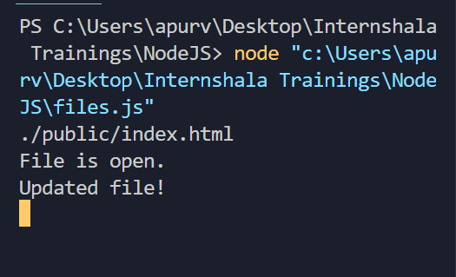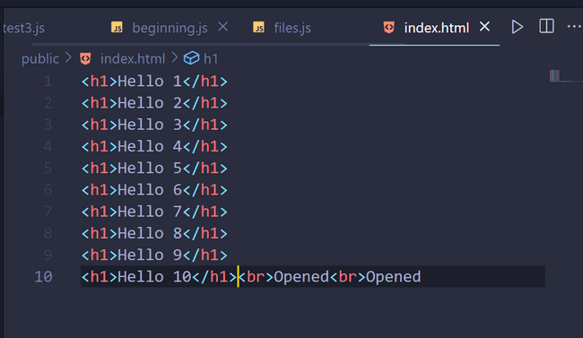

**We can see in right image that ‘opened’ is appended 2 times as I had opened the file 2 times.**

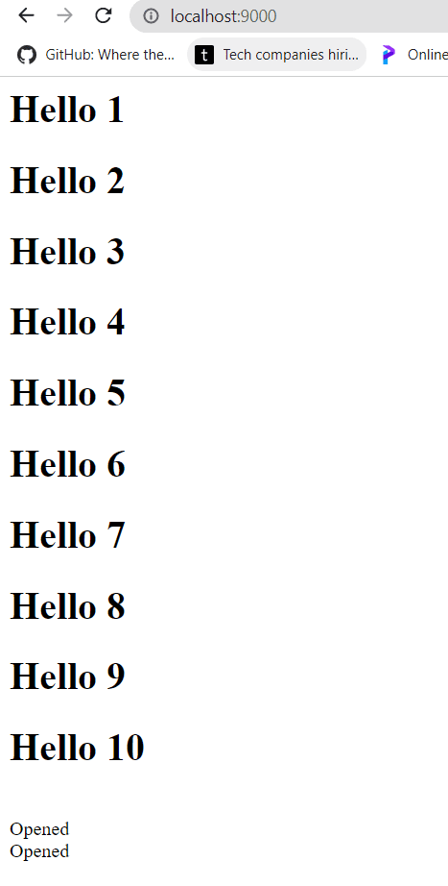**On webpage as well, we can see ‘opened’ as we were adding it in our HTML file.**

**To get all information about the file: we use fs.stat()**

**CODE:**

const fs=require('fs');

const dir='./public';

const http=require('http');

const mainFile='index.html';

const url=`${dir}/${mainFile}`;

console.log(url);

http.createServer((*req*,*res*)=>{

    fs.readFile(url,(*err*,*html*)=>{

*res*.writeHead(200,{

            'Content-Type':'text/html'

        });

*res*.write(*html*);

*return* *res*.end();

    })

}).listen(9000);

*//To check if file is open or not now.*

const rs=fs.createReadStream(url);

rs.on('open',(*e*)=>{

    console.log('File is open.');

    let val='<br>Opened';

    updateFile(val);

})

function updateFile(*val*){

    fs.appendFile(url,*val*,(*err*)=>{

*if*(*err*) *throw* *err*;

        console.log('Updated file!');

    })

}

*//above we are updating the html file with '<br>opened' to track that the file was opened.The more the number of times we start to execute our program, the more the number of times '<br>opened' will be appended in our mentioned file.*

*//To get all information about our file.*

fs.stat(url,(*err*,*stats*)=>{

    console.log(*stats*);

})

**OUTPUT:**

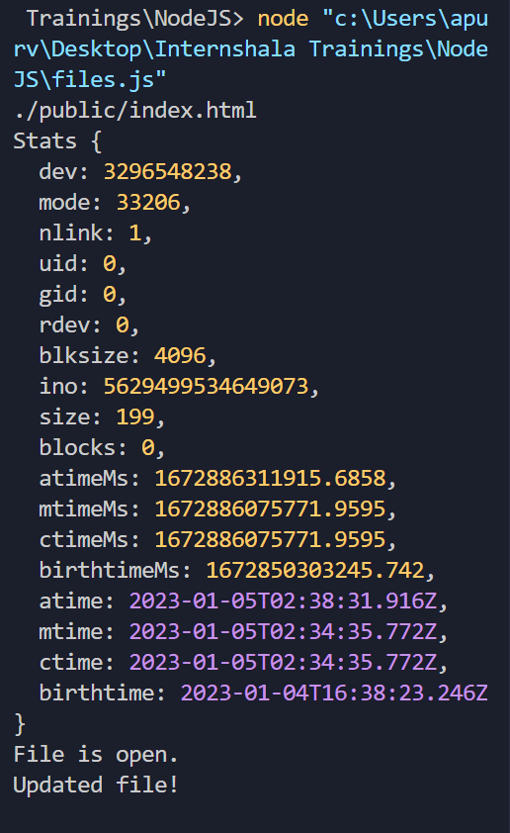

**We can also check if our file in which we are working is a file or a directory , also we can get file size etc using the same ‘fs.stat() function’.**

**CODE:**

const fs=require('fs');

const dir='./public';

const http=require('http');

const mainFile='index.html';

const url=`${dir}/${mainFile}`;

console.log(url);

http.createServer((*req*,*res*)=>{

    fs.readFile(url,(*err*,*html*)=>{

*res*.writeHead(200,{

            'Content-Type':'text/html'

        });

*res*.write(*html*);

*return* *res*.end();

    })

}).listen(9000);

*//To check if file is open or not now.*

const rs=fs.createReadStream(url);

rs.on('open',(*e*)=>{

    console.log('File is open.');

    let val='<br>Opened';

    updateFile(val);

})

function updateFile(*val*){

    fs.appendFile(url,*val*,(*err*)=>{

*if*(*err*) *throw* *err*;

        console.log('Updated file!');

    })

}

*//above we are updating the html file with '<br>opened' to track that the file was opened.The more the number of times we start to execute our program, the more the number of times '<br>opened' will be appended in our mentioned file.*

*//To get all information about our file.*

*// fs.stat(url,(err,stats)=>{*

*//     console.log(stats);*

*// })*

*//To check if we are working in a file or a directory:*

*//taking url i.e. file as input*

fs.stat(url,(*err*,*stats*)=>{

    console.log("Are we working on a file?",*stats*.isFile());

    console.log("Are we working on a directory? ",*stats*.isDirectory());

    console.log("Size of file is: ",*stats*.size);

})

*//Taking directory as input*

fs.stat(dir,(*err*,*stats*)=>{

    console.log("Are we working on a file?",*stats*.isFile());

    console.log("Are we working on a directory? ",*stats*.isDirectory());

})

**OUTPUT:**

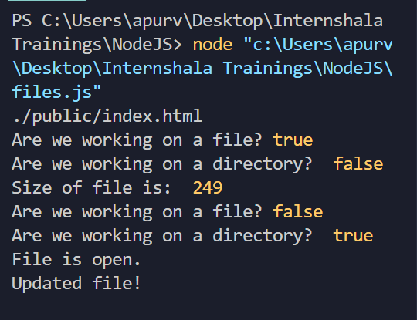

**Note: first we are checking file to be a file and then we are checking directory to be a directory in the above code.**

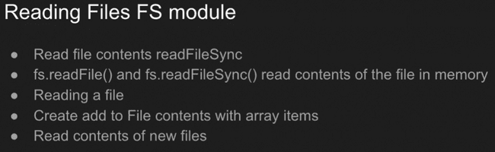

Reading the content from a different file:

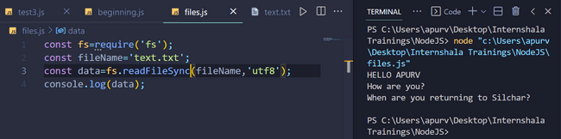

Text.txt:

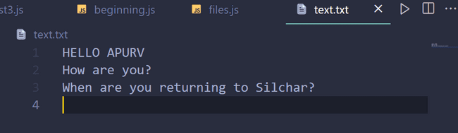

Writing in the file:

Text.txt contains:



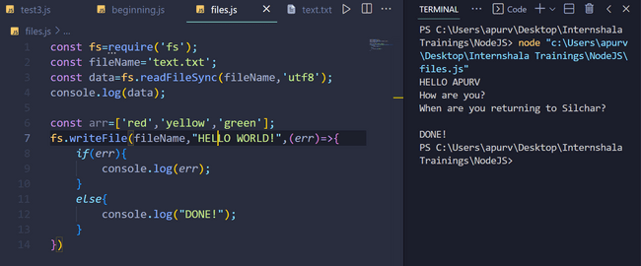

Now, text.txt

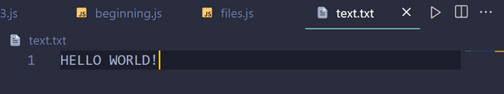

All previous contents are erased as we have used ‘fs.writeFile()’ and not ‘fs.appendFile()’.

If we would have appended then… :

CODE:

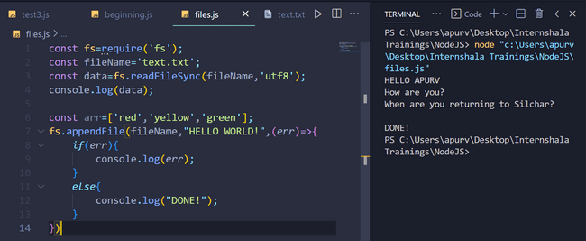

OUTPUT:

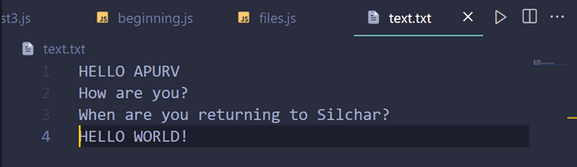

Adding array contents in the text.txt file:

Text.txt before:

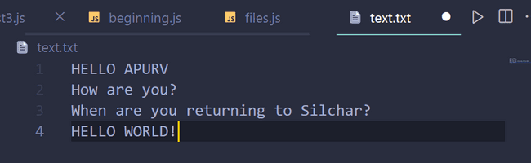

CODE:

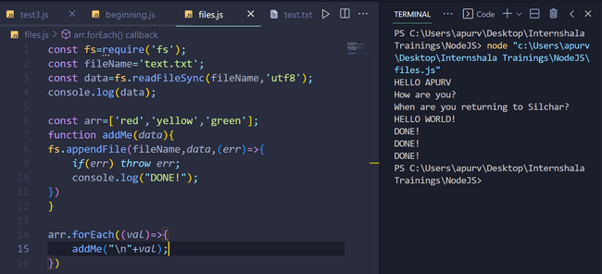

OUTPUT shown on right of above photo.

OUTPUT in text.txt:

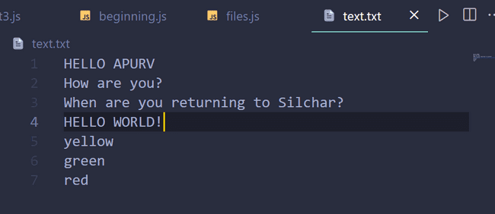

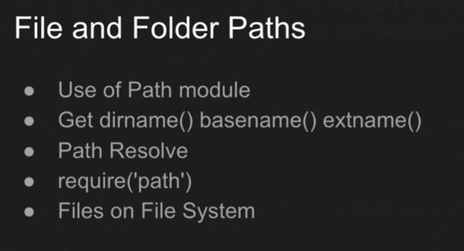

File and Folder Path:

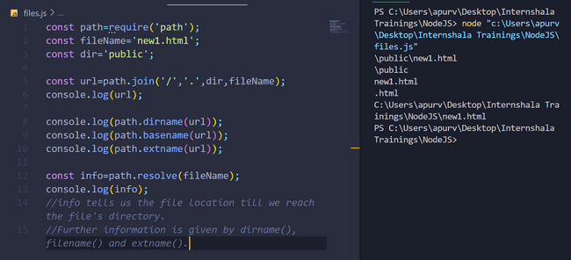

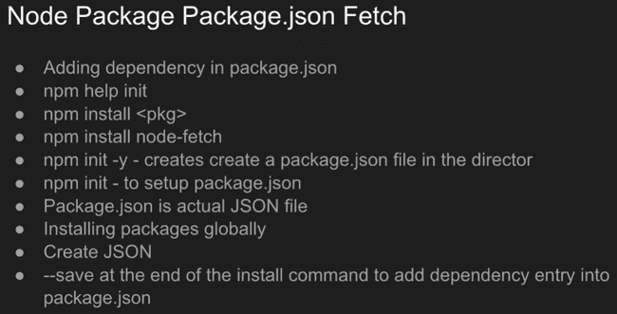

**Node Package Manager .json fetch :**

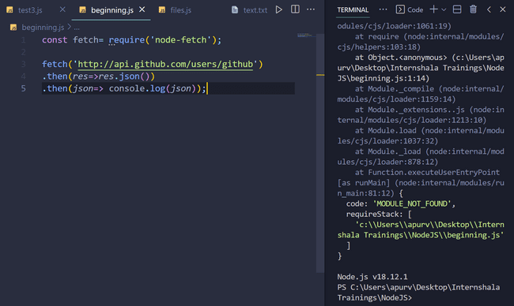

**We need to install the npm package first then only we can fetch it, otherwise, like above the console will throw an error.**

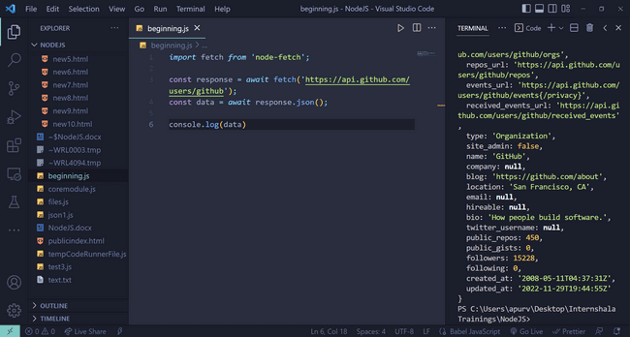

**Note: The above code is only used for installing ‘node-fetch’ for the first time after that from this code we will only use the first line of this code so, that we can bring node-fetch module to fetch our apis. When we run the above code we find that ‘package.json’ and ‘package-lock.json’ are downloaded either in the same file or if not in same file , one must check the main drive of the computer ,it will definitely have the above mentioned 2 files.**

**If we execute again just after downloading the 2 files , we will again get the error, to overcome it , we must open package.json file and in first row of the object , we must include “type”:”module” as shown below and run again , it will definitely work so, now ‘node-fetch’ is successfully installed in your computer. Cheers!**

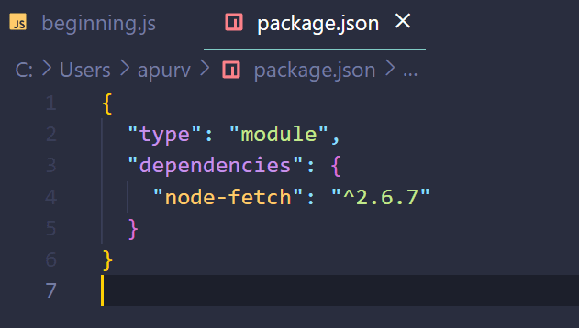

**#Important: Fetching from an API:**

1. **Get a site from where you can get an API. For example:** [**https://randomuser.me/**](https://randomuser.me/) **etc.**

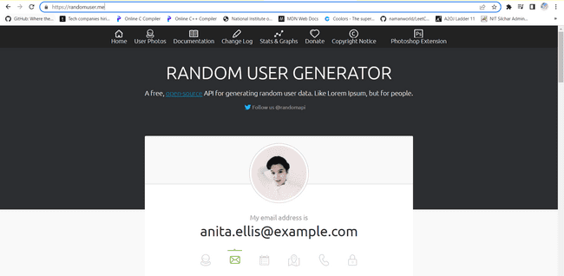

**2. Change its url to get api :** [**https://randomuser.me/api/?results=10**](https://randomuser.me/api/?results=10)

**Comparing it with the previous url, we have added ‘/api’ specifying that we want apis and ‘/?results=10’ specifies that out of all the results we want 10 results.**

**So,** [**https://randomuser.me/api/?results=5**](https://randomuser.me/api/?results=5) **will mean that we only want 5 apis.**

**3.Execute the changed link and we will get:**

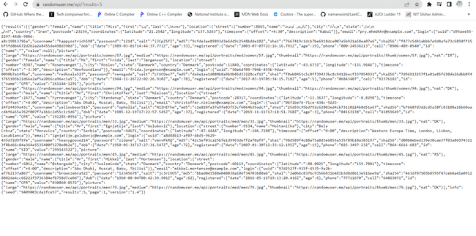

**4. Copy this link and use as shown below: Left side is the code and rightside is its output. So, we have successfully fetched the apis.**

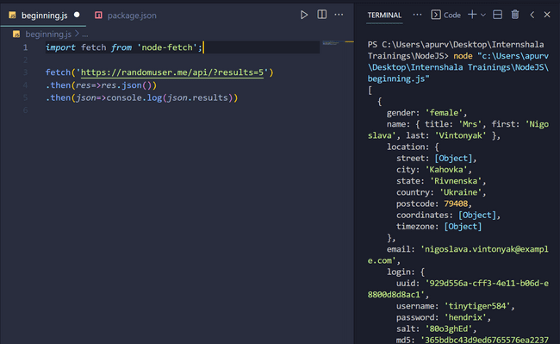

**Now, we can manipulate the information according to our requirements.**

**Like this example:**

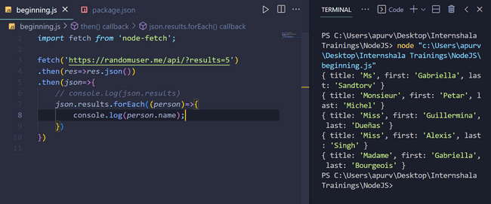

**It is clear from the previous (not above) code’s output that we have received an array containing objects equal to frequency that we had specified. We can access the objects key and values that’s what we have done in above code. It is clear from previous code that each object has key value has ‘name’ , we have printed out the names in our above code.**

**Another example:**

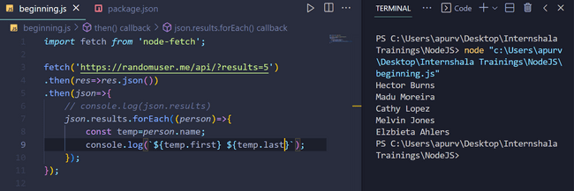

**One must also note that I was executing the files again and again, see that I was getting different names, names in above picture differ completely from names of previous picture , it means API is working correctly.**

**We can get text from sites as well:**

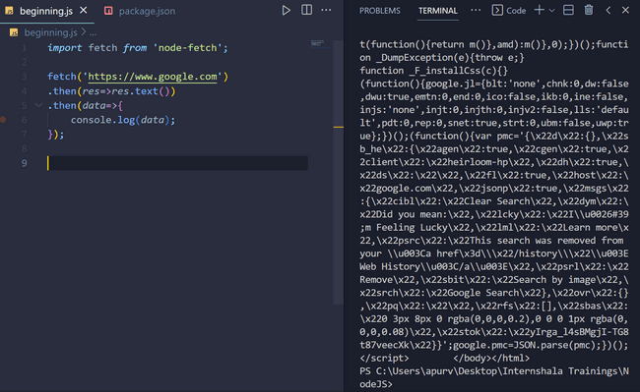

**The above code takes out HTML codes from google webpage.**

**So, we can ‘text’ as well as ‘json’ as output.**

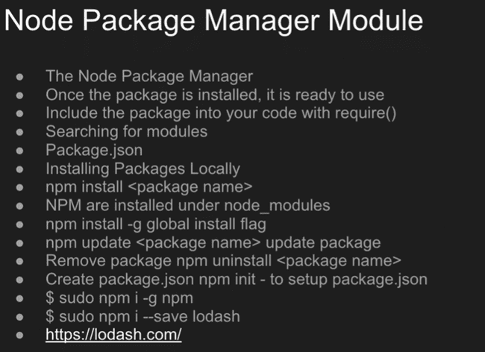

**npm init : it will help to create a package.json file ,if one already has package.json then new key and value pairs will be added to it.**

**npm help init : to get information about working with npm init.**

**npm install (package name) : to install a package.**

**Some of pictures from ‘npm init’ execution:**

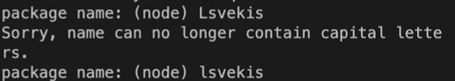

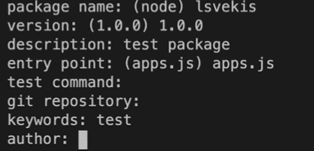 **Note that texts written in parenthesis are default values if one wishes to continue with default values , one can directly press ‘enter’ key , no need to write it again.**

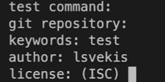

**Then:**

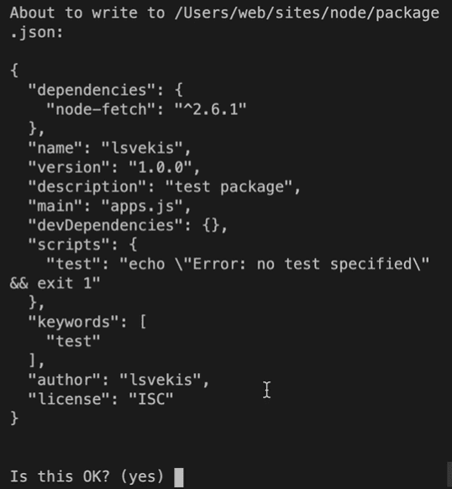

**Then:**

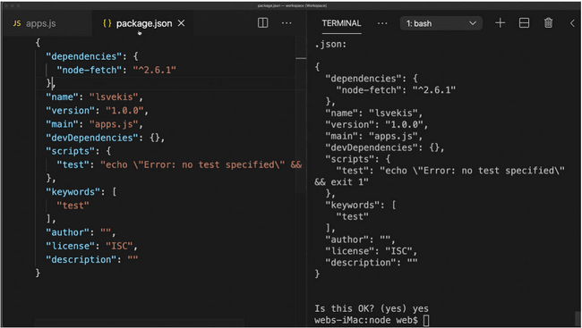

**npm update node-fetch : to update the node-fetch file to save the new contents entered by us. Otherwise, when we will open next time we will not see the contents we have updated this time. It basically updates the ‘dependencies’ as other information will remain same.**

**npm uninstall node-fetch : to uninstall a package i.e. to uninstall the dependencies. As other information like name, version etc as can be seen in above photo’s right panel except dependencies will remain same irrespective of package download.**

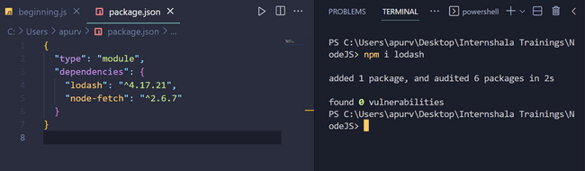

**In order to install a new package or a dependency, we can use npm install (package name) or one can take code to install from npmjs.com . We see that in above figure , the new packages are added as dependencies in package.json.**

**To uninstall lodash (say), we use npm uninstall lodash.**

**The codes of lodash now, are of older versions. They will throw errors now because of use of ‘require()’. But working of lodash functions will remain same.**

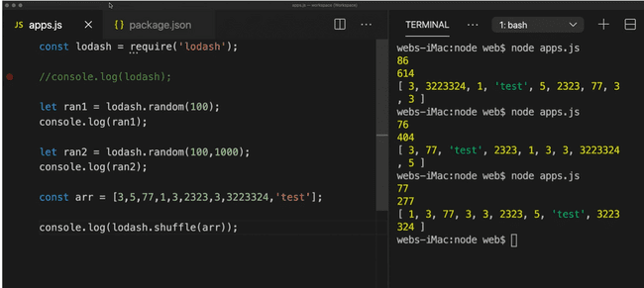

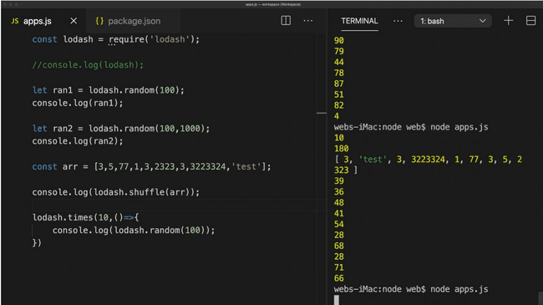

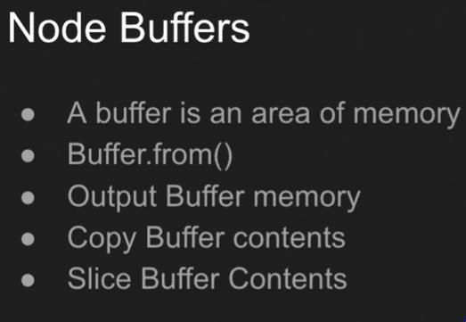

**Buffers are areas of memory that contains raw data , it can be output, copied and sliced etc.**

**All functions of buffer are shown below:**

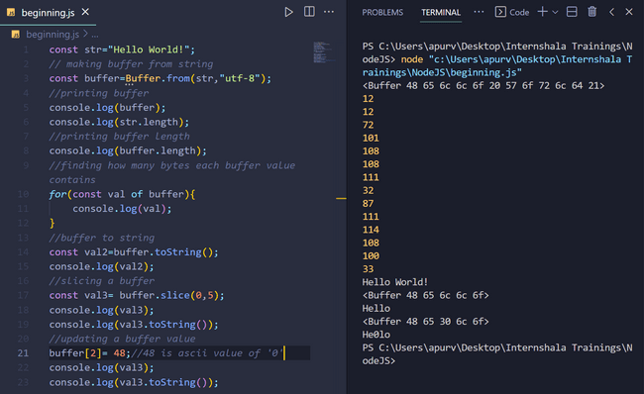

**Errors: try, catch, throw:**

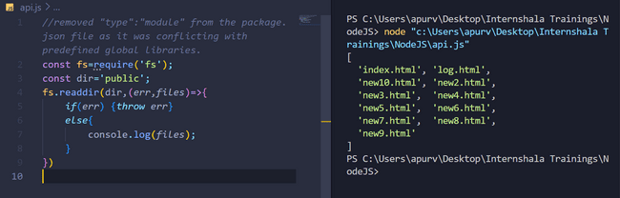

**An error was encountered here as mentioned in the ‘comments’ written at the top of the above code.**

**SOLUTION:**

**I.Every directory has its own package.json so, it can be used as a way to avoid the conflict if any package of node module conflicts.**

**II. it may be possible that module which we are trying to import is not a ‘global’ module so, we first need to import its module’s dependency in our ‘package.json’ using ‘npmjs.com’ and then use it.**

**Express.js**

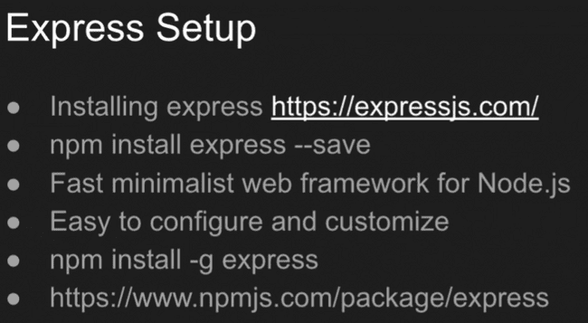

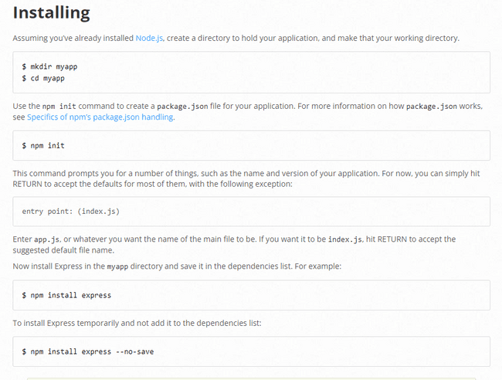

**ls (small L small S) : can be used to list all the files inside a directory or folder in the above code.**

**Entry point written above may be confusing, it means that starting point i.e. starting file of making the package.json , it may be any file even the default file will work. Even if one continues to use the default file of that directory even then it will not create any error in present or future.**

**First set up package .json using above mentioned steps:**

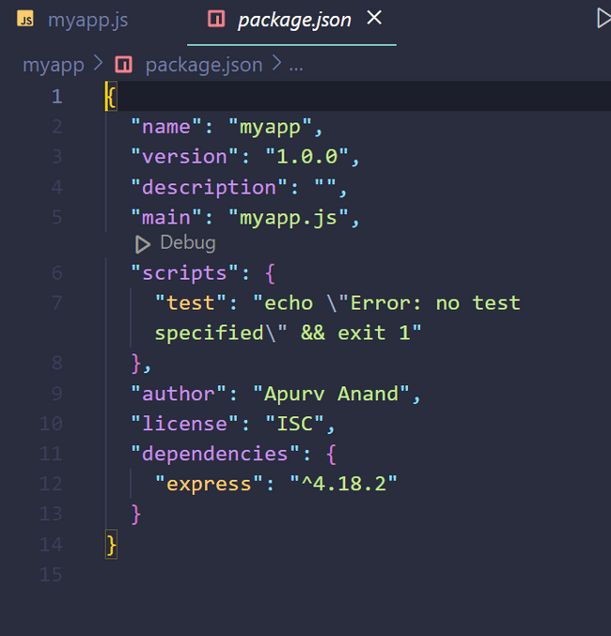

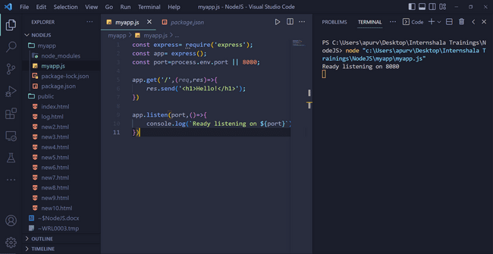

**From the output of console, it means local hosting has started at port 8080.**

**OUTPUT:**

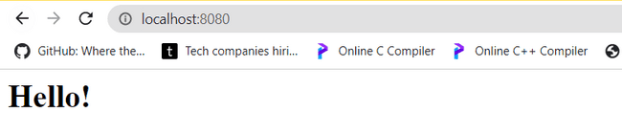

**CODE:**

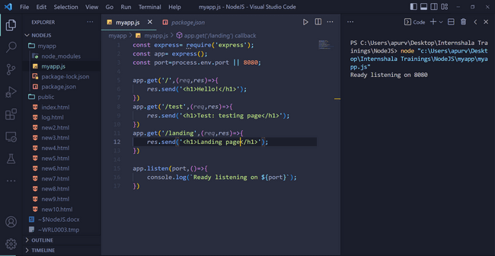

**Output:**

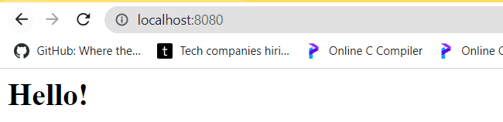

**On /test page:**

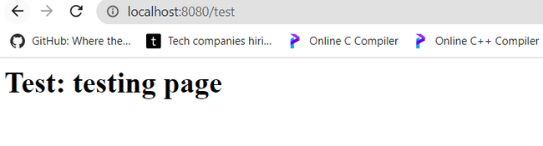

**On /landing page:**

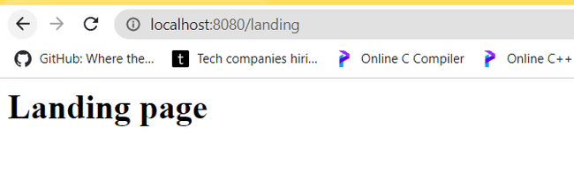

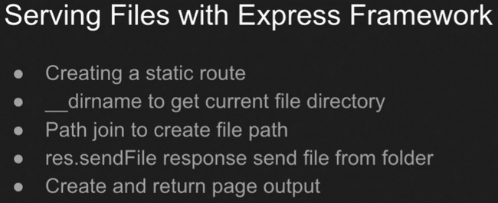

**Joining different file as main file: We made a new html file and then joined it path using path() function to create a new url. And set the url to the default as is clearly evident from the code below.**

**Index.html: the new file which will be set as default page.**

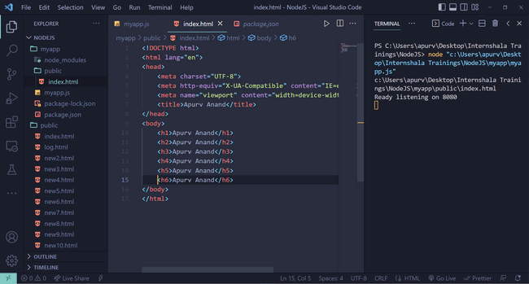

**myapp.js: it is express.js file which sets index.html as default.**

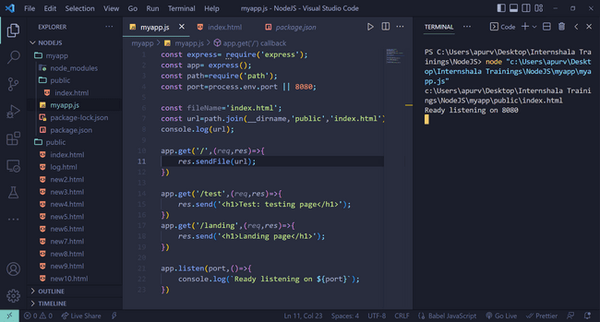

**Output on the local host (here port 8080):**

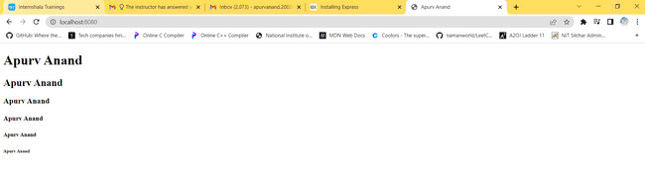

**Routing in Express.js :**

**We can perform routing in express.js like in above example we had to first make the url and then pass it to the function ,if there would have been more files so, we would have to make more urls and pass them individually to the function but here in express.js, we have routing feature that declares all files to have a specific location i.e. within the same directory as we will use to store only in 1 folder or directory so, we will use ‘static’ routing in this example.**

**CODE:**

const express= require('express');

const app= express();

const path=require('path');

const port=process.env.port || 8080;

const fileName='index.html';

const url=path.join(__dirname,'public','index.html');

console.log(url);

*//static routing:*

app.use(express.static(__dirname+'/public'));

app.get('/',(*req*,*res*)=>{

*// res.sendFile(url);*

*res*.sendFile(fileName);

})

app.get('/test',(*req*,*res*)=>{

*res*.send('<h1>Test: testing page</h1>');

})

app.get('/landing',(*req*,*res*)=>{

*res*.send('<h1>Landing page</h1>');

})

app.listen(port,()=>{

    console.log(`Ready listening on ${port}`);

})

**OUTPUT:**

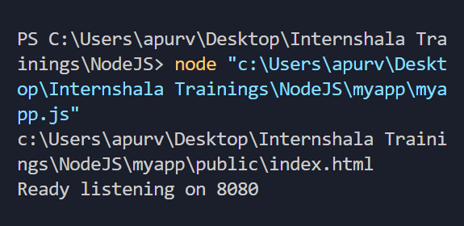

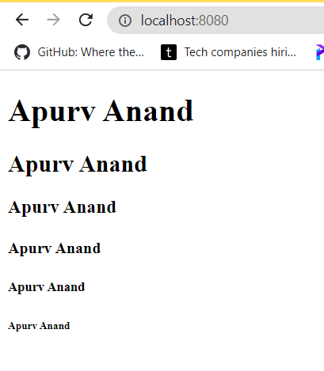

**We now created a new file named ‘index2.html’ , note, inside the same directory ‘myapp’ , but as we were routing of type ‘static routing’ , any thing we enter will route to the same directory name and folder location and hence would without any increase in our code and even without declaring anything new about the new file (index2.html) we were still able to use its html provided that we declared the new file inside the same folder or directory.**

**CODE:**

const express= require('express');

const app= express();

const path=require('path');

const port=process.env.port || 8080;

const fileName='index.html';

const url=path.join(__dirname,'public','index.html');

console.log(url);

*//static routing:*

app.use(express.static(__dirname+'/public'));

app.get('/',(*req*,*res*)=>{

*// res.sendFile(url);*

*res*.sendFile(fileName);

})

app.get('/test',(*req*,*res*)=>{

*res*.send('<h1>Test: testing page</h1>');

})

app.get('/landing',(*req*,*res*)=>{

*res*.send('<h1>Landing page</h1>');

})

app.listen(port,()=>{

    console.log(`Ready listening on ${port}`);

})

**Index2.html**

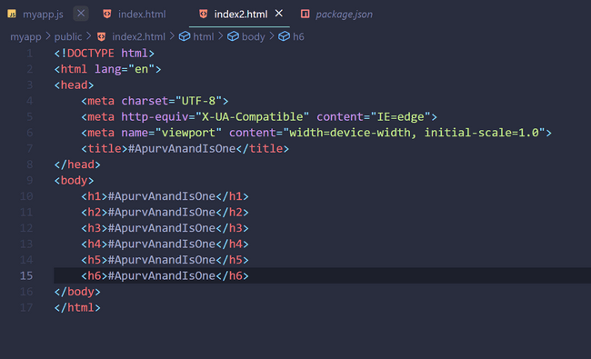

**Index.html**

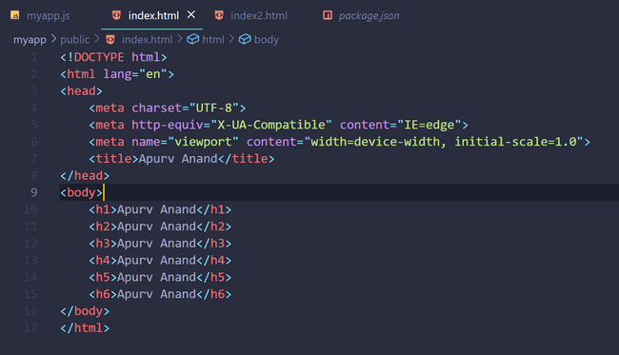

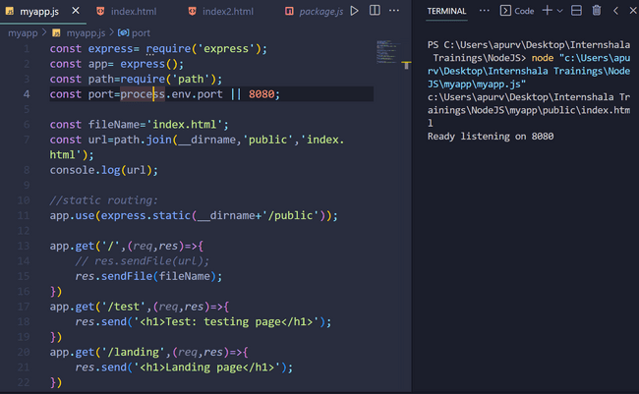

OUTPUTS:

Default page:

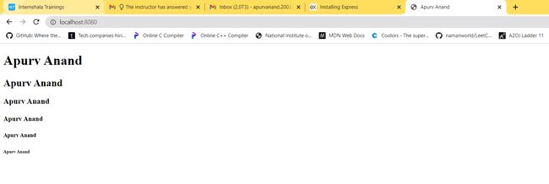

When I write ‘/test’ along with previous url:

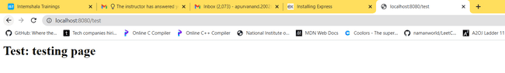

When I write ‘/landing’ along with previous url:

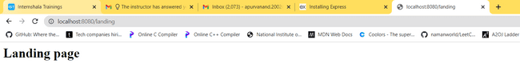

When I write ‘/index2.html’ :

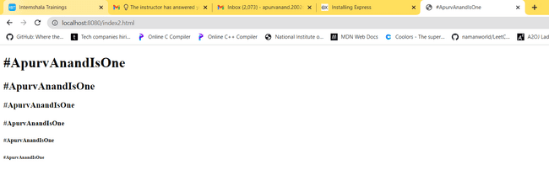

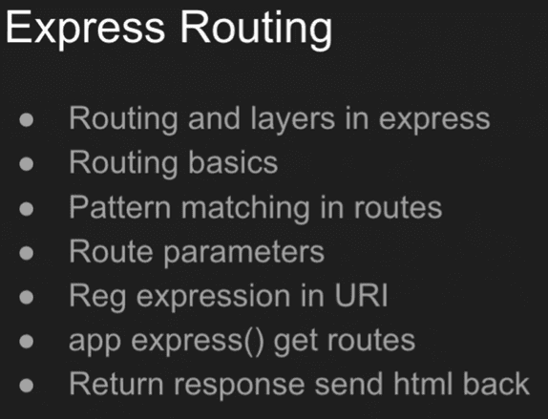

**Regular Expressions**:

**ab?cd** : will work for abcd and acd and not for bcd.

**ab+cd** : can contain as many ‘b’s as it wants in between but must always start with ‘ab’ and end in ‘cd’.

**ab*cd** : can contain any number or letter any number of times in between ‘ab’ and ‘cd’ .

**Route Parameters**: They take a particular value using the url and we can access that particular value.

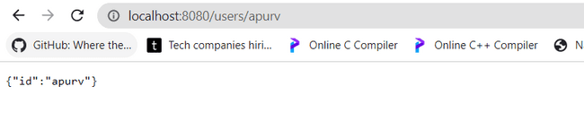

Code is given down. We have given ‘apurv’ after ‘users’ in the URL and that parameter as we are printing request parameters according to our code so, it is accessible by us as stated in the definition.

**CODE:**

const express= require('express');

const app= express();

const path=require('path');

const port=process.env.port || 8080;

const fileName='index.html';

const url=path.join(__dirname,'public','index.html');

console.log(url);

*//static routing:*

app.use(express.static(__dirname+'/public'));

app.get('/',(*req*,*res*)=>{

*// res.sendFile(url);*

*res*.sendFile(fileName);

})

*//----------------------------------------------------------------------------*

*//Pattern Matching in JS*

app.get('/ab?cd',(*req*,*res*)=>{

*res*.send('<h1>abcd or acd</h1>');

})

app.get('/ab+cd',(*req*,*res*)=>{

*res*.send('<h1>can contain as many `b`s as it wants but must always start with `ab` and end in `cd`</h1>');

})

app.get('/ab*cd',(*req*,*res*)=>{

*res*.send('<h1>Can contain any letter any number of times in between `ab` and `cd`</h1>');

})

app.get(/z/,(*req*,*res*)=>{

*res*.send('<h1>Whenever it will find any `z` in the url then it will execute this line of code.</h1>');

})

*//route parameters:they take a particular value using url and can we access that value.*

app.get('/users/:id',(*req*,*res*)=>{

*res*.send(*req*.params);

})

*//We can pass multiple root parameters at the same time*

app.get('/users/:id/:val',(*req*,*res*)=>{

*res*.send(*req*.params);

})

*//----------------------------------------------------------------------------*

app.get('/test',(*req*,*res*)=>{

*res*.send('<h1>Test: testing page</h1>');

})

app.get('/landing',(*req*,*res*)=>{

*res*.send('<h1>Landing page</h1>');

})

app.listen(port,()=>{

    console.log(`Ready listening on ${port}`);

})

**Example**: We can pass multiple route parameters at the same time separated by ‘/:’ and also, easily access them using ‘req.params’.

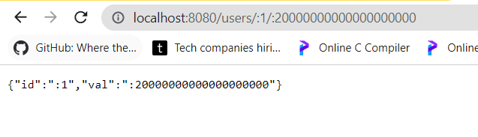

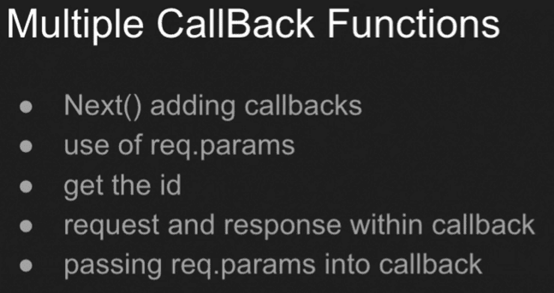

**(req,res)=>{}** : is called ‘callback function’.

**To use multiple callbacks, we use ‘next’ and ‘next()’ function at the end of 1 callback if we have other callback after it.**

CODE:

const express= require('express');

const app= express();

const path=require('path');

const port=process.env.port || 8080;

const fileName='index.html';

const url=path.join(__dirname,'public','index.html');

console.log(url);

*//static routing:*

app.use(express.static(__dirname+'/public'));

app.get('/',(*req*,*res*)=>{

*// res.sendFile(url);*

*res*.sendFile(fileName);

})

*//------------------------------------------------*

*//Pattern Matching in JS*

app.get('/ab?cd',(*req*,*res*)=>{

*res*.send('<h1>abcd or acd</h1>');

})

app.get('/ab+cd',(*req*,*res*)=>{

*res*.send('<h1>can contain as many `b`s as it wants but must always start with `ab` and end in `cd`</h1>');

})

app.get('/ab*cd',(*req*,*res*)=>{

*res*.send('<h1>Can contain any letter any number of times in between `ab` and `cd`</h1>');

})

app.get(/z/,(*req*,*res*)=>{

*res*.send('<h1>Whenever it will find any `z` in the url then it will execute this line of code.</h1>');

})

*//route parameters:they take a particular value using url and can we access that value.*

app.get('/users/:id',(*req*,*res*)=>{

*res*.send(*req*.params);

})

*//We can pass multiple root parameters at the same time*

*// app.get('/users/:id/:val',(req,res)=>{*

*//     res.send(req.params);*

*// })*

*//multiple callbacks*

app.get('/users/:id/:val',(*req*,*res*,next)=>{

*res*.send(*req*.params);

    console.log("First Callback",*req*.params.id);

    next()

},(*req*,*res*,next)=>{

console.log(`Second Callback ${*req*.params.val}`)

next()

},(*req*,*res*,next)=>{

console.log(`Third Callback ${*req*.params.val}`);

})

*//--------------------------------------------------------------------------------*

app.get('/test',(*req*,*res*)=>{

*res*.send('<h1>Test: testing page</h1>');

})

app.get('/landing',(*req*,*res*)=>{

*res*.send('<h1>Landing page</h1>');

})

app.listen(port,()=>{

    console.log(`Ready listening on ${port}`);

})

See the part of commented multiple callbacks.

OUTPUTS:

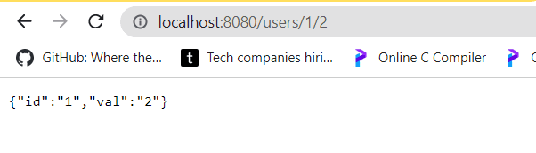 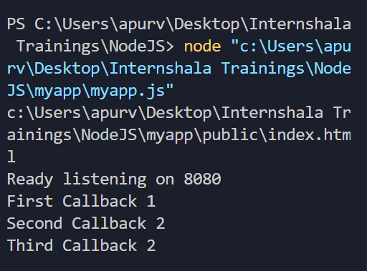

THEN:

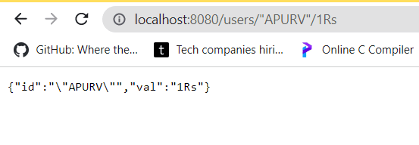 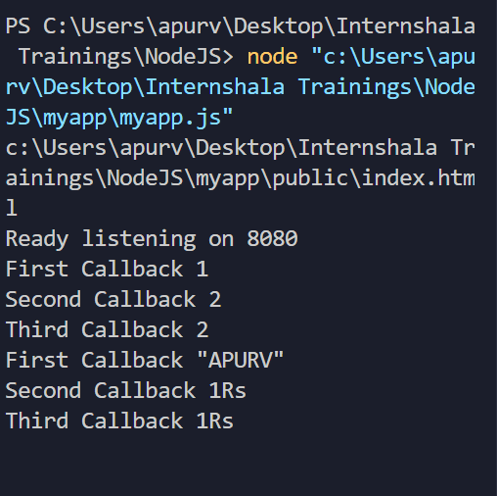

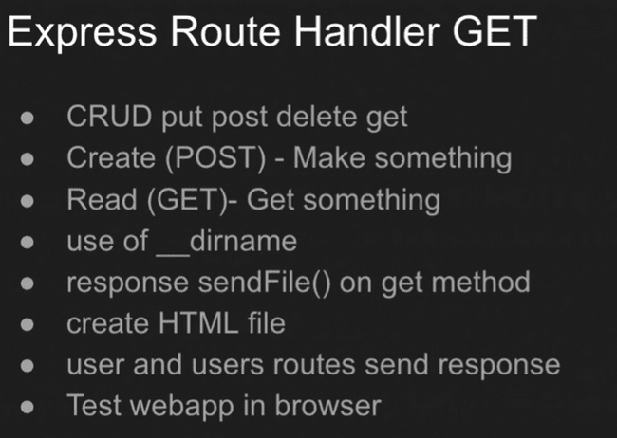

**EXCLUSIVE: Making a working form:**

**Making a simple form in ‘index.html’ file:**

**‘/users’ in form action mentions the file in which this information will be stored. And as we are POSTing the data from the form into ‘/users’ ,so ,we set have set ,method to be ‘POST’.**

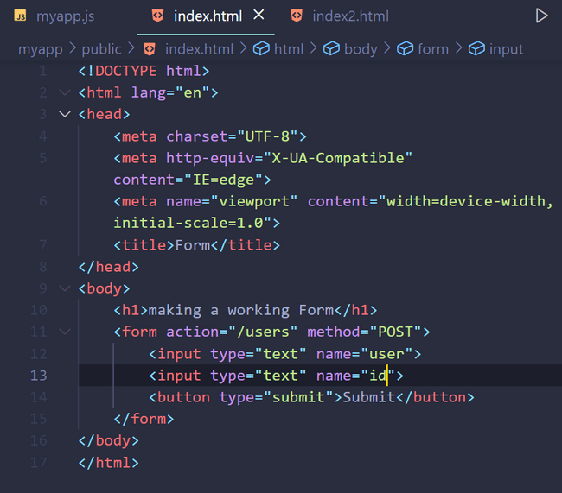

**CODE:**

**In express.js , we have to now set the code such that it posts the data from the HTML webpage into ‘/users’ file. So, we have used ‘app.post()’ for it.**

**As express can handle only sending files and urls but we can not do reading of the form using it, so, we install ‘body-parser’ first from npm using ‘npm install body-parser’ .**

**As ‘body-parser’ is helping us to import or read all information from the form, it is called ‘middleware’. As express.js supports ‘middleware’ and ‘routing’ ,so ,it is called middleware and routing framework.**

**So, ‘body-parser’ is ‘middleware’ and its main function is to read all things which are present on the webpage so, it requests for the contents on the webpage and then stores it in its body then it sends those as a response which is called ‘request body’ as it is body-parser’s response of webpage’s body and we need to request for it.**

**CODE:**

const express=require('express');

const app=express();

const bodyparser= require('body-parser');

const port= process.env.PORT ||8080;

*//to fetch request-body:*

app.use(bodyparser.urlencoded({extended:true}));

app.get('/user',(*req*,*res*)=>{

*res*.sendFile(__dirname+'/public'+'/index.html');

})

app.post('/users',(*req*,*res*)=>{

    console.log(*req*.body);

*//As if response is not set, browser will spin for some time and then throw the error.So, setting some response.*

*res*.send(`DONE: User: ${*req*.body.user} Id:${*req*.body.id}`);

})

app.listen(port,()=>{

    console.log(`ready listening on ${port}`);

})

**Output:**

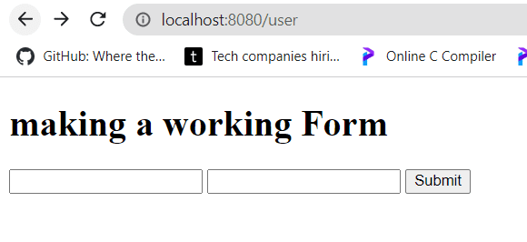

**Then:**

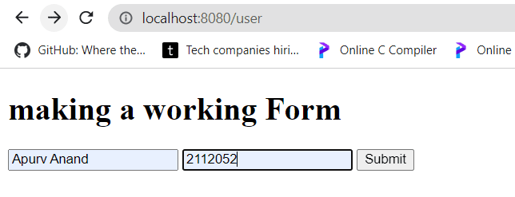

**Given the inputs and will now be clicking on submit. (above)**

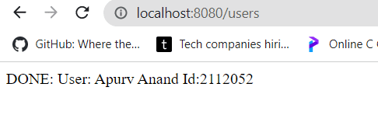

**After submission(above)**

**Note: See the url, it has now changed to ‘/users’ from ‘/user’ as we had mentioned in our url to get our output on ‘/users’ .**

**Also,in console: We get this(down) output and it will be updated on doing submissions again and again. Where did ‘user’ and ‘id’ come from?**

**See the input tags in body of HTML code above. So, name or id part of input tag defines what form demands and that also is accessible by the programmer,so, it can be easily stored in database, word file, text file etc and also, is printable on browser as we have done.**

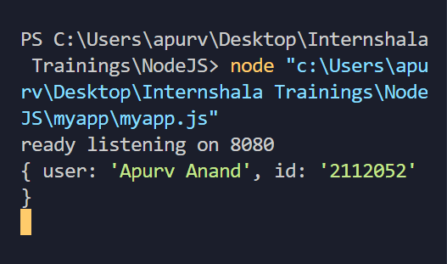

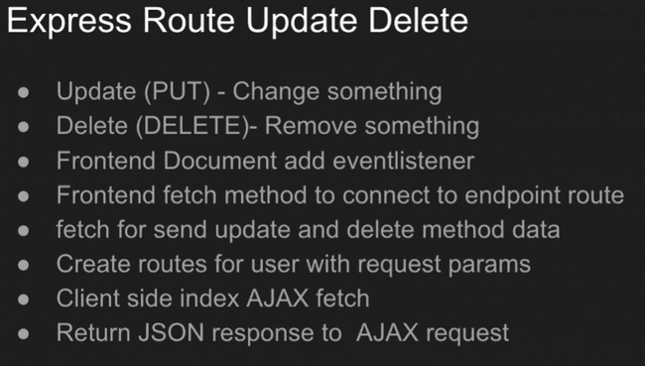

**Using AJAX for deletion:**

**CODE:**

const express=require('express');

const app=express();

const bodyparser= require('body-parser');

const port= process.env.PORT ||8080;

*//to fetch request-body:*

app.use(bodyparser.urlencoded({extended:true}));

app.get('/user',(*req*,*res*)=>{

*res*.sendFile(__dirname+'/public'+'/index.html');

})

app.post('/users',(*req*,*res*)=>{

    console.log(*req*.body);

*//As if response is not set, browser will spin for some time and then throw the error.So, setting some response.*

*res*.send(`DONE: User: ${*req*.body.user} Id:${*req*.body.id}`);

})

app.listen(port,()=>{

    console.log(`ready listening on ${port}`);

})

app.get('/users/:id',(*req*,*res*)=>{

    const id=*req*.params.id;

    console.log('found'+id);*//in console*

*res*.send('found'+id);*//on browser*

})

*//Addition for DELETE operation.*

app.delete('/users/:id',(*req*,*res*)=>{

    const id=*req*.params.id;

    console.log('deleted',id);*//in console*

*res*.send({status:'done', id:id});*//on browser's console*

})

**OUTPUT: second box takes ‘id’ as input and first I typed 100 and then 200.**

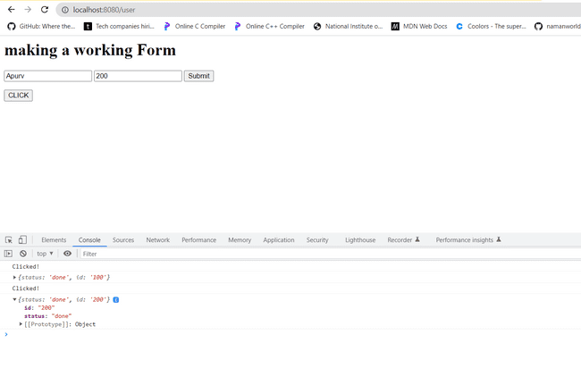

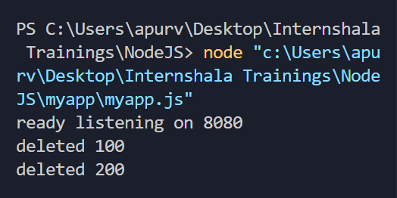

**For Update Operation:**

**CODE:**

const express=require('express');

const app=express();

const bodyparser= require('body-parser');

const port= process.env.PORT ||8080;

*//to fetch request-body:*

app.use(bodyparser.urlencoded({extended:true}));

app.get('/user',(*req*,*res*)=>{

*res*.sendFile(__dirname+'/public'+'/index.html');

})

app.post('/users',(*req*,*res*)=>{

    console.log(*req*.body);

*//As if response is not set, browser will spin for some time and then throw the error.So, setting some response.*

*res*.send(`DONE: User: ${*req*.body.user} Id:${*req*.body.id}`);

})

app.listen(port,()=>{

    console.log(`ready listening on ${port}`);

})

app.get('/users/:id',(*req*,*res*)=>{

    const id=*req*.params.id;

    console.log('found'+id);*//in console*

*res*.send('found'+id);*//on browser*

})

*//Addition for DELETE operation.*

*//Changes in function name 'app.delete()'*

app.delete('/users/:id',(*req*,*res*)=>{

    const id=*req*.params.id;

    console.log('deleted',id);*//in console*

*res*.send({status:'deleted', id:id});*//on browser's console*

})

*//for UPDATE operation.*

*//changes in function name 'app.put()'*

app.put('/users/:id',(*req*,*res*)=>{

    const id=*req*.params.id;

    console.log('updated',id);*//in console*

*res*.send({status:'updated', id:id});*//on browser's console*

})

**OUTPUT:**

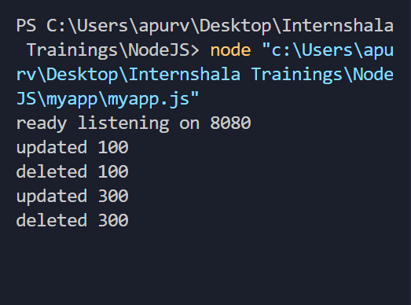

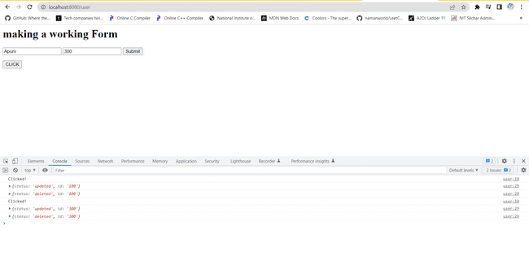

**NOTE: In all operation must note that function name changes i.e. for delete we use app.delete(); for updation use app.put() ; for getting a url , we used app.get() and for posting on a specific url we used app.post() etc and also, one must note what values are they returning some return json object, whereas others return nothing.**

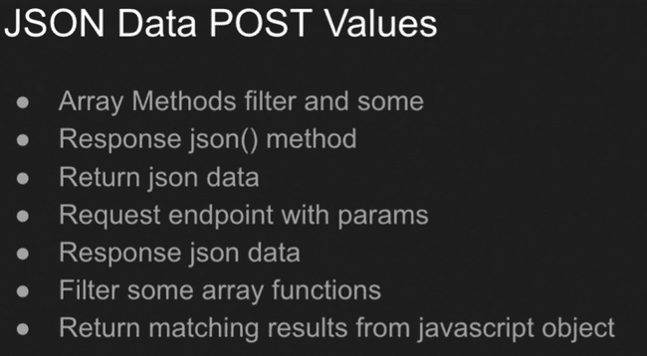

**array.some() : returns ‘true’ if any one element of the array satisfies a function and returns ‘false’ if none of the elements satisfy the function.**

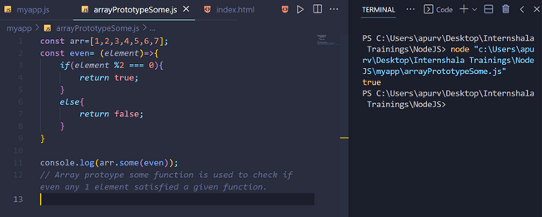

**array.filter() : It is used to filter out some elements which satisfy specific conditions.**

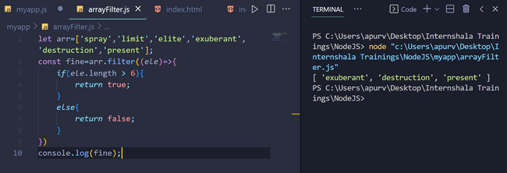

**CODE:**

**myapp.js**

const express=require('express');

const app=express();

const bodyparser= require('body-parser');

const port= process.env.PORT ||8080;

*//-------------------------------------------*

const myObj={

    users:[

        {

            id:1,

            name:"Apurv"

        },

        {

            id:2,

            name:"XYZ"

        },

        {

            id:3,

            name:"PQR"

        }

    ]

}

console.log(myObj);

console.log(myObj.users.some((*ele*)=> *ele*.id==1))

app.get('/users',(*req*,*res*)=>{

*res*.json(myObj);

})

app.get('/users/:id',(*req*,*res*)=>{

    console.log(*req*.params);

    let myJson=[];

*if*(myObj.users.some((*ele*)=> *ele*.id==*req*.params.id)){

        myJson= myObj.users.filter((*ele*)=> *ele*.id==*req*.params.id)

    }

*res*.json(myJson);

})

*//---------------------------------------------*

*//to fetch request-body:*

app.use(bodyparser.urlencoded({extended:true}));

app.get('/user',(*req*,*res*)=>{

*res*.sendFile(__dirname+'/public'+'/index.html');

})

app.post('/users',(*req*,*res*)=>{

    console.log(*req*.body);

*//As if response is not set, browser will spin for some time and then throw the error.So, setting some response.*

*res*.send(`DONE: User: ${*req*.body.user} Id:${*req*.body.id}`);

})

app.listen(port,()=>{

    console.log(`ready listening on ${port}`);

})

*//Addition for DELETE operation.*

*//Changes in function name 'app.delete()'*

app.delete('/users/:id',(req,res)=>{

    const id=*req*.params.id;

    console.log('deleted',id);*//in console*

*res*.send({status:'deleted', id:id});*//on browser's console*

})

*//for UPDATE operation.*

*//changes in function name 'app.put()'*

app.put('/users/:id',(req,res)=>{

    const id=*req*.params.id;

    console.log('updated',id);*//in console*

*res*.send({status:'updated', id:id});*//on browser's console*

})

**New code is inserted in between ‘dashed lines’ i.e //----------------**

**index.html**

<html>

<head>

    <title>Form</title>

</head>

<body>

    <h1>making a working Form</h1>

    <form action="/users" method="POST">

        <input type="text" name="user" value="Apurv">

        <input type="text" name="id" value="100">

        <button type="submit">Submit</button>

    </form>

    <button class="btn">CLICK</button>

    <button class="btn1">Get JSON</button>

    <script>

*//------------------------------------------*

        const btn1=document.querySelector('.btn1');

        btn1.addEventListener('click',()=>{

            fetch('/users').then(*res* =>*res*.json())

            .then(*data* =>{

                console.log(*data*);

*data*.users.forEach((*element*)=>{

                    console.log(*element*);

                })

            });

        })

*//------------------------------------------*

*//using Document Object Model(DOM)*

        const btn= document.querySelector('.btn');

        const myId=document.querySelector('input[name="id"]'); *//input[name="id"] selects whole input tag <input type="text" name="id" value="100">*

        btn.addEventListener('click',()=>{

            console.log("Clicked!");

            const endPoint='/users';

            const id=myId.value;

            fetch(endPoint+'/'+id,{

                method:'delete'

            }).then(*res*=> *res*.json())

            .then(*data* => console.log(*data*));

*//Updating deletion code for updation as well as deletion, i.e. using same code as before only method changes*

            fetch(endPoint+'/'+id,{

                method:'put'

            }).then(*res*=> *res*.json())

            .then(*data* => console.log(*data*));

        })

    </script>

</body>

</html>

**OUTPUT:**

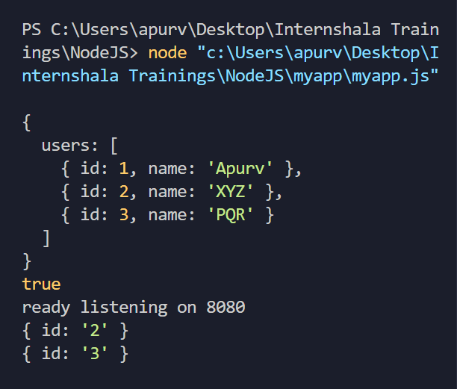

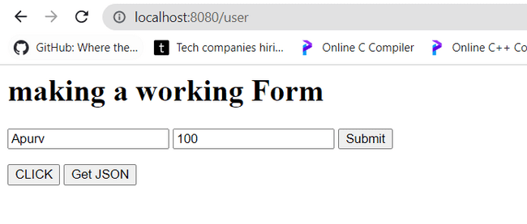

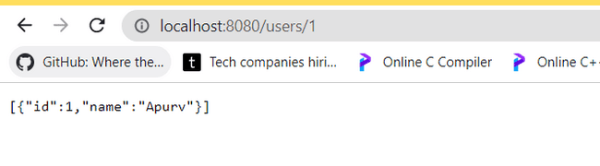

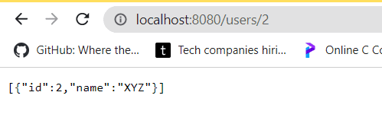

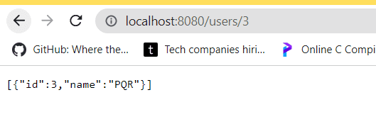

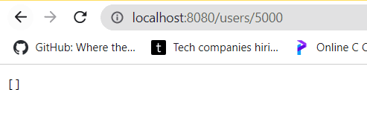

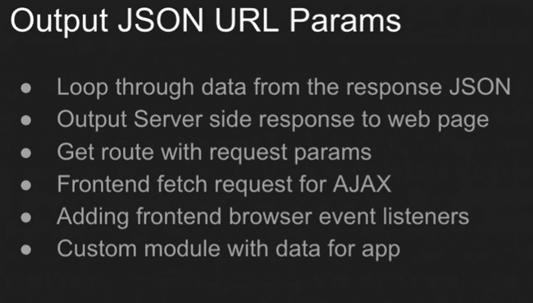

**CODE: We have made working ‘Get User’ button here as we have taken console.log in the HTML document so, it will be visible in browser’s console.**

**Index.html**

<html>

<head>

    <title>Form</title>

</head>

<body>

    <h1>making a working Form</h1>

    <form action="/users" method="POST">

        <input type="text" name="user" value="Apurv">

        <input type="text" name="id" value="100">

        <button type="submit">Submit</button>

    </form>

    <button class="btn">CLICK</button>

    <button class="btn1">Get JSON</button>

    <button class="btn2">Get User</button>

    <script>

        const btn= document.querySelector('.btn');

        const myId=document.querySelector('input[name="id"]'); *//input[name="id"] selects whole input tag <input type="text" name="id" value="100">*

        const btn1=document.querySelector('.btn1');

*//---------------------------------------*

        const btn2=document.querySelector('.btn2');

        btn2.addEventListener('click',()=>{

            fetch(`/users/${myId.value}`).then(*res* =>*res*.json())

            .then(*data* =>{

                console.log(*data*);

*data*.forEach((*element*)=>{

                    console.log(*element*);

                })

            });

        })

*//-----------------------------------------*

        btn1.addEventListener('click',()=>{

            fetch('/users').then(*res* =>*res*.json())

            .then(*data* =>{

                console.log(*data*);

*data*.users.forEach((*element*)=>{

                    console.log(*element*);

                })

            });

        })

*//------------------------------------------*

*//using Document Object Model(DOM)*

        btn.addEventListener('click',()=>{

            console.log("Clicked!");

            const endPoint='/users';

            const id=myId.value;

            fetch(endPoint+'/'+id,{

                method:'delete'

            }).then(*res*=> *res*.json())

            .then(*data* => console.log(*data*));

*//Updating deletion code for updation as well as deletion, i.e. using same code as before only method changes*

            fetch(endPoint+'/'+id,{

                method:'put'

            }).then(*res*=> *res*.json())

            .then(*data* => console.log(*data*));

        })

    </script>

</body>

</html>

**Here we have fetched the data from a different file called ‘users.js’ So, we have exported users.js data into myapp.js first and then used html code to fetch it in browser’s console.**

**Users.js**

const myObj={

    users:[

        {

            id:1,

            name:"Apurv"

        },

        {

            id:2,

            name:"XYZ"

        },

        {

            id:3,

            name:"PQR"

        }

    ]

}

module.exports =myObj;

**myapp.js**

const express=require('express');

const app=express();

const bodyparser= require('body-parser');

const myObj= require('./users');

const port= process.env.PORT ||8080;

*//-------------------------------------------*

console.log(myObj);

console.log(myObj.users.some((*ele*)=> *ele*.id==1))

app.get('/users',(*req*,*res*)=>{

*res*.json(myObj);

})

app.get('/users/:id',(*req*,*res*)=>{

    console.log(*req*.params);

    let myJson=[];

*if*(myObj.users.some((*ele*)=> *ele*.id==*req*.params.id)){

        myJson= myObj.users.filter((*ele*)=> *ele*.id==*req*.params.id)

    }

*res*.json(myJson);

})

*//---------------------------------------------*

*//to fetch request-body:*

app.use(bodyparser.urlencoded({extended:true}));

app.get('/user',(*req*,*res*)=>{

*res*.sendFile(__dirname+'/public'+'/index.html');

})

app.post('/users',(*req*,*res*)=>{

    console.log(*req*.body);

*//As if response is not set, browser will spin for some time and then throw the error.So, setting some response.*

*res*.send(`DONE: User: ${*req*.body.user} Id:${*req*.body.id}`);

})

app.listen(port,()=>{

    console.log(`ready listening on ${port}`);

})

*//Addition for DELETE operation.*

*//Changes in function name 'app.delete()'*

app.delete('/users/:id',(req,res)=>{

    const id=*req*.params.id;

    console.log('deleted',id);*//in console*

*res*.send({status:'deleted', id:id});*//on browser's console*

})

*//for UPDATE operation.*

*//changes in function name 'app.put()'*

app.put('/users/:id',(*req*,*res*)=>{

    const id=*req*.params.id;

    console.log('updated',id);*//in console*

*res*.send({status:'updated', id:id});*//on browser's console*

})

**OUTPUT:**

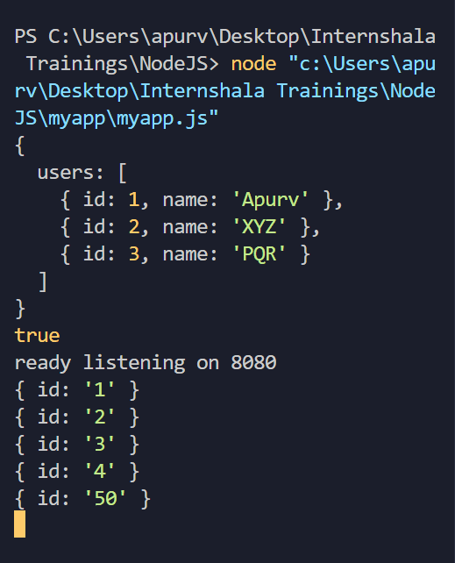

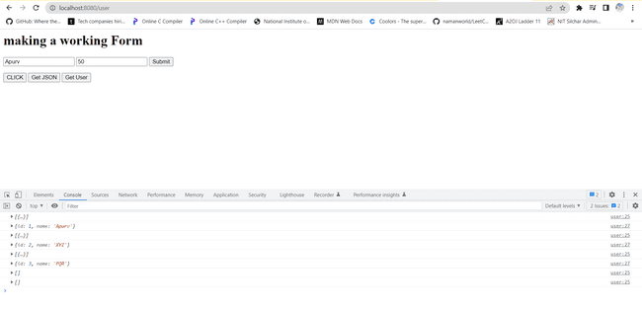

**NOTE:**

*if*(myObj.users.some((*ele*)=> *ele*.id==*req*.params.id)){

**this line of code(highlighted by yellow coloured font colour in above code) in above myapp.js file, has ‘ele.id’ has ‘integer’ and ‘req.params.id’ as ‘string’. So, as to convert string to integer , we use ‘parseInt’ function. It is very necessary as then only we can apply ‘===’ i.e. strict equality operator as it compares value as well as data type.**

**CODE:**

**myapp.js**

const express=require('express');

const app=express();

const bodyparser= require('body-parser');

const myObj= require('./users');

const port= process.env.PORT ||8080;

*//-------------------------------------------*

console.log(myObj);

console.log(myObj.users.some((*ele*)=> *ele*.id==1))

app.get('/users',(*req*,*res*)=>{

*res*.json(myObj);

})

app.get('/users/:id',(*req*,*res*)=>{

    console.log(*req*.params);

    let myJson=[];

*if*(myObj.users.some((*ele*)=> *ele*.id===parseInt(*req*.params.id))){

        myJson= myObj.users.filter((*ele*)=> *ele*.id===parseInt(*req*.params.id))

    }

*res*.json(myJson);

})

*//---------------------------------------------*

*//to fetch request-body:*

app.use(bodyparser.urlencoded({extended:true}));

app.get('/user',(*req*,*res*)=>{

*res*.sendFile(__dirname+'/public'+'/index.html');

})

app.post('/users',(*req*,*res*)=>{

    console.log(*req*.body);

*//As if response is not set, browser will spin for some time and then throw the error.So, setting some response.*

*res*.send(`DONE: User: ${*req*.body.user} Id:${*req*.body.id}`);

})

app.listen(port,()=>{

    console.log(`ready listening on ${port}`);

})

*//Addition for DELETE operation.*

*//Changes in function name 'app.delete()'*

app.delete('/users/:id',(*req*,*res*)=>{

    const id=*req*.params.id;

    console.log('deleted',id);*//in console*

*res*.send({status:'deleted', id:id});*//on browser's console*

})

*//for UPDATE operation.*

*//changes in function name 'app.put()'*

app.put('/users/:id',(req,res)=>{

    const id=*req*.params.id;

    console.log('updated',id);*//in console*

*res*.send({status:'updated', id:id});*//on browser's console*

})

**OUTPUT:**

**Output will be same as previous one.**

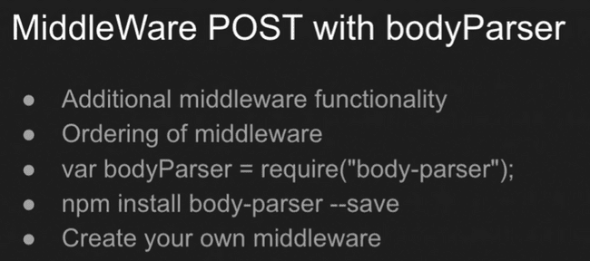

**Creating our own middleware:**

**As middleware helps us to ‘read’ as we can only write and send using nodejs so, we can get the parameters that we have requested using middleware. Here, in our created callback use of ‘next’ and next() function is very important as we will execute it in any case i.e it will always be executed unlike other callbacks which will be excuted only in specific condition of get, post etc.**

**CODE: (new code is added in //---------------------------------------- )**

const express=require('express');

const app=express();

const bodyparser= require('body-parser');

const myObj= require('./users');

const port= process.env.PORT ||8080;

*//-------------------------------------------*

*//Creating our own middleware*

const logOutput=(*req*,*res*,*next*)=>{

    console.log('Middleware in action');

    console.log(*req*.params);

    next();

*//use of next is very important as it helps us to move to next callback.*

}

app.use(logOutput);

*//--------------------------------------------*

console.log(myObj);

console.log(myObj.users.some((*ele*)=> *ele*.id==1))

app.get('/users',(*req*,*res*)=>{

*res*.json(myObj);

})

app.get('/users/:id',(*req*,*res*)=>{

    console.log(*req*.params);

    let myJson=[];

*if*(myObj.users.some((*ele*)=> *ele*.id===parseInt(*req*.params.id))){

        myJson= myObj.users.filter((*ele*)=> *ele*.id===parseInt(*req*.params.id))

    }

*res*.json(myJson);

})

*//to fetch request-body:*

app.use(bodyparser.urlencoded({extended:true}));

app.get('/user',(*req*,*res*)=>{

*res*.sendFile(__dirname+'/public'+'/index.html');

})

*//-------------------------------------------------*

app.post('/users',(*req*,*res*)=>{

    console.log(*req*.body);

*res*.sendFile(__dirname+'/public'+'/index.html');

})

*//---------------------------------------------------*

app.post('/users',(req,res)=>{

    console.log(*req*.body);

*//As if response is not set, browser will spin for some time and then throw the error.So, setting some response.*

*res*.send(`DONE: User: ${*req*.body.user} Id:${*req*.body.id}`);

})

app.listen(port,()=>{

    console.log(`ready listening on ${port}`);

})

*//Addition for DELETE operation.*

*//Changes in function name 'app.delete()'*

app.delete('/users/:id',(*req*,*res*)=>{

    const id=*req*.params.id;

    console.log('deleted',id);*//in console*

*res*.send({status:'deleted', id:id});*//on browser's console*

})

*//for UPDATE operation.*

*//changes in function name 'app.put()'*

app.put('/users/:id',(*req*,*res*)=>{

    const id=*req*.params.id;

    console.log('updated',id);*//in console*

*res*.send({status:'updated', id:id});*//on browser's console*

})

**Index.html:**

<html>

<head>

    <title>Form</title>

</head>

<body>

    <h1>making a working Form</h1>

    <form action="/users" method="POST">

        <input type="text" name="user" value="Apurv">

        <input type="text" name="id" value="100">

        <button type="submit">Submit</button>

    </form>

    <button class="btn">CLICK</button>

    <button class="btn1">Get JSON</button>

    <button class="btn2">Get User</button>

    <script>

        const btn= document.querySelector('.btn');

        const myId=document.querySelector('input[name="id"]'); *//input[name="id"] selects whole input tag <input type="text" name="id" value="100">*

        const btn1=document.querySelector('.btn1');

*//---------------------------------------*

        const btn2=document.querySelector('.btn2');

        btn2.addEventListener('click',()=>{

            fetch(`/users/${myId.value}`).then(*res* =>*res*.json())

            .then(*data* =>{

                console.log(*data*);

*data*.forEach((*element*)=>{

                    console.log(*element*);

                })

            });

        })

*//-----------------------------------------*

        btn1.addEventListener('click',()=>{

            fetch('/users').then(*res* =>*res*.json())

            .then(*data* =>{

                console.log(*data*);

*data*.users.forEach((*element*)=>{

                    console.log(*element*);

                })

            });

        })

*//------------------------------------------*

*//using Document Object Model(DOM)*

        btn.addEventListener('click',()=>{

            console.log("Clicked!");

            const endPoint='/users';

            const id=myId.value;

            fetch(endPoint+'/'+id,{

                method:'delete'

            }).then(*res*=> *res*.json())

            .then(*data* => console.log(*data*));

*//Updating deletion code for updation as well as deletion, i.e. using same code as before only method changes*

            fetch(endPoint+'/'+id,{

                method:'put'

            }).then(*res*=> *res*.json())

            .then(*data* => console.log(*data*));

        })

    </script>

</body>

</html>

**Output:**

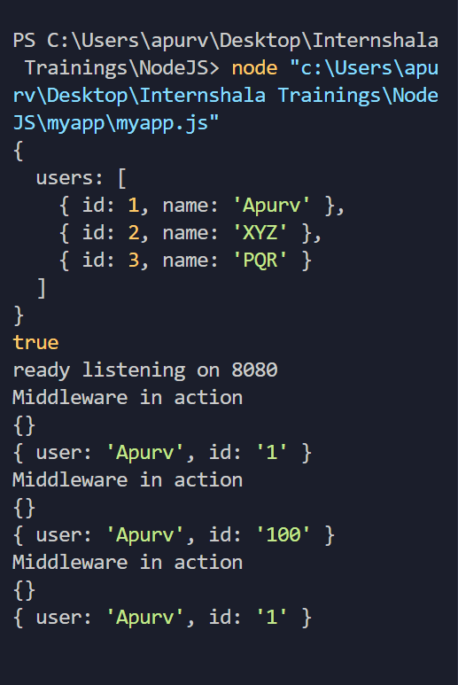

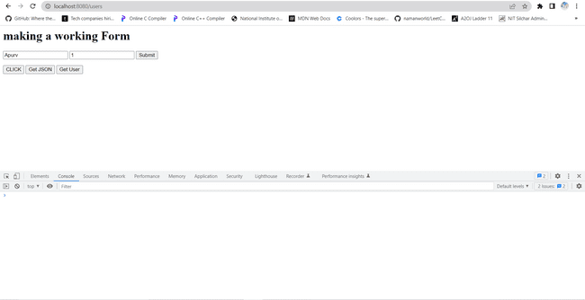

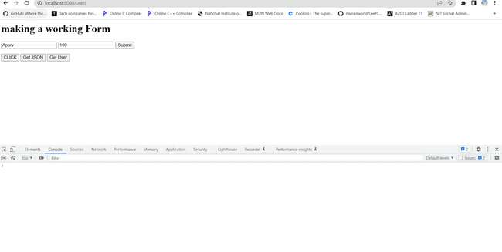

**We will find no output in browser’s console as we aren’t doing any console.log in html file relating to this(see index.html in previous code) and also, we are not printing any response.**

**NOTE: Use of ‘next’ and ‘next()’ function is very important in our defined callback function.**

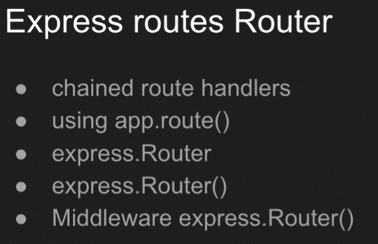

**We have seen a lot of functions in express like get() to implement a code block when ever we get a particular URL, put() to update, post() to post on a specific URL etc.**

**Whenever we will have to use all these functions on the same address, we can use a common function.**

**OLD WAY: (see the part in between //----------------------------------)**

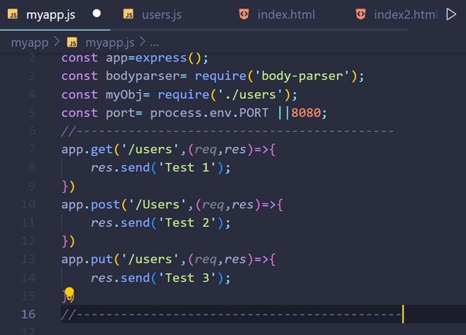

**New way:**

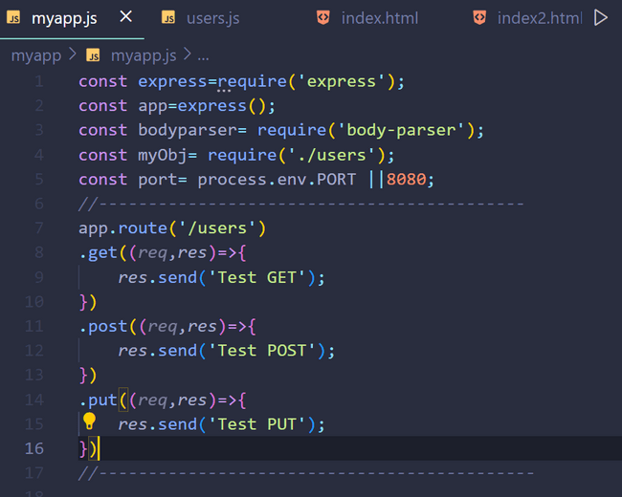

**Complete code for above:**

const express=require('express');

const app=express();

const bodyparser= require('body-parser');

const myObj= require('./users');

const port= process.env.PORT ||8080;

*//-------------------------------------------*

app.route('/users')

.get((*req*,*res*)=>{

*res*.send('Test GET');

})

.post((*req*,*res*)=>{

*res*.send('Test POST');

})

.put((*req*,*res*)=>{

*res*.send('Test PUT');

})

*//--------------------------------------------*

*//Creating our own middleware*

const logOutput=(*req*,*res*,*next*)=>{

    console.log('Middleware in action');

    console.log(*req*.params);

    next();

*//use of next is very important as it helps us to move to next callback.*

}

app.use(logOutput);

console.log(myObj);

console.log(myObj.users.some((*ele*)=> *ele*.id==1))

app.get('/users',(*req*,*res*)=>{

*res*.json(myObj);

})

app.get('/users/:id',(*req*,*res*)=>{

    console.log(*req*.params);

    let myJson=[];

*if*(myObj.users.some((*ele*)=> *ele*.id===parseInt(*req*.params.id))){

        myJson= myObj.users.filter((*ele*)=> *ele*.id===parseInt(*req*.params.id))

    }

*res*.json(myJson);

})

*//to fetch request-body:*

app.use(bodyparser.urlencoded({extended:true}));

app.get('/user',(req,res)=>{

*res*.sendFile(__dirname+'/public'+'/index.html');

})

app.post('/users',(req,res)=>{

    console.log(*req*.body);

*res*.sendFile(__dirname+'/public'+'/index.html');

})

app.post('/users',(req,res)=>{

    console.log(*req*.body);

*//As if response is not set, browser will spin for some time and then throw the error.So, setting some response.*

*res*.send(`DONE: User: ${*req*.body.user} Id:${*req*.body.id}`);

})

app.listen(port,()=>{

    console.log(`ready listening on ${port}`);

})

*//Addition for DELETE operation.*

*//Changes in function name 'app.delete()'*

app.delete('/users/:id',(*req*,*res*)=>{

    const id=*req*.params.id;

    console.log('deleted',id);*//in console*

*res*.send({status:'deleted', id:id});*//on browser's console*

})

*//for UPDATE operation.*

*//changes in function name 'app.put()'*

app.put('/users/:id',(*req*,*res*)=>{

    const id=*req*.params.id;

    console.log('updated',id);*//in console*

*res*.send({status:'updated', id:id});*//on browser's console*

})

**Using Express router:**

**Code:**

**myapp.js**

const express=require('express');

const app=express();

const router=express.Router();

const bodyparser= require('body-parser');

const myObj= require('./users');

const port= process.env.PORT ||8080;

const users=require('./user');

app.use('/users',users);

*//-------------------------------------------*

*// app.route('/users')*

*// .get((req,res)=>{*

*//     res.send('Test GET');*

*// })*

*// .post((req,res)=>{*

*//     res.send('Test POST');*

*// })*

*// .put((req,res)=>{*

*//     res.send('Test PUT');*

*// })*

*//--------------------------------------------*

*//Creating our own middleware*

const logOutput=(*req*,*res*,*next*)=>{

    console.log('Middleware in action');

    console.log(*req*.params);

    next();

*//use of next is very important as it helps us to move to next callback.*

}

app.use(logOutput);

console.log(myObj);

console.log(myObj.users.some((*ele*)=> *ele*.id==1))

app.get('/users',(*req*,*res*)=>{

*res*.json(myObj);

})

app.get('/users/:id',(*req*,*res*)=>{

    console.log(*req*.params);

    let myJson=[];

*if*(myObj.users.some((*ele*)=> *ele*.id===parseInt(req.params.id))){

        myJson= myObj.users.filter((*ele*)=> *ele*.id===parseInt(*req*.params.id))

    }

*res*.json(myJson);

})

*//to fetch request-body:*

app.use(bodyparser.urlencoded({extended:true}));

app.get('/user',(req,res)=>{

*res*.sendFile(__dirname+'/public'+'/index.html');

})

app.post('/users',(req,res)=>{

    console.log(*req*.body);

*res*.sendFile(__dirname+'/public'+'/index.html');

})

app.post('/users',(*req*,*res*)=>{

    console.log(*req*.body);

*//As if response is not set, browser will spin for some time and then throw the error.So, setting some response.*

*res*.send(`DONE: User: ${*req*.body.user} Id:${*req*.body.id}`);

})

app.listen(port,()=>{

    console.log(`ready listening on ${port}`);

})

*//Addition for DELETE operation.*

*//Changes in function name 'app.delete()'*

app.delete('/users/:id',(*req*,*res*)=>{

    const id=*req*.params.id;

    console.log('deleted',id);*//in console*

*res*.send({status:'deleted', id:id});*//on browser's console*

})

*//for UPDATE operation.*

*//changes in function name 'app.put()'*

app.put('/users/:id',(*req*,*res*)=>{

    const id=*req*.params.id;

    console.log('updated',id);*//in console*

*res*.send({status:'updated', id:id});*//on browser's console*

})

**user.js**

const express=require('express');

const { users } = require('./users');

const router=express.Router();

router.use((*req*,*res*,next)=>{

    console.log("Users middleware");

    next()

})

router.get('/',(*req*,*res*)=>{

*res*.send('main user');

})

router.get('/info',(*req*,*res*)=>{

*res*.send('user info');

})

module.exports=router;

**OUTPUT:**

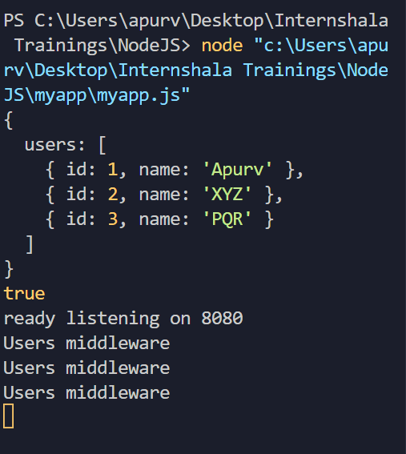

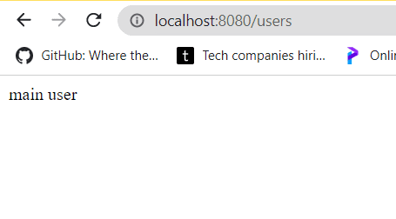

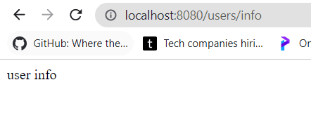

**Express Application generator :VERY VERY IMPORTANT**

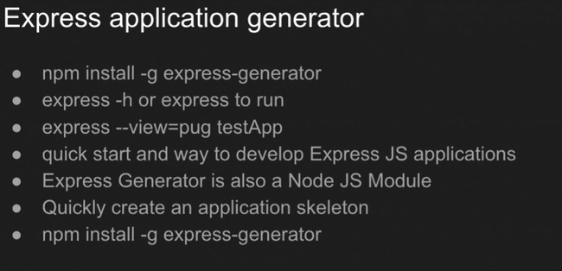

**Smetimes this may work and sometimes not: It throws errors.**

**Use ‘npm install express-generator’ to install express application generator.**

**Best way:**

**Write in new terminal:**

**Express –view=pug newApp**

**NOTE: ‘newApp’ here is name of new folder which will be created containing prebuilt and particulary built files used by professional programmers.**

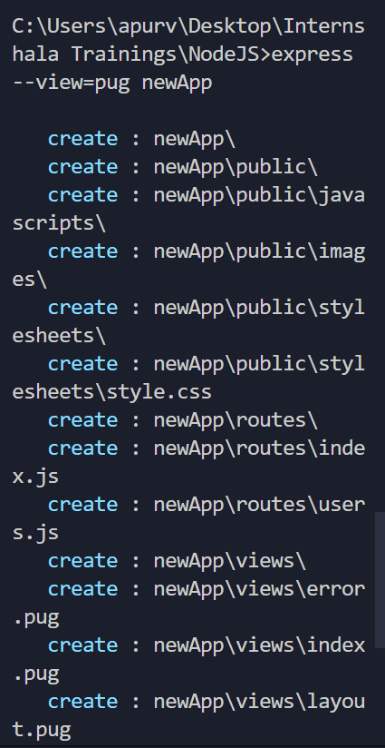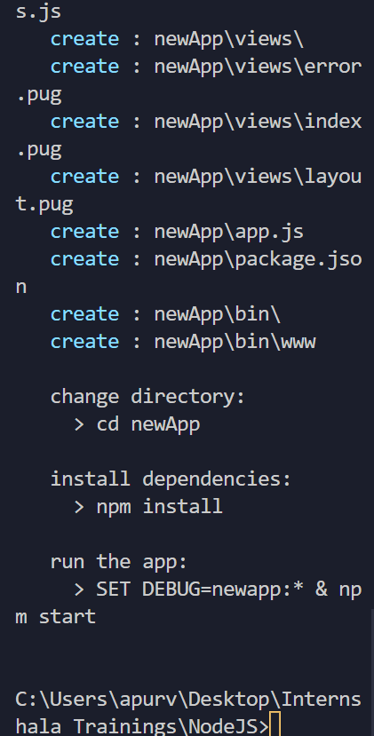

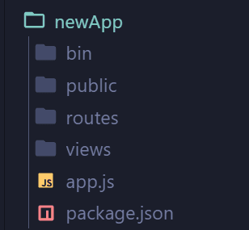 **New folder created named ‘newApp’.**